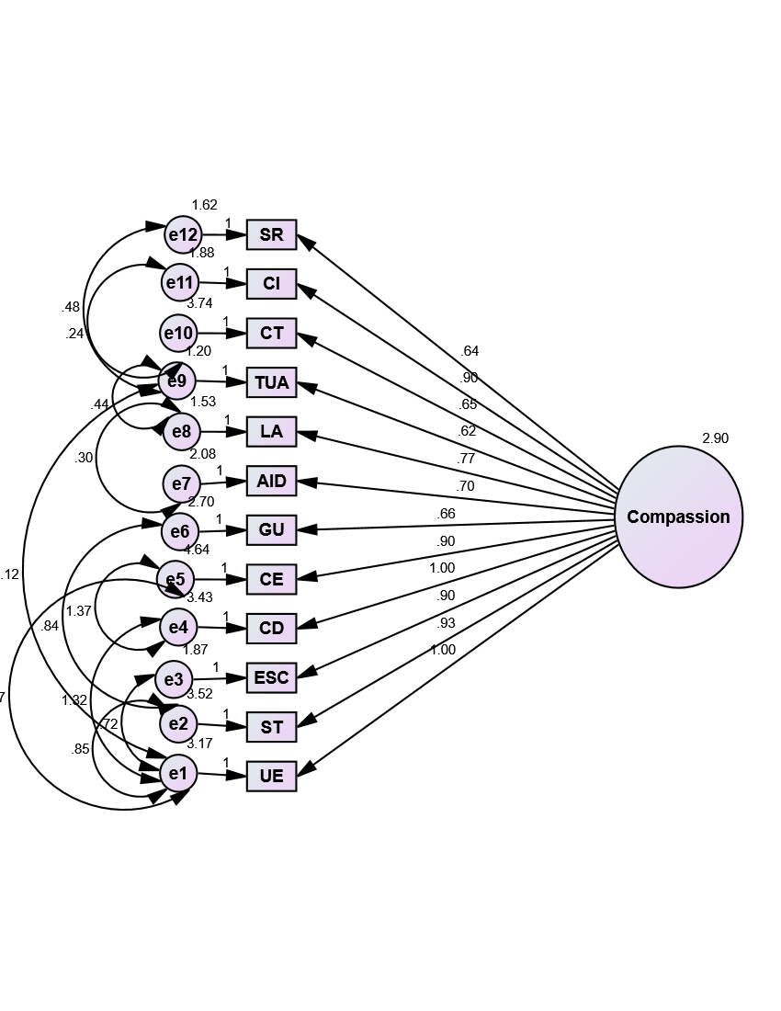
S3 Fig. One factor model of the SCCCS with standardized estimates and co-variance between errors.

