Supplemental Data
Supplemental Tables and Figures
Supplemental Table 1. Summarized miRNA sequence counts and percent per total.

Average miRNA sequence counts
Sample | NS | CN | PCM | CMELL | CMELM | CMELD | Melanoma cell lines*
hsa-miR-451a | 668.0 | 52.5 | 80.8 | 0.0 | 0.0 | 0.0 | 0.0
hsa-miR-144-3p | 216.0 | 6.0 | 31.2 | 0.0 | 8.3 | 0.0 | 0.0
hsa-miR-144-5p | 4.0 | 0.0 | 1.5 | 0.0 | 0.0 | 0.0 | 0.0
Total miRNAs | 26391.8 | 111455.0 | 14315.6 | 13617.0 | 18193.0 | 15572.0 | 9962.7
Average percent/total miRNAs
Sample | NS | CN | PCM | CMELL | CMELM | CMELD | Melanoma cell lines*
hsa-miR-451a | 2.1 | 0.0 | 0.7 | 0.0 | 0.0 | 0.0 | 0.0
hsa-miR-144-3p | 0.6 | 0.0 | 0.2 | 0.0 | 0.0 | 0.0 | 0.0
hsa-miR-144-5p | 0.0 | 0.0 | 0.0 | 0.0 | 0.0 | 0.0 | 0.0
*Melanoma cell lines were A2058, A375P, A375SM, C32, WM35 and WM1552C. CMELL, cultured melanocytes of light skin color. CMELM, cultured melanocytes of medium skin color. CMELD, cultured melanocytes of dark skin color.

Supplemental Table 2. TaqMan qRT-PCR primer assays for miR-451a isomiRs.
>hsa-mir-451a MI0001729  (miRBase v18) | CUUGGGAAUGGCAAGGAAACCGUUACCAUUACUGAGUUUAGUAAUGGUAAUGGUUCUCUUGCUAUACCCAGA
>hsa-mir-451a MI0001729  (miRBase v17) | ………………..……………AAACCGUUACCAUUACUGAGUUU…………………
>has-mir-451a  qRT-PCR assay | ……………………………..AAACCGUUACCAUUACUGAGUUU…………………
>has-mir-451a.1  qRT-PCR assay | ……………………………..AAACCGUUACCAUUACUGAGU……………
The underlined denotes the sequence for miR-451a in miRBase.

Supplemental Table 3. Clinicopathological characteristics of patient specimens.
Diagnostic Group | NS | CN | DN | MIS | PCM
Number of Samples | 19 | 16 | 19 | 17 | 30
Male | 9 | 9 | 6 | 7 | 21
Female | 10 | 7 | 13 | 10 | 9
Anatomic Site
Head & Neck | 3 | 2 | 1 | 3 | 9
Upper Extremity | 2 | 1 | 0 | 4 | 4
Trunk | 13 | 12 | 18 | 7 | 14
Lower extremity | 1 | 1 | 0 | 3 | 3
Age at diagnosis (years)
Mean | 58.6 | 36.5 | 43.9 | 53.2 | 54.9
Min | 40 | 10 | 20 | 26 | 18
Max | 94 | 68 | 77 | 79 | 94
Histology Subtype
Superficial spreading |  |  |  | 8 | 22
Lentigo maligna |  |  |  | 9 | 4
Nodular |  |  |  | 0 | 3
Vertical growth phase
Absent |  |  |  | 17 | 15
Present |  |  |  | 0 | 14
Depth of invasion (mm)
Mean |  |  |  |  | 1.29
Min |  |  |  |  | 0.12
Max |  |  |  |  | 11.5
Ulceration
Absent |  |  |  |  | 29
Present |  |  |  |  | 1
Mitotic index (/mm²)
0 |  |  |  |  | 17
1 |  |  |  |  | 4
2 |  |  |  |  | 5
4 |  |  |  |  | 2
6 |  |  |  |  | 1
Anatomic level of invasion (Clark’s)
I |  |  |  |  | 1
II |  |  |  |  | 13
III |  |  |  |  | 6
IV |  |  |  |  | 5
V |  |  |  |  | 1
Mean |  |  |  |  | 2.69
Tumor Inflammation
Absent |  |  |  |  | 11
Non-brisk |  |  |  |  | 14
Brisk |  |  |  |  | 5
Regression
Absent |  |  |  |  | 24
Present |  |  |  |  | 5
Morphological Features
Scatter of IEM
Absent |  |  |  | 7 | 11
1 |  |  |  | 3 | 6
2 |  |  |  | 3 | 3
3 |  |  |  | 4 | 8
Nesting of IEM
Absent |  |  |  | 11 | 4
1 |  |  |  | 2 | 8
2 |  |  |  | 2 | 11
3 |  |  |  | 2 | 6
Cell Shapes
Round |  |  |  | 4 | 7
Ovoid |  |  |  | 11 | 13
Elongated |  |  |  | 0 | 5
Spindled |  |  |  | 2 | 4
Solar Elastosis
Absent |  |  |  | 1 | 11
Slight |  |  |  | 6 | 6
Moderate |  |  |  | 5 | 4
Severe |  |  |  | 5 | 7
Cytoplasmic Melanin
Absent (amelanotic) |  |  |  | 2 | 2
Faint |  |  |  | 6 | 11
Moderate |  |  |  | 9 | 12
Abundant |  |  |  | 2 | 4
NS, normal skin; CN, common nevus; MIS, melanoma in situ; PCM, primary cutaneous melanoma (invasive), IEM, intraepidermal melanocytes.

Supplemental Table 4. Pairwise statistical comparisons of miRNA levels among diagnostic groups by Tukey and non-parametric methods.
miRNA | NS | CN | DN | MIS | PCM
miR-451a^{t, n} | *
 | *
 | *
 | *
miR-451a.1^{t, n} | *
 | *
 | *
 | *
The pairwise comparisons of the two statistically significant disease groups are shown in the same color. *The group with higher miRNA levels. ^{t}Tukey and ^{n}Non-parametric methods.

Supplemental Table 5. Correlation between melanoma clinicopathological characteristics and miR-211, miR-451a and miR-451a.1 expression
 | PCM (n=30) |  | MIS (n=17)
 | miRNA | Parameter with higher value | miRNA | Parameter with higher value
Gender | miR-211^{m} | Male | NSD
 | miR-451a^{m, t}
 | miR-451a.1^{m, t}
Age at diagnosis | NSD |  | NSD
Histological subtype | miR-451a^{m} | SSM | NSD
Cytoplasmic melanin | miR-451a.1^{m, t} | Absent to faint | miR-451a^{m, t}  miR-451a.1^{m} | Absent to moderate
Upward scatter of IEM | NSD |  | miR-451a^{m} | Absent
Nesting of IEM | NSD |  | NSD
Solar elastosis | NSD |  | NSD
Cell shape | NSD |  | NSD
Vertical growth phase | NSD
Depth of invasion (mm) | NSD
Clark’s level | NSD
Mitotic index (/mm²) | NSD
Tumor inflammation | miR-211^{m, t}  miR-451a^{m, t} | Present, non-brisk
PCM, primary cutaneous melanoma (invasive); MIS, melanoma in situ; NSD, no significant difference for any miRNA. ^{m}Statistically significant by Wilcoxon-Mann-Whitney test (alpha =0.05); ^{t}Statistically significant by t-test (alpha =0.05). IEM, intraepidermal melanocytes; SSM, superficial spreading melanoma.

Supplemental Table 6. Association between histopathological phenotype and miR-451a isomiRs in melanoma (n=47)
Melanoma phenotype | miR-451a | miR-451a.1
Melanin | Melanotic | Amelanotic
Pagetoid scatter of melanocytes | Absent
Histological subtype | Superficial spreading
Tumor inflammation | Present

Supplemental Table 7. List of used abbreviations
Abbreviations | Description
NS | Normal skin
CN | Common (melanocytic) nevus
DN | Dysplastic nevus
PCM | Primary cutaneous melanoma
qRT-PCR | Quantitative real time polymerase chain reaction
NGS | Next generation sequencing
FFPE | Formalin-fixed paraffin-embedded
CMEL | Cultured primary melanocytes
CPM | Cultured primary melanoma cell lines
CMM | Cultured metastatic melanoma cell lines
isomiR | Isomeric microRNAs
miRNA | microRNA
LKB1 | Liver kinase B1
AMPK | 5' adenosine monophosphate-activated protein
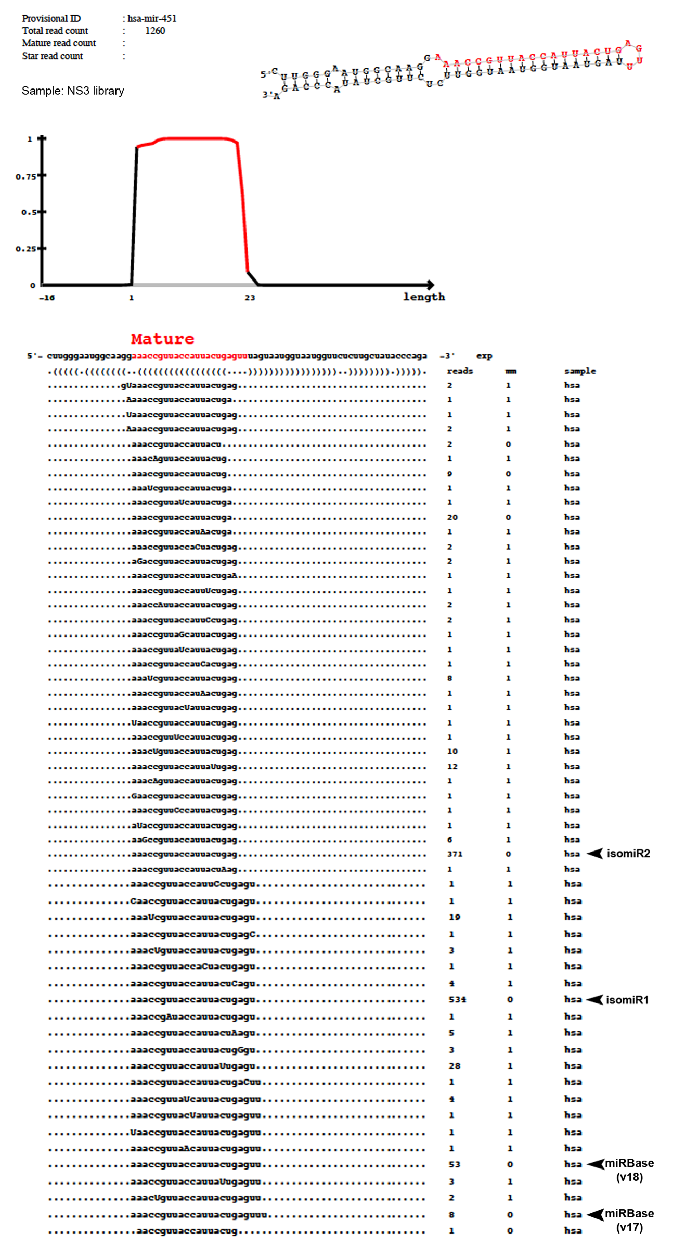
Supplemental Figure 1.
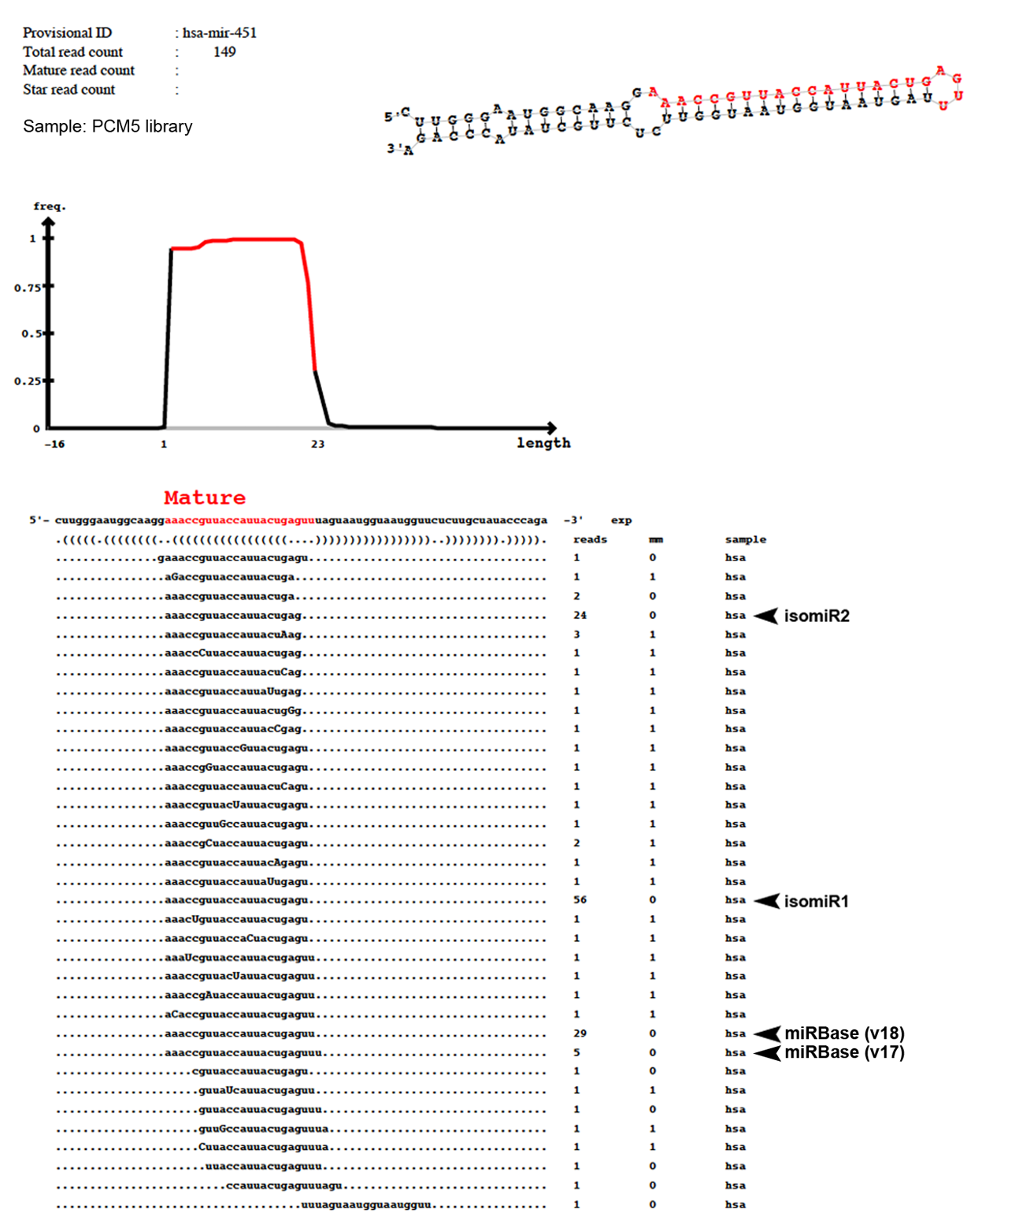
Supplemental Figure 2.

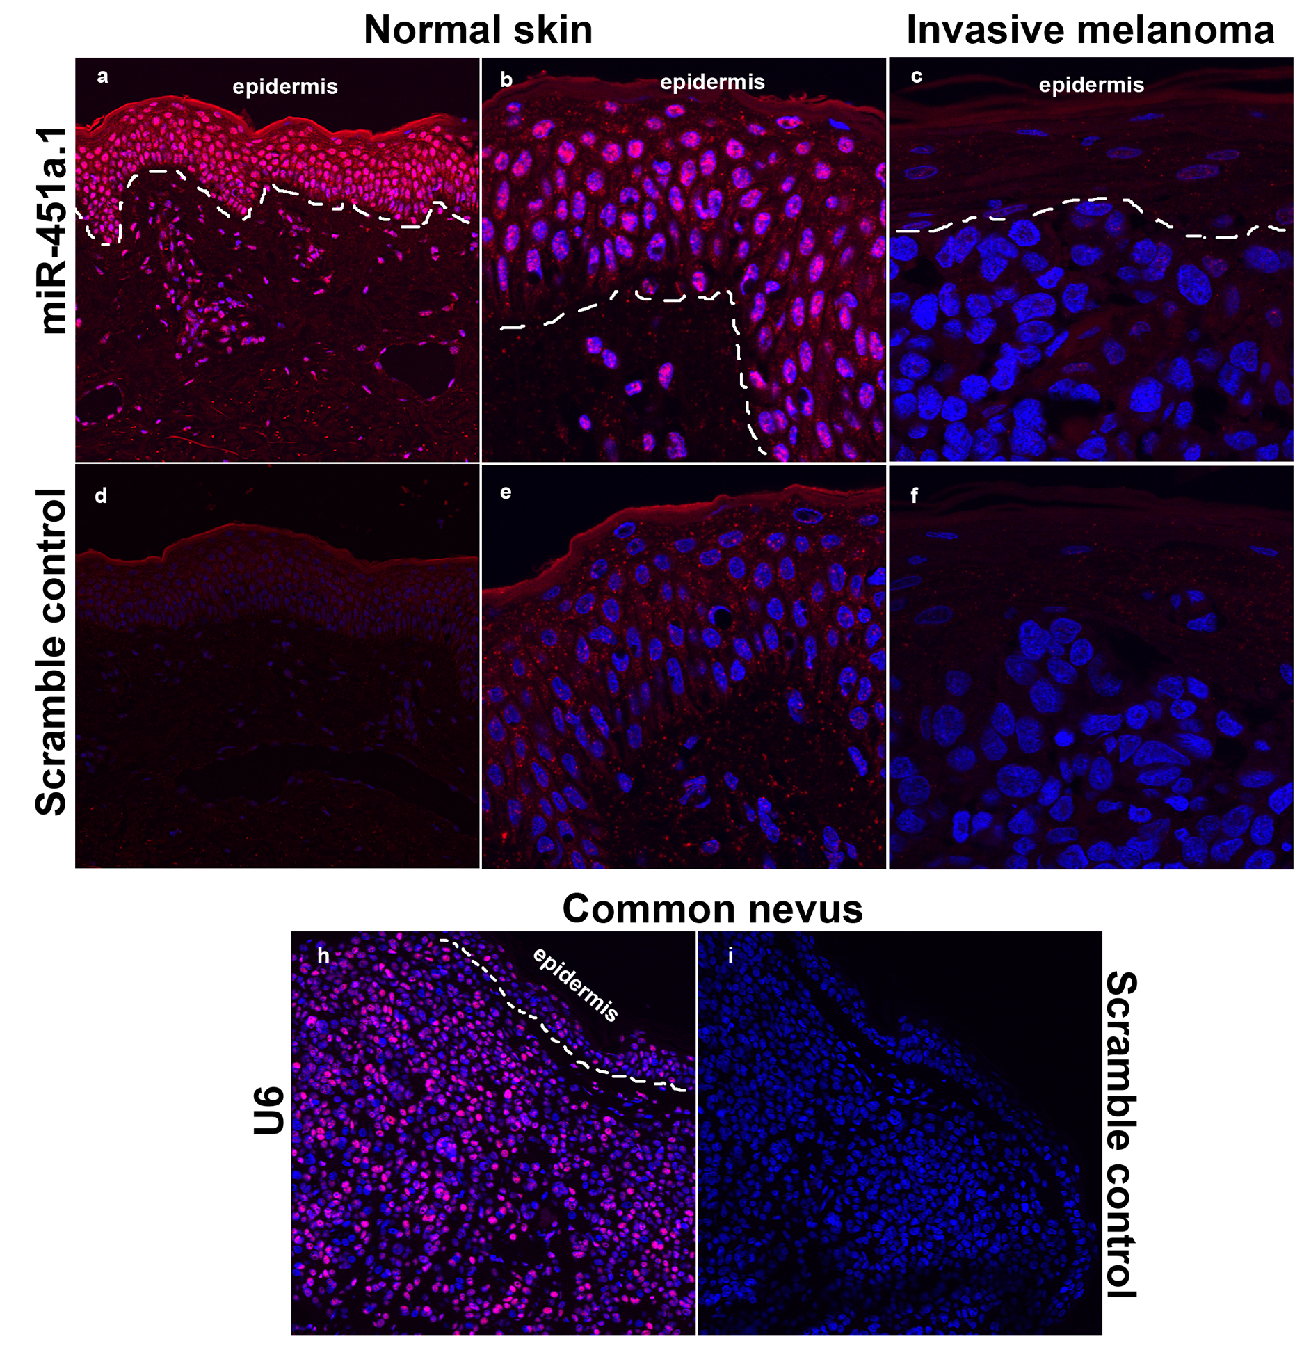
Supplemental Figure 3.

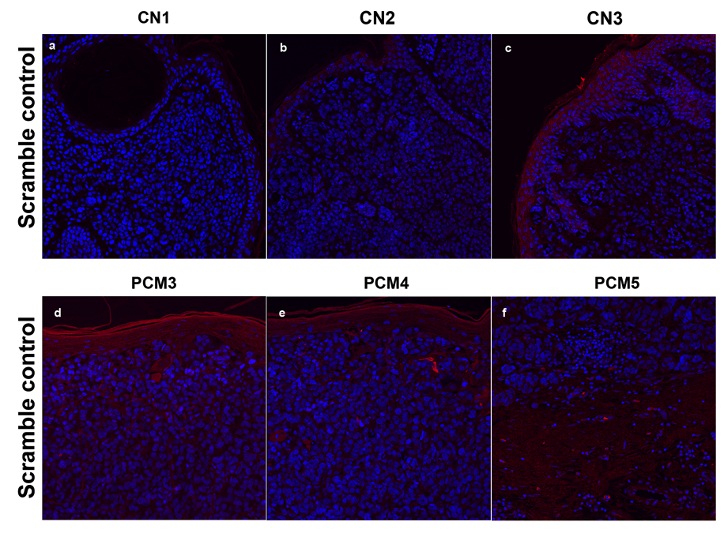
Supplemental Figure 4.

