Figure 3s.
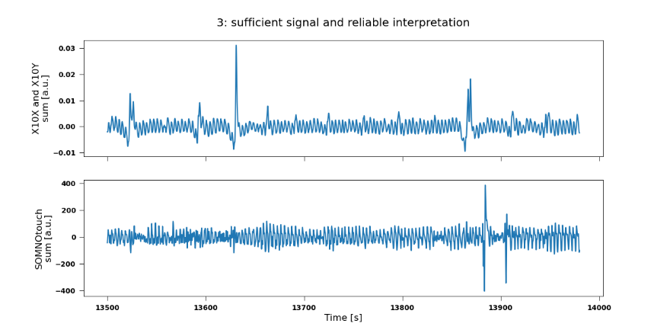
Example of grade 3 = sufficient signal and reliable interpretation

