A Warburg effect targeting vector designed to increase the uptake of compounds by cancer cells demonstrates glucose and hypoxia dependent uptake

Alexandra Glenister,§ Michela I. Simone,† and Trevor W. Hambley§
§ School of Chemistry, University of Sydney, New South Wales, 2006, Australia
† Discipline of Chemistry, Priority Research Centre for Chemical Biology & Clinical Pharmacology, University of Newcastle, Callaghan, New South Wales, 2308, Australia.

Supporting Information

Raw data for Fig 4
Values used to build graph: Relative fluorescence intensity (± standard deviation)
 | Glucose Concentration in Media
Compound |  | 0 mg L⁻¹ | 1000 mg L⁻¹ | 4000 mg L⁻¹ | 8000 mg L⁻¹
 | 2-NBDG | 100.0 ± 6.4 | 83.4 ± 7.3 | 73.7 ± 5.8 | 63.2 ± 4.2
 | 9 | 100.0 ± 9.3 | 81.4 ± 9.1 | 56.2 ± 7.3 | 29.5 ± 6.1
 | 10 | 100.0 ± 9.6 | 108.4 ±12.3 | 128.9 ± 11.8 | 121.4 ± 17.8

Values behind means and standard deviation: Relative fluorescence intensity for cell regions (30 µm x 30 µm)
 | Glucose Concentration in Media
Compound |  | 0 mg L⁻¹ | 1000 mg L⁻¹ | 4000 mg L⁻¹ | 8000 mg L⁻¹
 | 2-NBDG | 97.9  111.7  98.5  102.3  96.2  102.6  110.0  90.2  100.4  96.8 | 71.4  86.6  82.1  90.9  87.4  73.9  91.6  83.4  76.8  90.2 | 67.5  71.7  69.7  66.3  84.9  75.5  80.6  77.1  72.0  72.1 | 53.8  62.3  67.2  64.0  68.2  59.9  67.6  62.9  62.6  63.8
 | 9 | 92.6  87.0  107.6  95.9  88.1  99.1  105.9  102.5  110.8  113.2 | 95.6  88.3  86.3  63.98  84.0  84.4  71.7  83.0  82.2  74.2 | 46.7  46.2  55.1  62.4  57.8  63.3  51.9  55.5  69.4  53.5 | 19.8  34.1  36.4  33.9  32.8  29.4  24.6  35.5  20.9  27.1
 | 10 | 114.2  115.6  101.8  101.1  99.7  102.2  97.1  88.4  88.1  90.1 | 123.7  136.1  101.0  99.9  102.7  108.3  110.5  104.1  97.9  99.9 | 144.2  135.5  146.9  115.9  126.8  139.2  117.3  125.7  121.2  116.2 | 109.1  116.2  97.9  143.7  138.6  132.7  100.2  132.8
Raw data values of fluorescence intensities for cell regions (30 µm x 30 µm). Fluorescence intensities were determined by quantification with LAS AF Lite.
 | Glucose Concentration in Media
Compound |  | 0 mg L⁻¹ | 1000 mg L⁻¹ | 4000 mg L⁻¹ | 8000 mg L⁻¹
 | 2-NBDG | 2429  2771  2444  2538  2387  2545  2729  2238  2491  2402 | 1772  2149  2037  2255  2169  1834  2273  2069  1906  2238 | 1675  1779  1729  1645  2106  1873  2000  1913  1786  1789 | 1335  1546  1667  1588  1692  1486  1677  1561  1553  1583
 | 9 | 402  378  465  410  383  430  459  445  481  491 | 401  371  362  269  353  354  301  348  345  311 | 196  194  231  262  243  266  218  233  291  225 | 83  143  153  142  138  123  103  149  88  114
 | 10 | 459  464  409  406  401  411  390  355  354  362 | 497  547  406  401  413  435  444  418  393  401 | 579  544  590  466  509  559  471  505  487  467 | 438  467  393  577  557  533  403  534

Data for S1 Fig
Values used to build graph: Relative rate of HK phosphorylation (Vi (substrate)/Vi) at increasing concentrations of compound (substrate)
 | Compound
Concentration of Compound (µM) | Glucosamine hydrochloride | 2-[2-(2-aminoethoxy)ethoxy]ethanol | 8
36 | 1.00 |  | 0.98
71 |  | 1.00 | 0.97
143 | 0.89 | 0.96 | 0.96
214
286 | 0.78 |  | 0.90
357 | 0.79 | 0.97
714 | 0.61 | 0.99 | 0.88

High Resolution Mass Spectra
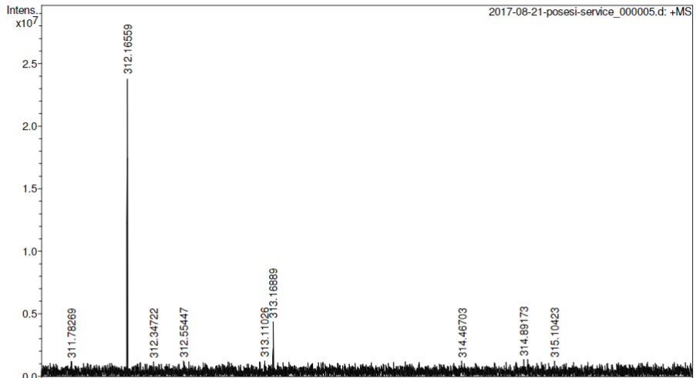
2-(2-[2-(2-aminoethoxy)ethoxy]ethoxy)-D-glucose (8)

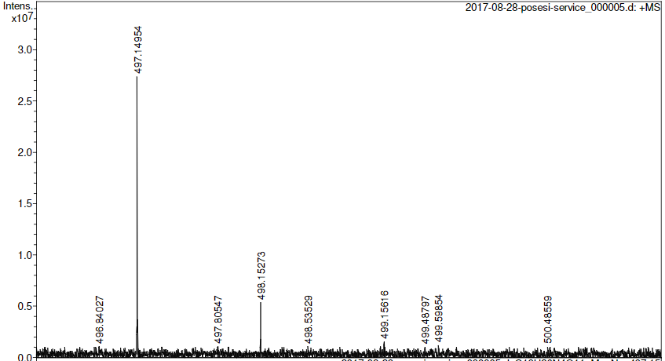
2-(2-[2-(2-(N-(7-Nitrobenz-2-oxa-1,3-diazol-4-yl))aminoethoxy)ethoxy]ethoxy)-D-glucose (9)
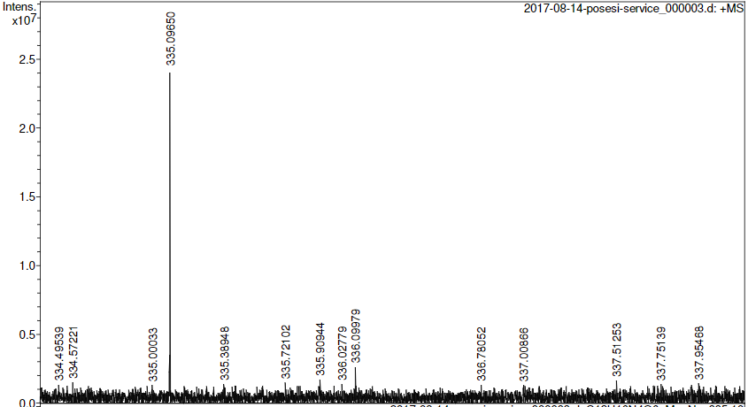
((N-(7-Nitrobenz-2-oxa-1,3-diazol-4-yl)aminoethoxy)ethoxy)ethanol (10)

¹H NMR Spectra
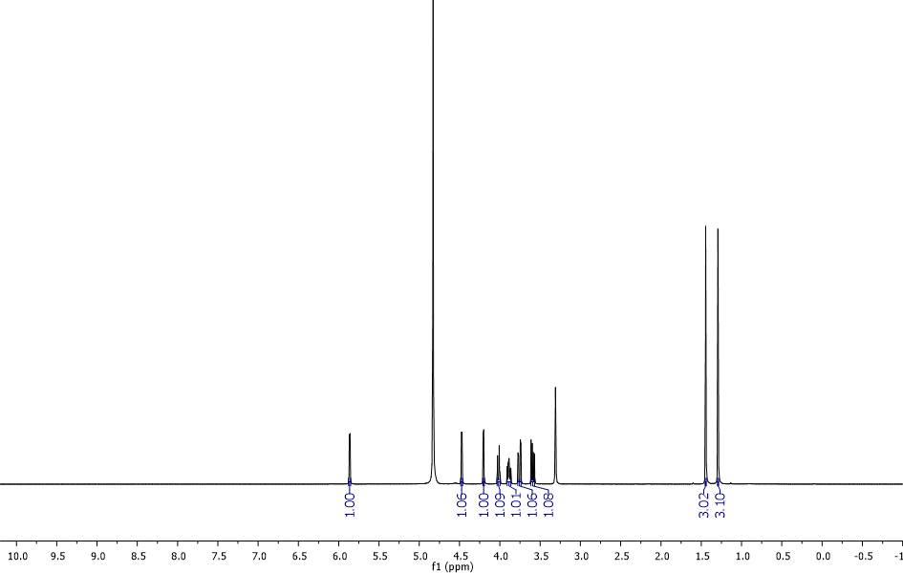
1,2-O-isopropylidene-α-D-glucofuranose (1)
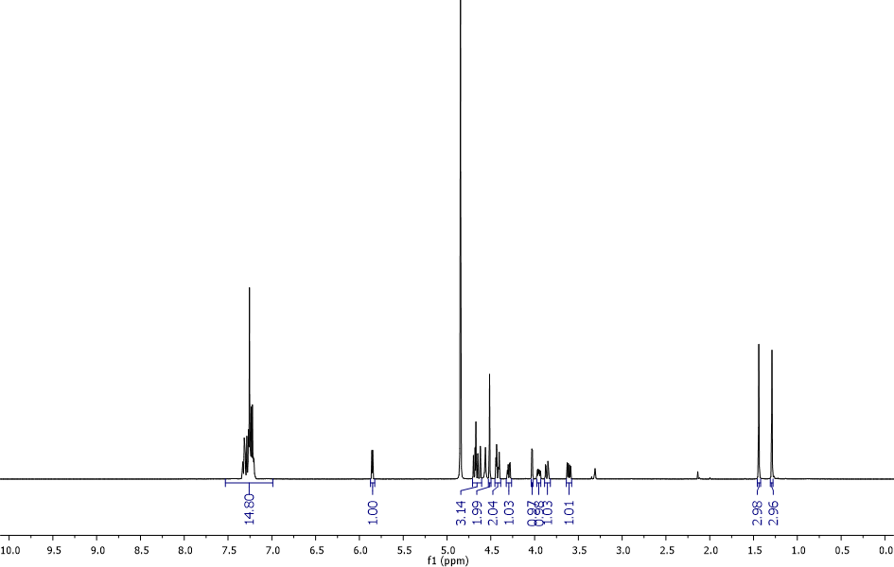
3,5,6-tri-O-benzyl-1,2-O-isopropylidene-α-D-glucofuranose (2)
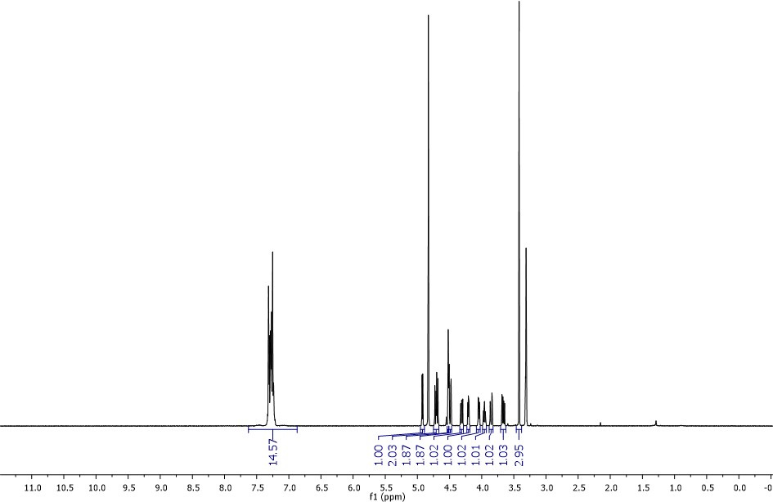
Methyl 3,5,6-tri-O-benzyl-α-D-glucofuranoside (3a)
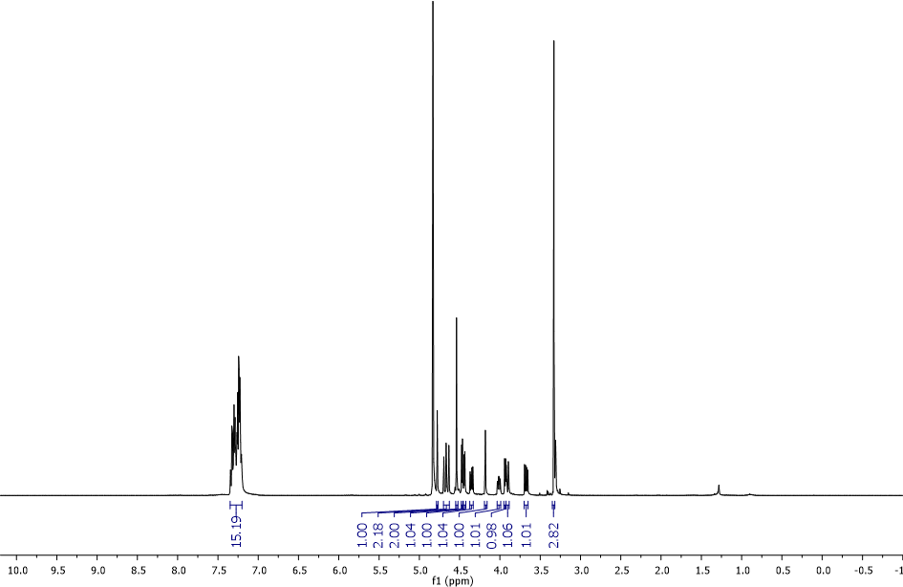
Methyl 3,5,6-tri-O-benzyl-β-D-glucofuranoside (3b)
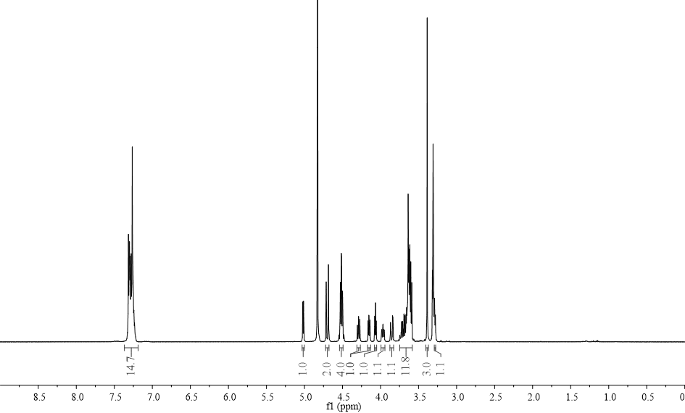
Methyl 2-(2-[2-(2-azidoethoxy)ethoxy]ethoxy)-3,5,6-tri-O-benzyl-α-D-glucofuranoside (4a)

Methyl 2-(2-[2-(2-azidoethoxy)ethoxy]ethoxy)-3,5,6-tri-O-benzyl-β-D-glucofuranoside (4b)
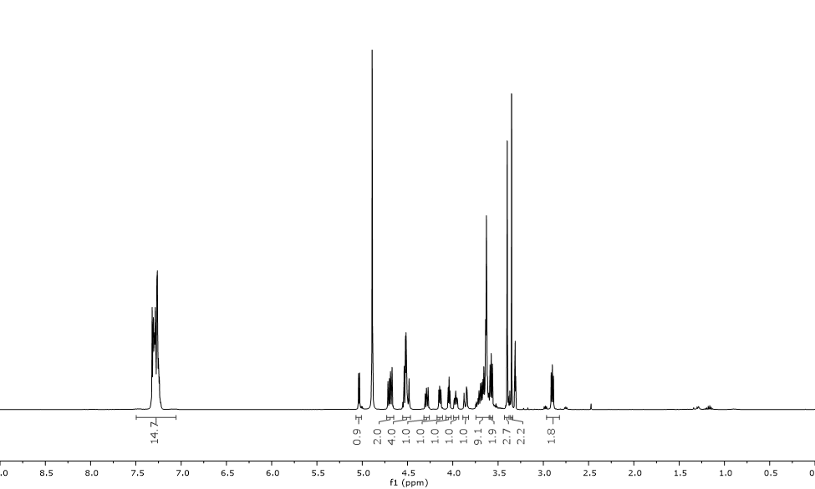
Methyl 2-(2-[2-(2-aminoethoxy)ethoxy]ethoxy)-3,5,6-tri-O-benzyl-α-D-glucofuranoside (5a)

Methyl 2-(2-[2-(2-aminoethoxy)ethoxy]ethoxy)-3,5,6-tri-O-benzyl-β-D-glucofuranoside (5b)
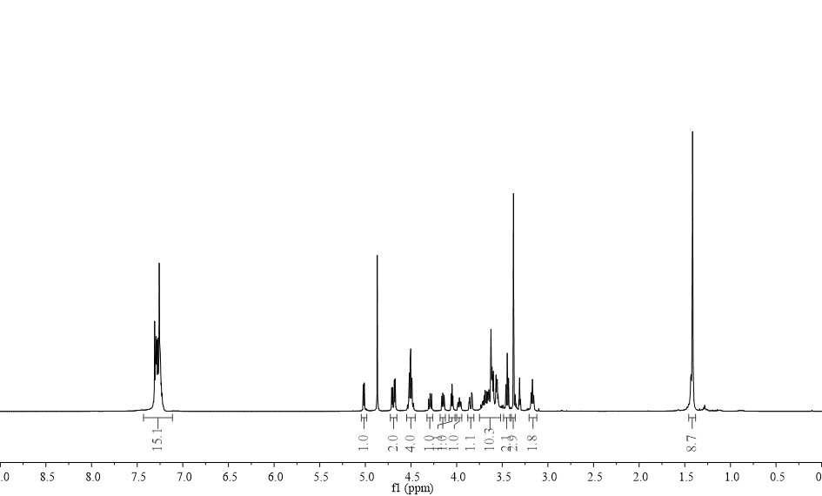
Methyl 2-(2-[2-(2-(tert-butoxycarboxamido)ethoxy)ethoxy]ethoxy)-3,5,6-tri-O-benzyl-α-D-glucofuranoside (6a)
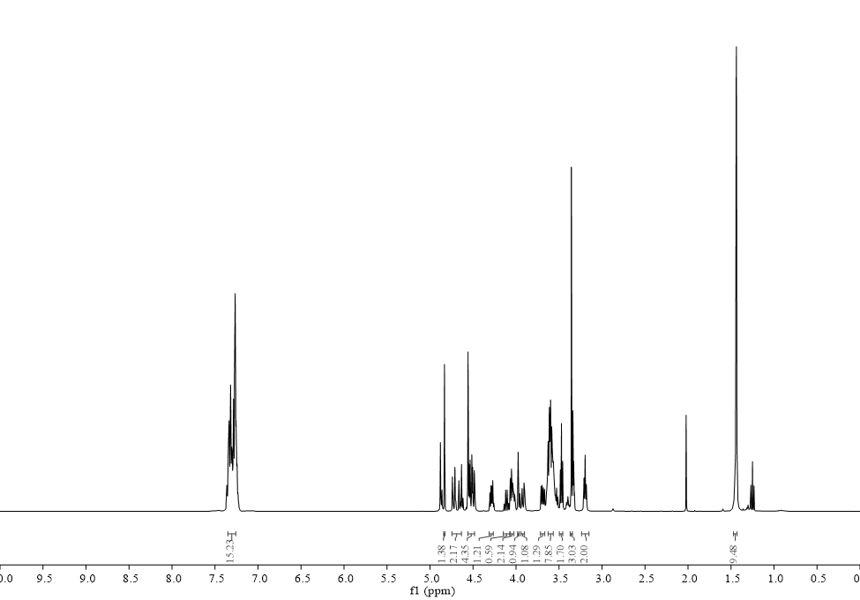
Methyl 2-(2-[2-(2-(tert-butoxycarboxamido)ethoxy)ethoxy]ethoxy)-3,5,6-tri-O-benzyl-β-D-glucofuranoside (6b)
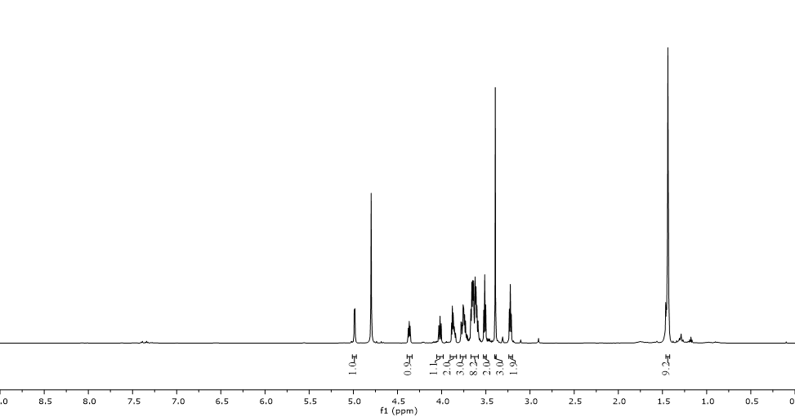
Methyl 2-(2-[2-(2-(tert-butoxycarboxamido)ethoxy)ethoxy]ethoxy)-α-D-glucofuranoside (7a)

Methyl 2-(2-[2-(2-(tert-butoxycarboxamido)ethoxy)ethoxy]ethoxy)-β-D-glucofuranoside (7b)

¹³C NMR Spectra
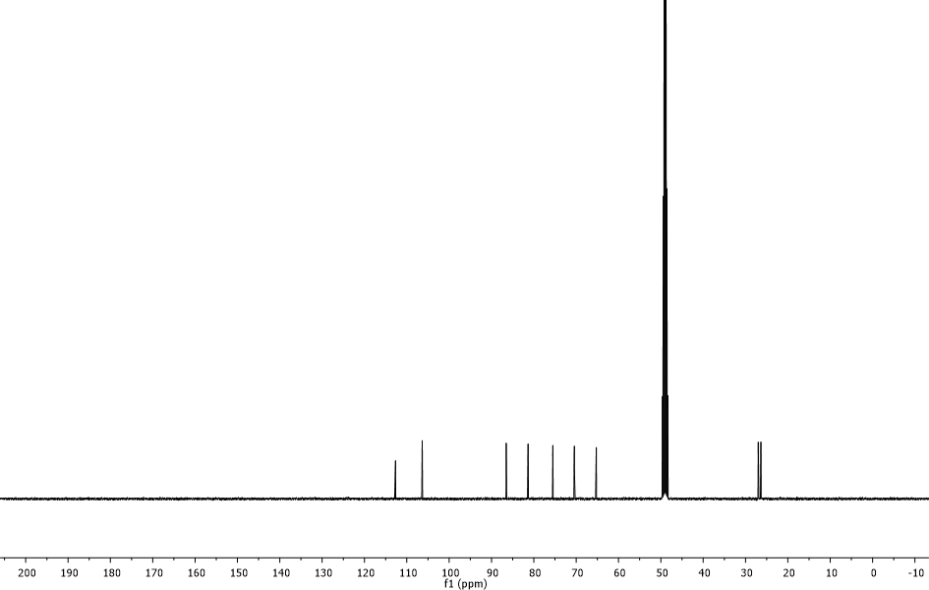
1,2-O-isopropylidene-α-D-glucofuranose (1)
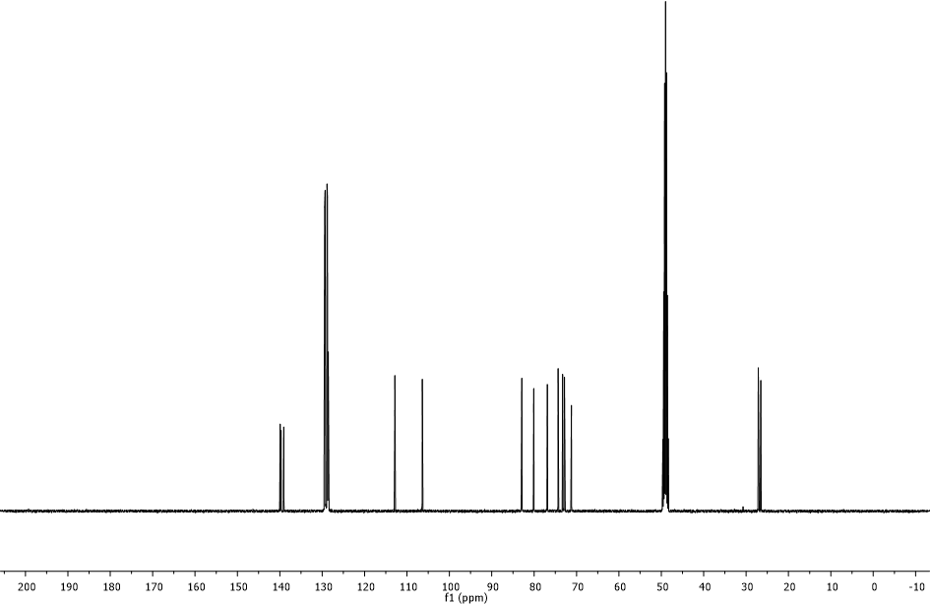
3,5,6-tri-O-benzyl-1,2-O-isopropylidene-α-D-glucofuranose (2)
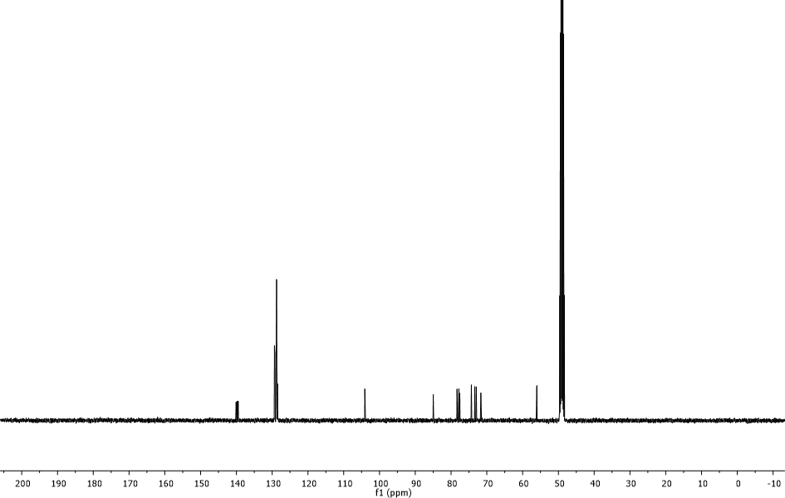
Methyl 3,5,6-tri-O-benzyl-α-D-glucofuranoside (3a)
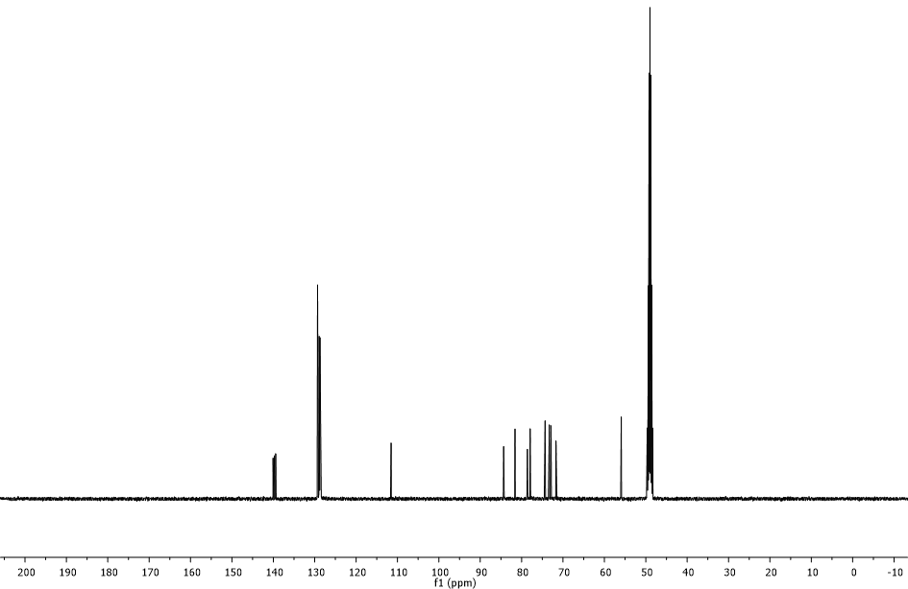
Methyl 3,5,6-tri-O-benzyl-β-D-glucofuranoside (3b)
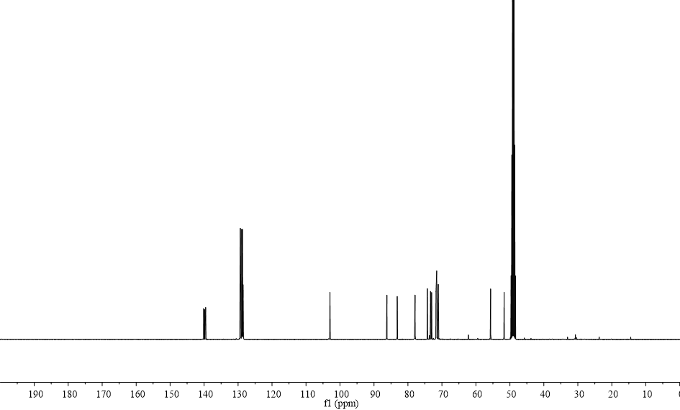
Methyl 2-(2-[2-(2-azidoethoxy)ethoxy]ethoxy)-3,5,6-tri-O-benzyl-α-D-glucofuranoside (4a)

Methyl 2-(2-[2-(2-azidoethoxy)ethoxy]ethoxy)-3,5,6-tri-O-benzyl-β-D-glucofuranoside (4b)
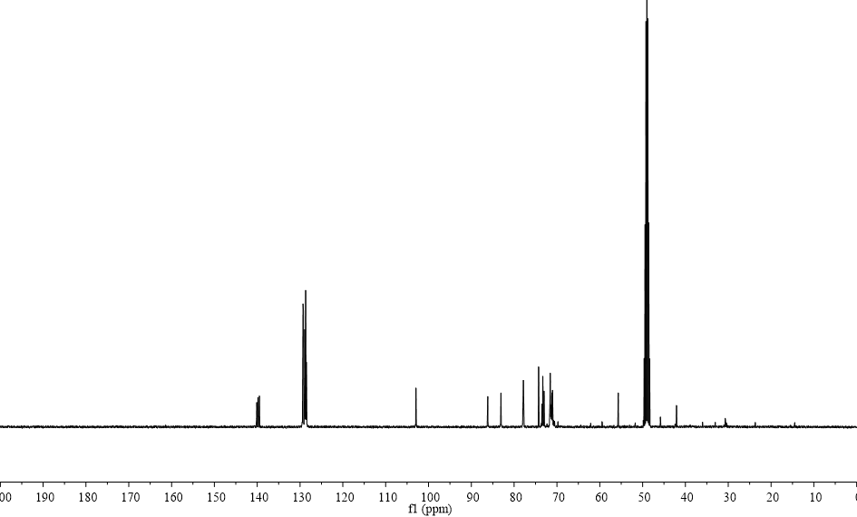
Methyl 2-(2-[2-(2-aminoethoxy)ethoxy]ethoxy)-3,5,6-tri-O-benzyl-α-D-glucofuranoside (5a)
Methyl 2-(2-[2-(2-aminoethoxy)ethoxy]ethoxy)-3,5,6-tri-O-benzyl-β-D-glucofuranoside (5b)
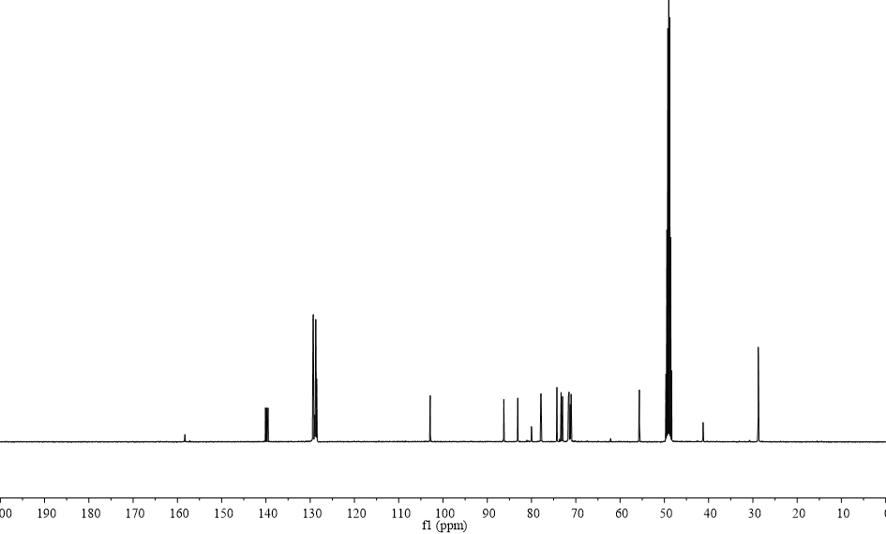
Methyl 2-(2-[2-(2-(tert-butoxycarboxamido)ethoxy)ethoxy]ethoxy)-3,5,6-tri-O-benzyl-α-D-glucofuranoside (6a)
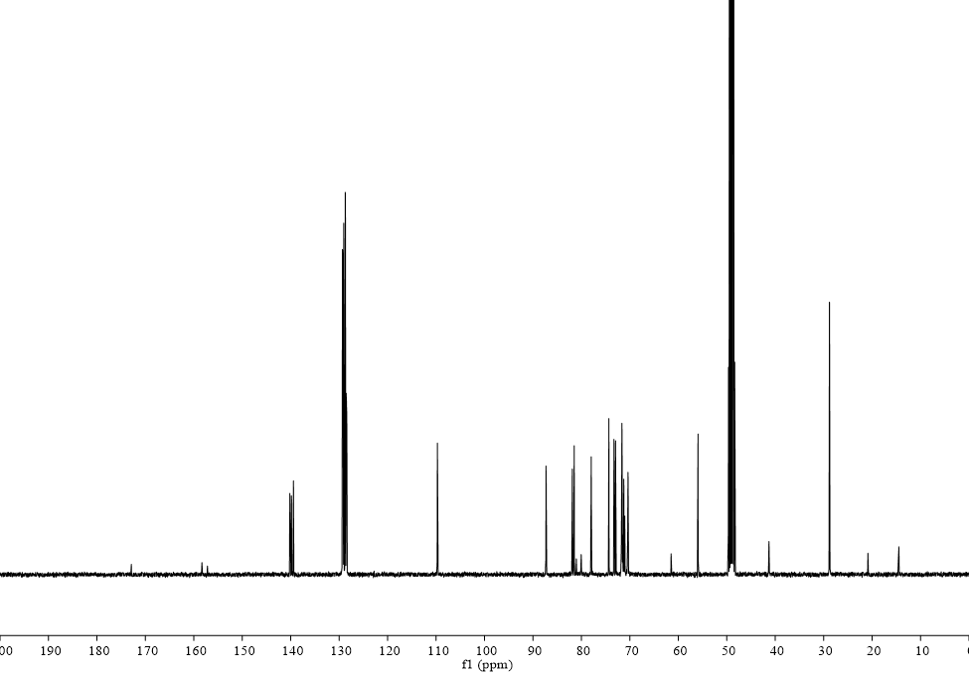
Methyl 2-(2-[2-(2-(tert-butoxycarboxamido)ethoxy)ethoxy]ethoxy)-3,5,6-tri-O-benzyl-β-D-glucofuranoside (6b)
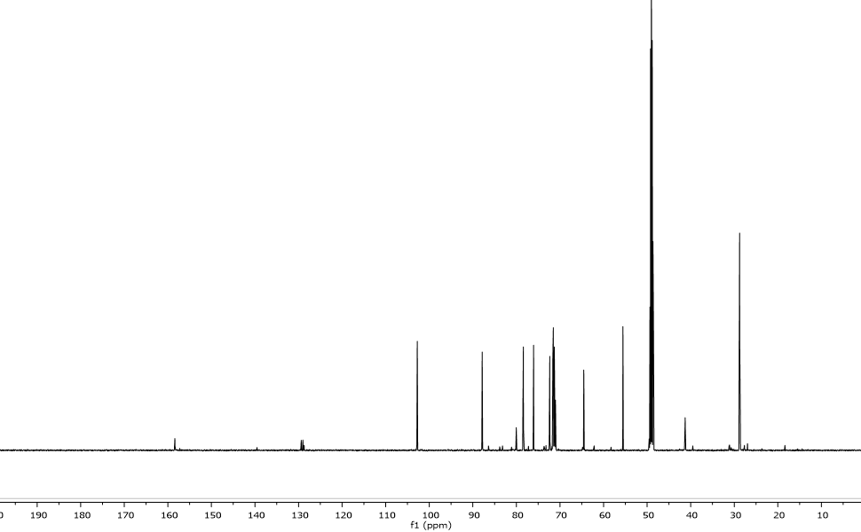
Methyl 2-(2-[2-(2-(tert-butoxycarboxamido)ethoxy)ethoxy]ethoxy)-α-D-glucofuranoside (7a)
Methyl 2-(2-[2-(2-(tert-butoxycarboxamido)ethoxy)ethoxy]ethoxy)-β-D-glucofuranoside (7b)

