The ARRIVE Guidelines Checklist
Animal Research: Reporting In Vivo Experiments
Carol Kilkenny¹, William J Browne², Innes C Cuthill³, Michael Emerson⁴ and Douglas G Altman⁵
¹The National Centre for the Replacement, Refinement and Reduction of Animals in Research, London, UK, ²School of Veterinary Science, University of Bristol, Bristol, UK, ³School of Biological Sciences, University of Bristol, Bristol, UK, ⁴National Heart and Lung Institute, Imperial College London, UK, ⁵Centre for Statistics in Medicine, University of Oxford, Oxford, UK.

 |  | ITEM | RECOMMENDATION | Section/  Paragraph
 |  |  |  | Section 1
 |  |  |  | Section 2
 | INTRODUCTION
 | 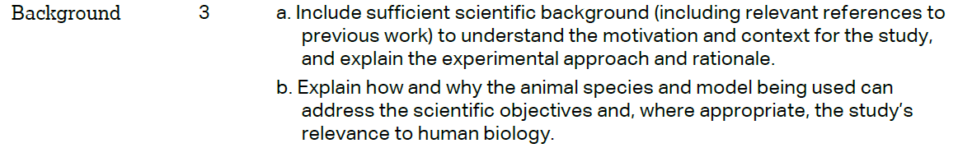 |  |  | Section 3 Pargraph 1,2
 |  |  |  | Section 3 Paragraph 3
 | METHODS
 |  |  |  | Section 4 Paragraph 15
 | 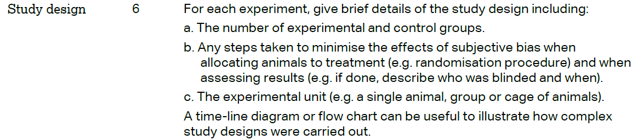 |  |  | Section 4 Paragraph 17
 | 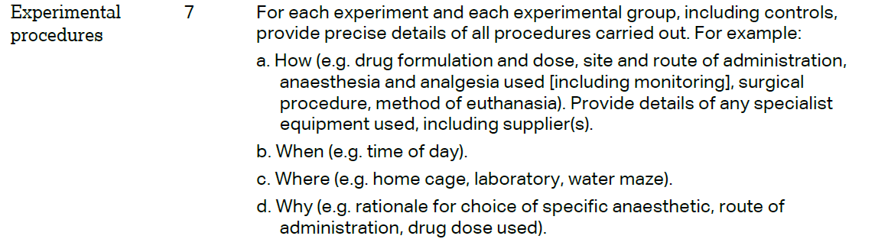 |  |  | Section 4 Paragraph 17
 | 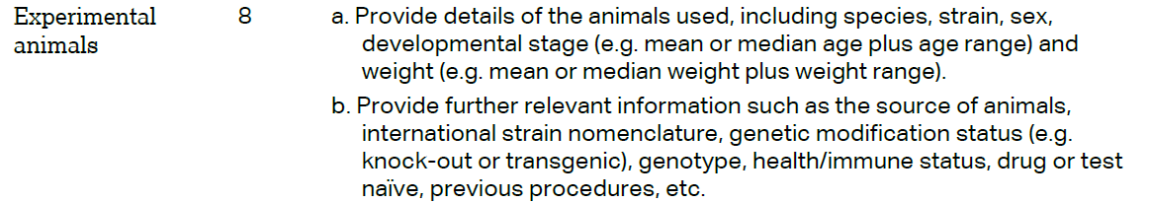 |  |  | Section 4 Paragraph 15
The ARRIVE guidelines. Originally published in PLoS Biology, June 2010¹
 | 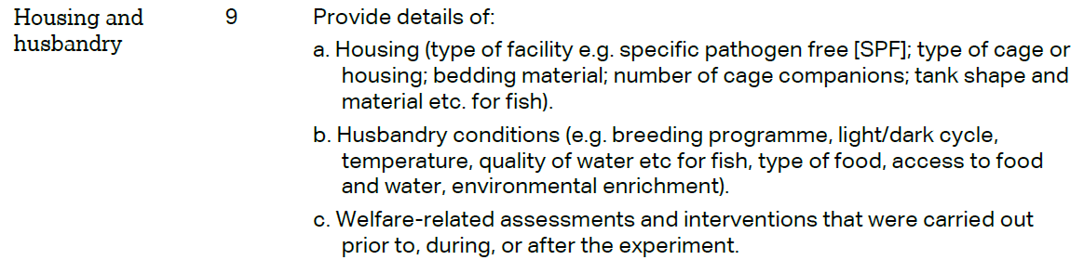 | Section 4 Paragraph 15
 | 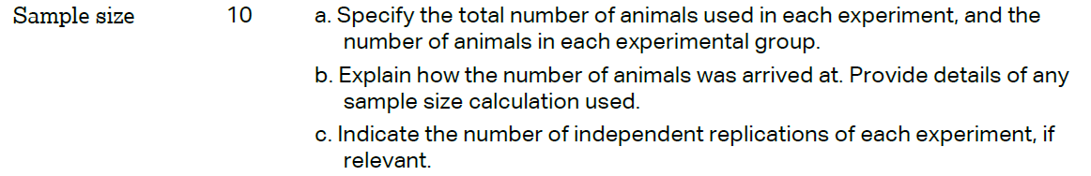 | Section 4 Paragraph 17
 | 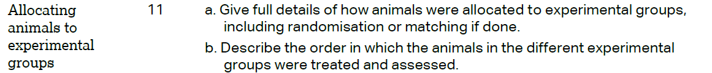 | Section 4 Paragraph 17
 |  | Section 4 Paragraph 18-25
 | 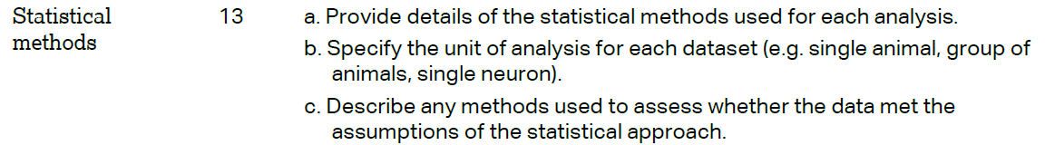 | Section 4 Paragraph 26
 | RESULTS
 |  | Section 5 Paragraph 6
 |  | Section 5 Paragraph 7-11
 |  | Section 5 Paragraph 7-11
 |  | Section 5 Paragraph 7-11
 | DISCUSSION
 | 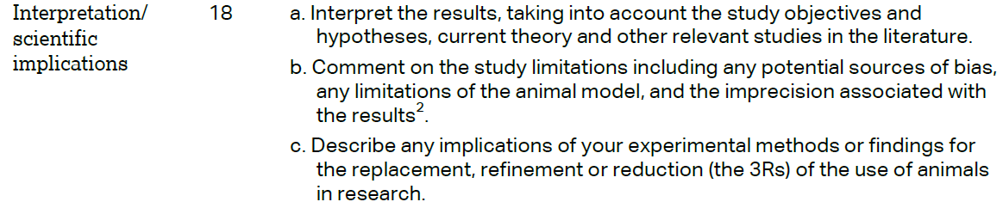 | Section 5
 |  | Section 6
 |  | Section 11
