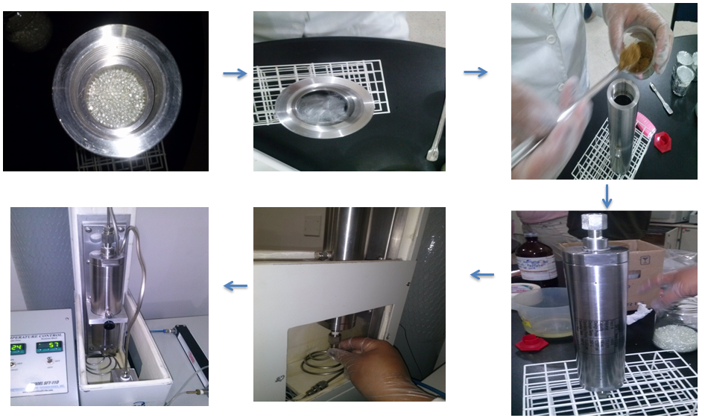
S2 Fig. Mounting the extraction cell (100 ml capacity): The ethanol was homogenised with the sample and placed in the extraction cell, together with wool and glass pearls to fill the cell.

