S2 File: Supplementary results
Results from a second review of incorrectly coded sepsis cases – Identification of reasons for incorrect coding
A) Implicit coding strategy
False-positive cases identified by implicit sepsis coding (infection and organ dysfunction) resulted from concurrence of infection and organ dysfunction without causality (51%) or that infection or organ dysfunctions were not identifiable retrospectively from manual patient chart review (40%). 9% were SIRS-negative and were not classified as severe sepsis according to our clinical criteria. In false-negative patients, organ dysfunction, infection or both were not coded in 67%, 14% and 17%, respectively. Encephalopathy, respiratory failure and hypotension were coded in 10.5%, 56.1% and 36.7% of cases, respectively.
B) Explicit coding strategy
In cases identified by the explicit coding strategy that were coded false positive (n=13), organ dysfunction was not caused by infection (n=3), infection or organ dysfunction were not identifiable by manual patient chart review (n=7) or patients were SIRS negative and thus not classified as sepsis (n=3).
Supplementary tables
Table A: Hospital cases ≥18y in Germany per year by ICD code abstraction strategies
Characteristic | ICD abstraction strategies for sepsis |  | ICD abstraction strategies for severe sepsis
 | R codes (R65.0!, R65.1!, R57.2) | explicit sepsis coding | R codes (R65.1!, R57.2) | explicit sepsis coding +odf | implicit sepsis coding (inf+odf)
2007 | 105.797 | 181.440 | 52.213 | 98.587 | 474.094
2008 | 113.810 | 184.849 | 60.811 | 106.216 | 520.856
2009 | 134.792 | 197.827 | 70.006 | 119.221 | 605.201
2010 | 156.435 | 214.533 | 86.223 | 136.444 | 688.562
2011 | 176.111 | 225.335 | 94.661 | 145.746 | 749.146
2012 | 194.736 | 242.535 | 103.327 | 159.136 | 818.361
2013 | 216.541 | 264.991 | 113.537 | 176.607 | 929.291

Table B: Hospital deaths ≥18y in Germany per year by ICD code abstraction strategies
Characteristic | ICD abstraction strategies for sepsis |  | ICD abstraction strategies for severe sepsis
 | R codes (R65.0!, R65.1!, R57.2) | explicit sepsis coding | R codes (R65.1!, R57.2) | explicit sepsis coding +odf | implicit sepsis coding (inf+odf)
2007 | 35.799 | 53.504 | 26.380 | 42.530 | 105.820
2008 | 37.937 | 54.202 | 30.454 | 45.022 | 114.544
2009 | 43.561 | 56.436 | 34.018 | 48.387 | 127.332
2010 | 50.294 | 60.441 | 41.766 | 53.790 | 139.040
2011 | 53.204 | 60.628 | 44.156 | 54.975 | 143.476
2012 | 56.153 | 62.898 | 46.373 | 57.451 | 151.617
2013 | 60.790 | 67.310 | 50.036 | 62.097 | 167.687

Table C: Hospital mortality rate of patients ≥18y in Germany per year by ICD code abstraction strategies
Characteristic | ICD abstraction strategies for sepsis |  | ICD abstraction strategies for severe sepsis
 | R codes (R65.0!, R65.1!, R57.2) | explicit sepsis coding | R codes (R65.1!, R57.2) | explicit sepsis coding +odf | implicit sepsis coding (inf+odf)
2007 | 34% | 29% | 51% | 43% | 22%
2008 | 33% | 29% | 50% | 42% | 22%
2009 | 32% | 29% | 49% | 41% | 21%
2010 | 32% | 28% | 48% | 39% | 20%
2011 | 30% | 27% | 47% | 38% | 19%
2012 | 29% | 26% | 45% | 36% | 19%
2013 | 28% | 25% | 44% | 35% | 18%

Table D: Hospital incidence ≥18y in Germany per 100 000 persons ≥18y per year by ICD code abstraction strategies
Characteristic | ICD abstraction strategies for sepsis |  | ICD abstraction strategies for severe sepsis
 | R codes (R65.0!, R65.1!, R57.2) | explicit sepsis coding | R codes (R65.1!, R57.2) | explicit sepsis coding +odf | implicit sepsis coding (inf+odf)
2007 | 155 | 266 | 77 | 144 | 695
2008 | 167 | 271 | 89 | 155 | 762
2009 | 197 | 290 | 102 | 175 | 886
2010 | 229 | 314 | 126 | 199 | 1007
2011 | 262 | 335 | 141 | 217 | 1115
2012 | 289 | 360 | 153 | 236 | 1214
2013 | 320 | 391 | 168 | 261 | 1372

Table E: Hospital deaths ≥18y in Germany per 100 000 persons ≥18y per year of discharge by different ICD code abstraction strategies
Characteristic | ICD abstraction strategies for sepsis |  | ICD abstraction strategies for severe sepsis
 | R codes (R65.0!, R65.1!, R57.2) | explicit sepsis coding | R codes (R65.1!, R57.2) | explicit sepsis coding +odf | implicit sepsis coding (inf+odf)
2007 | 52 | 78 | 39 | 62 | 155
2008 | 56 | 79 | 45 | 66 | 168
2009 | 64 | 83 | 50 | 71 | 186
2010 | 74 | 88 | 61 | 79 | 203
2011 | 79 | 90 | 66 | 82 | 214
2012 | 83 | 93 | 69 | 85 | 225
2013 | 90 | 99 | 74 | 92 | 248

Table F: Hospital incidence ≥18y in Germany per 100 000 persons ≥18y per year by ICD code abstraction strategies, adjusted to the German population ≥18y in 2010
Characteristic | ICD abstraction strategies for sepsis |  | ICD abstraction strategies for severe sepsis
 | R codes (R65.0!, R65.1!, R57.2) | explicit sepsis coding | R codes (R65.1!, R57.2) | explicit sepsis coding +odf | implicit sepsis coding (inf+odf)
2007 | 162 | 279 | 80 | 151 | 733
2008 | 172 | 280 | 92 | 161 | 792
2009 | 200 | 294 | 104 | 177 | 902
2010 | 229 | 314 | 126 | 199 | 1007
2011 | 259 | 331 | 139 | 214 | 1099
2012 | 282 | 351 | 149 | 230 | 1181
2013 | 309 | 379 | 162 | 252 | 1322

Table G: Hospital deaths ≥18y in Germany per 100 000 persons ≥18y per year of discharge by different ICD code abstraction strategies, adjusted to the German population ≥18y in 2010
Characteristic | ICD abstraction strategies for sepsis |  | ICD abstraction strategies for severe sepsis
 | R codes (R65.0!, R65.1!, R57.2) | explicit sepsis coding | R codes (R65.1!, R57.2) | explicit sepsis coding +odf | implicit sepsis coding (inf+odf)
2007 | 56 | 83 | 41 | 66 | 166
2008 | 58 | 83 | 46 | 69 | 176
2009 | 65 | 84 | 51 | 72 | 191
2010 | 74 | 88 | 61 | 79 | 203
2011 | 78 | 89 | 65 | 81 | 210
2012 | 81 | 91 | 67 | 83 | 218
2013 | 86 | 95 | 71 | 88 | 237

Table H: Comparison of clinical sepsis diagnosis according to ACCP/SCCM consensus criteria [1, 2] vs. “sepsis-3” [3] criteria by retrospective chart review
 |  | Sepsis 3 Definitions
 | Characteristic | Infection (w/o ODF) | Sepsis | Septic Shock
Consensus Definitions | Infection (w/o SIRS) | 132 | 3 | 0
 | Sepsis | 6 | 64 | 0
 | Severe Sepsis | 0 | 17 | 0
 | Septic Shock | 0 | 5 | 59

Supplementary figures
Figure A

Hospital deaths ≥18y in Germany per 100 000 persons ≥18y per year of discharge by different ICD code abstraction strategies, adjusted to the German population ≥18y in 2010
Figure B
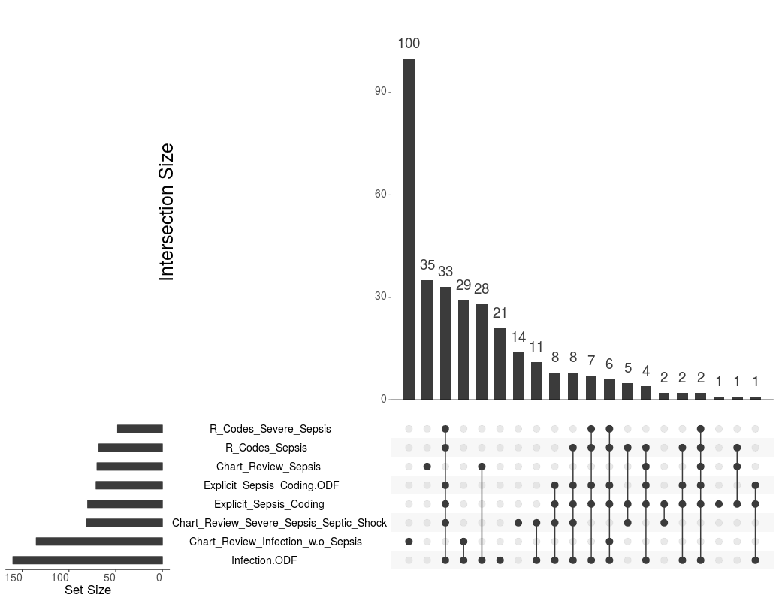
Intersecting sets of all reviewed cases with at least a single positive result from ICD code abstraction strategies or at least a diagnosis of infection in chart review; horizontal bars represent the numbers of patients identified by a specific coding strategy or diagnosed by chart review to have infection with or without (severe) sepsis; vertical bars represent the number of patients diagnosed by only one or several coding strategies and/or chart review indicated by dots with connecting lines;
e.g. 29 patients had infection without sepsis on chart review but coding for infection&ODF but no R-codes or explicit sepsis codes (generated with UpSetR[4])

References
1. Bone RC, Balk RA, Cerra FB, Dellinger RP, Fein AM, Knaus WA, et al. Definitions for sepsis and organ failure and guidelines for the use of innovative therapies in sepsis. The ACCP/SCCM Consensus Conference Committee. American College of Chest Physicians/Society of Critical Care Medicine. Chest. 1992;101(6):1644-55. Epub 1992/06/01. PubMed PMID: 1303622.
2. Levy MM, Fink MP, Marshall JC, Abraham E, Angus D, Cook D, et al. 2001 SCCM/ESICM/ACCP/ATS/SIS International Sepsis Definitions Conference. Crit Care Med. 2003;31(4):1250-6. Epub 2003/04/12. doi: 10.1097/01.CCM.0000050454.01978.3B. PubMed PMID: 12682500.
3. Singer M, Deutschman CS, Seymour CW, Shankar-Hari M, Annane D, Bauer M, et al. The Third International Consensus Definitions for Sepsis and Septic Shock (Sepsis-3). JAMA : the journal of the American Medical Association. 2016;315(8):801-10. Epub 2016/02/24. doi: 10.1001/jama.2016.0287. PubMed PMID: 26903338.
4. Lex A, Gehlenborg N, Strobelt H, Vuillemot R, Pfister H. UpSet: Visualization of Intersecting Sets. IEEE transactions on visualization and computer graphics. 2014;20(12):1983-92. doi: 10.1109/TVCG.2014.2346248. PubMed PMID: 26356912; PubMed Central PMCID: PMC4720993.

