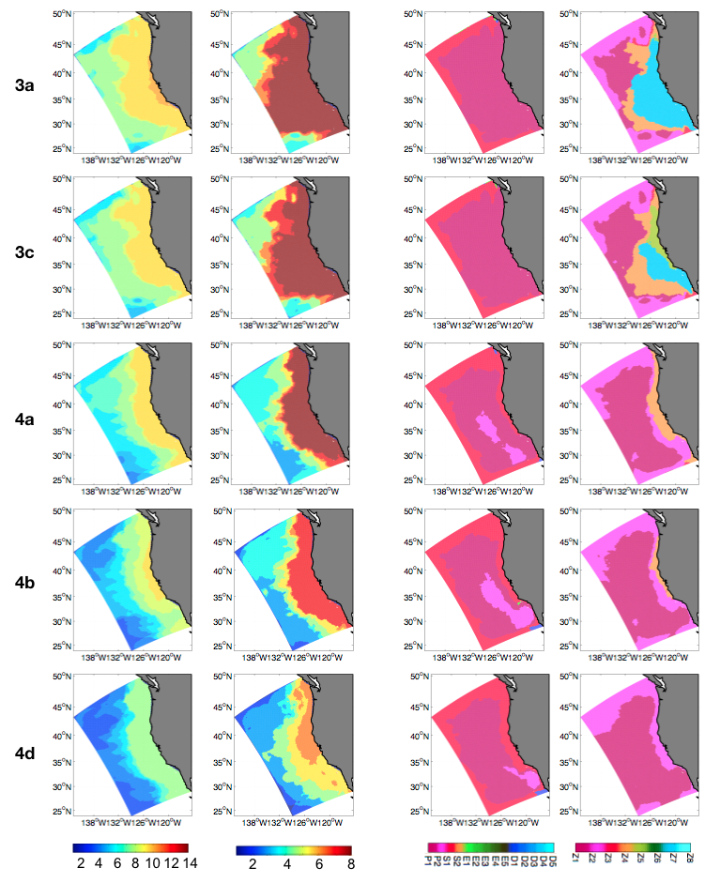S7 Fig. (columns 1 and 2) Richness and (column 3 and 4) niches of phytoplankton (columns 1 and 3) and zooplankton (columns 2 and 4) for grazing in cases 3 and 4.

