Aspalathin, a natural product with the potential to reverse hepatic insulin resistance by improving energy metabolism and mitochondrial respiration
Sithandiwe E. Mazibuko-Mbeje^{1,2} Phiwayinkosi V. Dludla^{1,3}, Rabia Johnson^{1,2}, Elizabeth Joubert^{4,5}, Johan Louw^{2,6}, Khanyisani Ziqubu^{2,6}, Luca Tiano³, Sonia Silvestri³, Patrick Orlando³, Andy R. Opoku⁶, Christo J.F. Muller^{1,2,6}

¹Biomedical Research and Innovation Platform, South African Medical Research Council, Tygerberg 7505, South Africa.
²Division of Medical Physiology, Faculty of Health Sciences, Stellenbosch University, Tygerberg 7505, South Africa.
³Department of Life and Environmental Sciences, Polytechnic University of Marche, Ancona 60121, Italy.
⁴Plant Bioactives Group, Post-Harvest and Agro-Processing Technologies, Agricultural Research Council, Infruitec-Nietvoorbij, Stellenbosch 7599, South Africa.
⁵Department of Food Science, Stellenbosch University, Stellenbosch 7599, South Africa.
⁶Department of Biochemistry and Microbiology, University of Zululand, KwaDlangezwa 3886, South Africa.

Corresponding author:
Sithandiwe E. Mazibuko-Mbeje, Biomedical Research and Innovation Platform, South African Medical Research Council, Tygerberg 7505, South Africa. Email: sithandiwe.mazibuko@mrc.ac.za. Tel.: +2721 938 0341.

Material and methods

Western blot analysis

For Western blot analysis, membranes were probed overnight at 4°C with the relevant primary antibodies glucose transporter (GLUT)2, protein kinase B (AKT, p-AKT (Ser 473), 5' AMP-activated protein kinase (AMPK, p-AMPK (Thr172), carnitine palmitoyltransferase 1 (CPT1) and phosphoinositide 3-kinase (PI3K, p-PI3K (p85)) , as well as horseradish peroxidase (HRP) conjugated secondary antibody (β-actin) applied for 1.5h the following day. Chemiluminenscence using a Chemidoc-XRS imager and Quantity One 1-D software (Biorad Laboratories, Hercules, CA, USA) were used detect and quantify proteins. β-actin was used as the reference control.Three independet experimnents were conducted and one blot was selected as a representative. The selected represenative image was croped and image was used to quantify molecular weight size. In some of the the pictures out of 8 lanes loaded only 6 were used as the other treatment [gree rooibos extract (GRE) and green rooibos extract + insulin (GRE+I)] is not discussed in the current article. Molecular weight and band analysis was quantified using image J software.

Protein kinase B (AKT) original Western blots

Three independent experiments were conducted for both phosphorylated (pAKT) and total AKT (tAKT), and in all figures, GRE and GRE+I were run on the same blot. However, GRE and GRE+I is not discussed in this paper. Similar tread was attained in all blots (Fig.2A-F). Experiment 2 (Fig.2C and D) was cropped and used as a representative as shown in (Fig. 2G).

A B
Marker kDa G GI P PI GRE GRE+I ASP ASP+I Marker kDa
Marker kDa G GI P PI GRE GRE+I ASP ASP+I Marker kDa
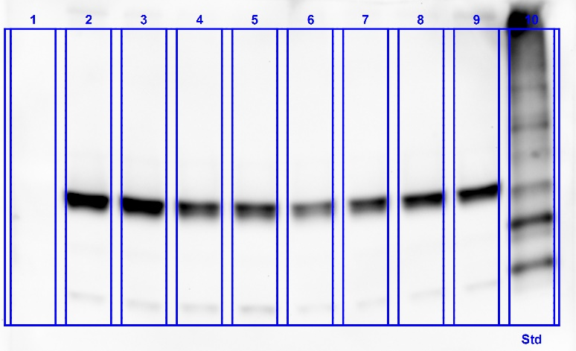
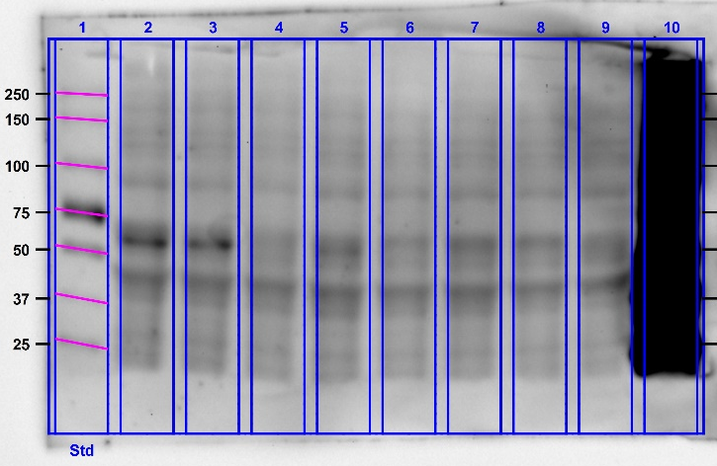
~60 tAKT
~60 pAKT

C D
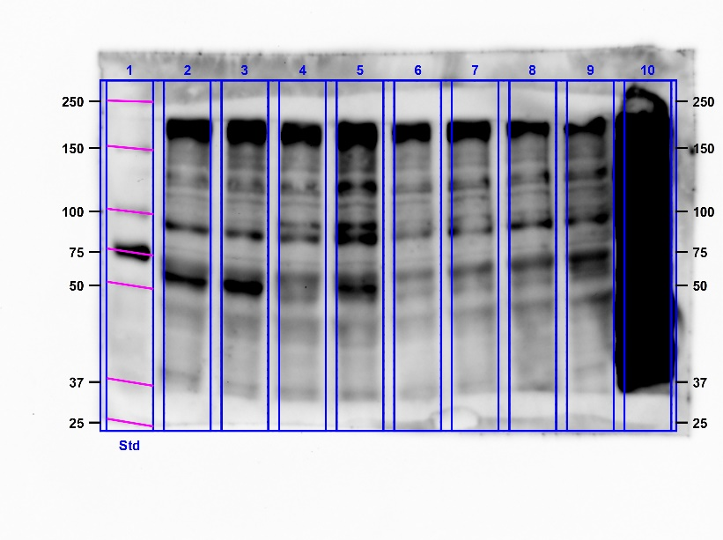
~60 pAKT
~60 tAKT
Marker kDa G GI P PI GRE GRE+I ASP ASP+I Marker kDa
Marker kDa G GI P PI GRE GRE+I ASP ASP+I Marker kDa

E F
Marker kDa G GI P PI GRE GRE+I ASP ASP+I Marker kDa
Marker kDa G GI P PI GRE GRE+I ASP ASP+I Marker kDa

~60 tAKT
~60 pAKT

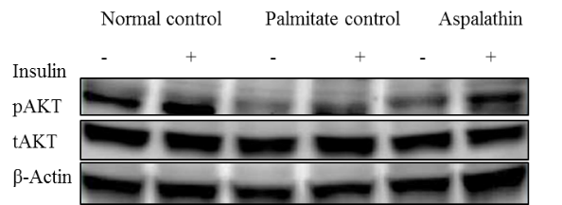
G
G GI P PI ASP ASP+I

S2 Data set.

