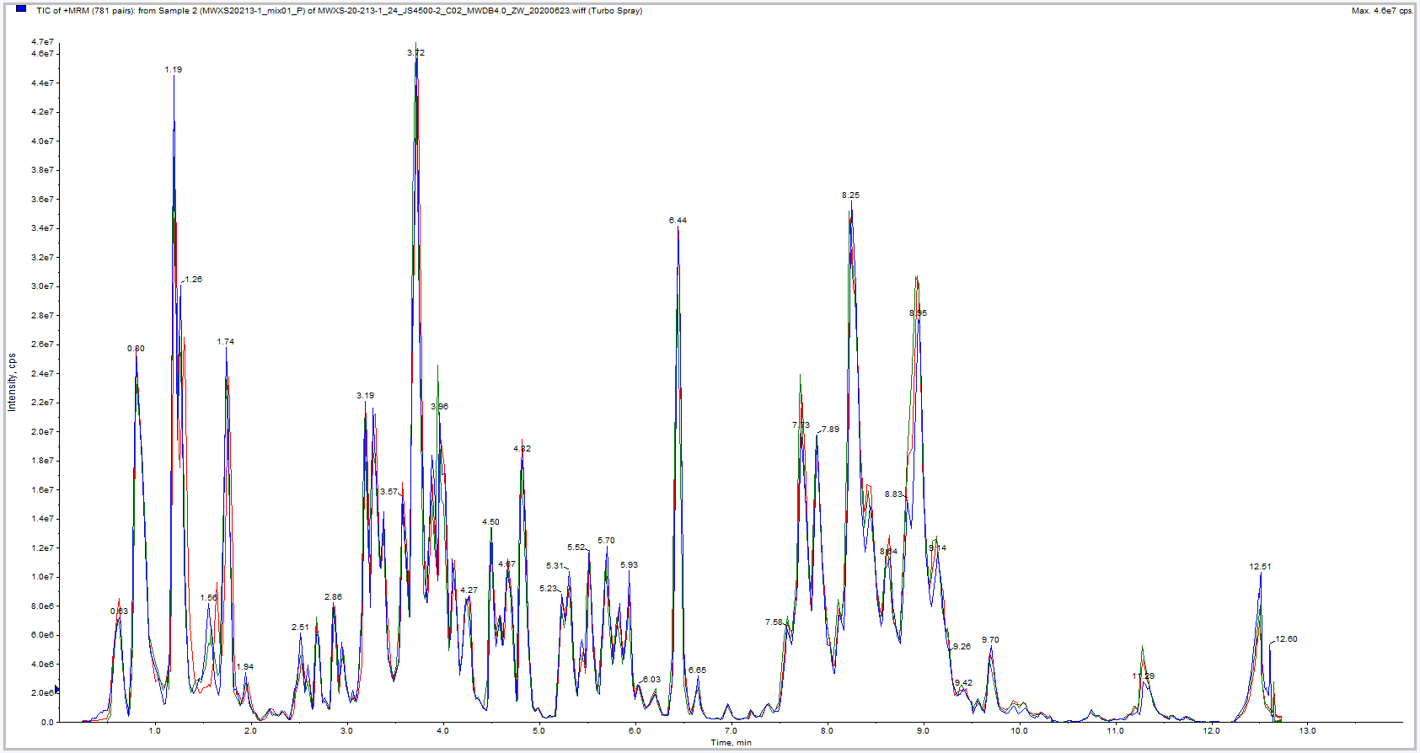
S1 Fig. Total ion chromatogram of quality control samples in positive ion mode

