S1 Fig. Regional agricultural land area in the initial 2010 situation and in 2050 in the various scenarios (Million hectares)
S1 Fig a. Cropland
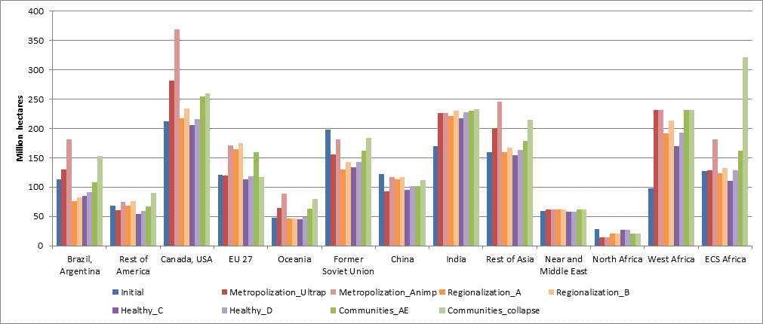

S1 Fig b. Pastureland
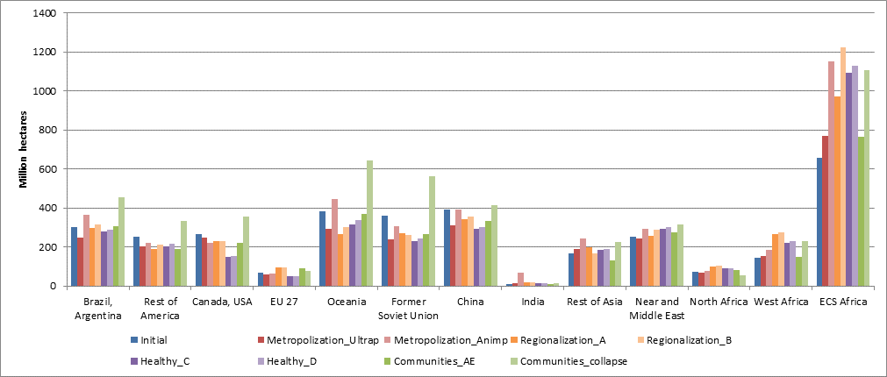
Source: GlobAgri-AgT simulation results

