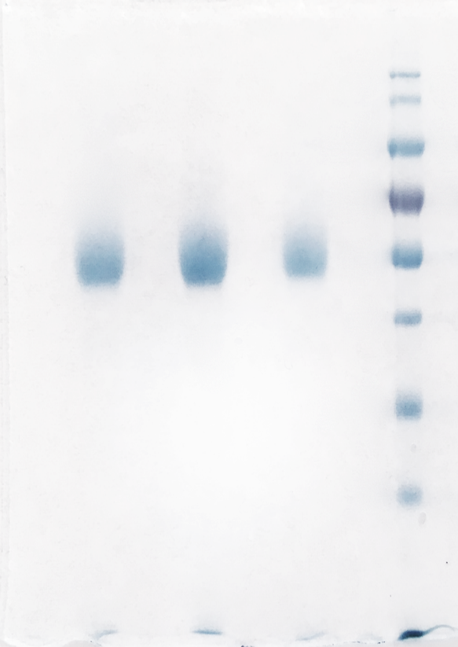
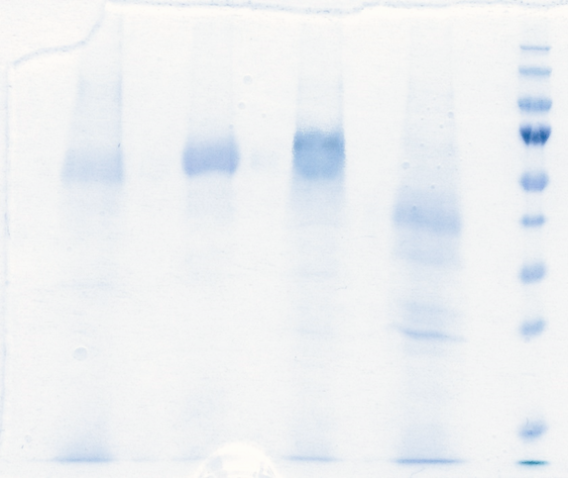
1 2 3 4 5 6 7

S1 Figure. SDS-PAGE analysis of the three LPMO regioselectivity representatives. Lane 1: Hypocrea jecorina LPMO9A native enzyme; lane 2: Phanerochaete chrysosporium LPMO9D native enzyme; lane 3: Neurospora crassa LPMO9C native enzyme; lane 4: PageRuler prestained protein ladder (Thermo Scientific); lane 5: histag purified HjLPMO9A; lane 6: histag purified HjLPMO9A variant Y24A; lane 7: HjLPMO9A variant Y211A.

