Figure 4s.
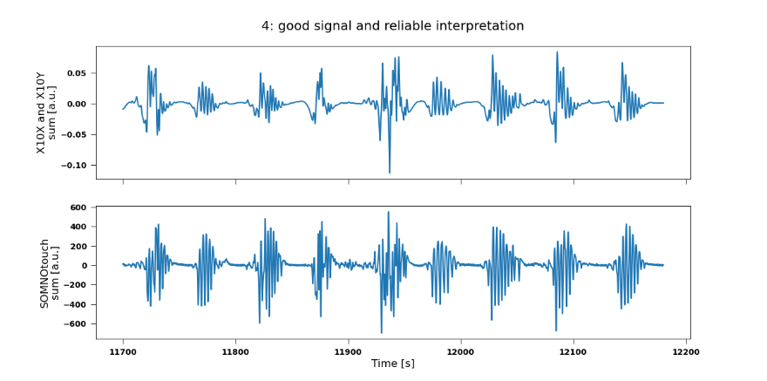
Example of grade 4 = good signal and reliable interpretation

