S1 Appendix

A Mathematical Model of the Olfactory Bulb for the Selective Adaptation Mechanism in the Rodent Olfactory System
Zu Soh^{1*}, Shinya Nishikawa²⁾, Yuichi Kurita¹⁾, Noboru Takiguchi³⁾, Toshio Tsuji^{1*}

Symbols and Parameters
The parameters and variables used in this paper are listed in Tables A–E. The third column in these tables gives either the parameter value used or “adjustable” if the parameter was adjusted. The symbol “-” denotes a variable.

Table A. Parameters related to glomerular layer
Symbol | Explanation | Value
i | Number of unit | -
n_{q} | An odorant specified by q | -
q | Odorant number | -
c_{i}(n_{q}) | Input value corresponding to odorant n_{q} to i-th glomerular unit | -
$$C\left(n_{q}\right)=[c_{1}\left(n_{q}\right),… ,c_{k}\left(n_{q}\right),… ,c_{1805}\left(n_{q}\right)]∈R^{1805×1}$$ | Input vector corresponding to odorant n_{q}. | -

Table B. Parameters related to respiration function
Symbol | Explanation | Value
I_{sniff,i}(t) | Respiration input to i-th mitral cell | -
t_{inhale} | Inhalation duration [19] | 220 [ms]
t_{exhale} | Exhalation duration [19] | 400 [ms]
τ_{exhale} | Time constant for exhalation [19] | 33 [ms]
o_{γ} | An odor specified by γ | -
γ | Odor number | -
k | Odorant number composed in the odor o_{γ} | -
P_{i}(o_{γ}) | Input to i-th glomerular unit corresponding to odor o | -
$$P(o_{γ})={[P}_{1}\left(o_{γ}\right),… ,P_{k}\left(o_{γ}\right),… ,P_{1805}\left(o_{γ}\right)]∈R^{1805×1}$$ | Input vector corresponding to odor o_{γ}. | -
θ | Threshold value for binarization | 0.6

Table C. Parameters related to mitral layer and granular layer
Symbol | Explanation | Value
x_{L} | Internal state of mitral unit | -
$$X=[x_{1},… ,x_{k},… ,x_{1805}]∈R^{1805×1}$$ | Internal state vector of mitral units | -
y_{L} | Internal state of granular unit | -
$Y=$[$y_{1},… ,y_{k},… ,y_{1805}]∈R^{1805×1}$ | Internal state vector of granular units | -
I_{L} | Input to mitral unit
$$I={[I}_{1},… ,I_{k},… ,I_{1805}]∈R^{1805×1}$$ | Input vector to mitral units
I_{background} | Background noise input | 0
I_{cortex} | Excitatory input from olfactory cortex | 0
τ_{x} | Time constant in Eq. (3) [19] | 7 [ms]
τ_{y} | Time constant in Eq. (4) [19] | 7 [ms]
g_{x}(x_{L}) | Action potential of mitral cell | -
$$G_{X}={[g}_{x}(x_{1}),… ,g_{x}(x_{k}),… ,g_{x}(x_{1805})]∈R^{1805×1}$$ | Action potential vector of mitral cells | -
g_{y}(y_{L}) | Action potential of granular cell | -
$$G_{Y}={[g}_{y}\left(y_{1}\right),… ,g_{y}\left(y_{k}\right),… ,g_{y}\left(y_{1805}\right)]∈R^{1805×1}$$ | Action potential vector of granular cells | -
S'x | Constant of asymmetrical sigmoid function (Eq. (5)) [19] | 0.14
Sx | Constant of asymmetrical sigmoid function (Eq. (5)) [19] | 1.4
S'y | Constant of asymmetrical sigmoid function (Eq. (5)) [19] | 0.29
Sy | Constant of asymmetrical sigmoid function (Eq. (5)) [19] | 2.9
ζ | Threshold of asymmetrical sigmoid function (Eqs. (5) and (6)) [19] | 1.0
$$H={[H}_{(1,1)},… ,H_{\left(j,k\right)},… ,H_{\left(1805,1805\right)}]∈R^{1805×1805}$$  $$H_{0}={{[H}_{0}}_{(1,1)},… ,{H_{0}}_{\left(j,k\right)},… ,{H_{0}}_{\left(1805,1805\right)}]∈R^{1805×1805}$$ | Synapse connection matrix from granular units to mitral units | -
$$W={[W}_{(1,1)},… ,W_{\left(j,k\right)},… ,W_{\left(1805,1805\right)}]∈R^{1805×1805}$$  $$W_{0}={{[W}_{0}}_{(1,1)},… ,{W_{0}}_{\left(j,k\right)},… ,{W_{0}}_{\left(1805,1805\right)}]∈R^{1805×1805}$$ | Synapse connection matrix from mitral units to granular units | -
$$L={[L}_{(1,1)},… ,L_{\left(j,k\right)},… ,L_{\left(1805,1805\right)}]∈R^{1805×1805}$$  $$L_{0}={{[L}_{0}}_{(1,1)},… ,{L_{0}}_{\left(j,k\right)},… ,{L_{0}}_{\left(1805,1805\right)}]∈R^{1805×1805}$$ | Synapse connection matrix between mitral units | -

Table D. Parameters related to synapse connection matrices
Symbol | Explanation | Value
ζ_{m} | Connection range of mitral cells | Adjustable
ζ_{g} | Connection range of granular cells | Adjustable
α_{i} | Position of i-th unit on α-axis | -
α_{A,i} | Position of the left end of the α-axis where i-th unit is located | -
β_{i} | Position of i-th unit on β-axis | -
β_{B,i} | Position of the lower end of the β-axis where i-th unit is located | -
d_{α(i,j)} | Distance between i-th and j-th unit on α-axis | -
d_{β(i,j)} | Distance between i-th and j-th unit on β-axis | -

Table E. Parameters related to dissimilarity evaluation part
Symbol | Explanation | Value
S_{i,o} | Activity strength of i-th mitral unit responding to an odor o | -
E | Dissimilarity index | -

Odor discrimination experiment on mice
Takiguchi et al. [16] used an 8-week-old mouse (C57BL/6J, male) to perform odor discrimination experiments with a Y-maze behavioral assay. The following describes the experimental results and the selective adaptation function identified by the experiment.
Fig. A shows the Y-maze assay. In the experiments, an individual mouse deprived of water was allowed to run from the start position along either arm, each of which was scented by an air current conducted through an odor box. If the mouse chose the rewarded odor, a drop of water was provided from the water-feeder; otherwise, the mouse was immediately returned to the start position. The mouse performed 24 consecutive trials in one session. The total number of times that the mouse selected the rewarded odor was recorded, from which the discrimination rate was calculated. The experiment essentially performed the following two steps.

Step 1. Operant conditioning training: The rewarded odor and mineral oil (no scent) were conducted into the arms of a Y-maze so that the mouse became conditioned to the rewarded odor.
Step 2. Odor discrimination: The rewarded odor and the discrimination target odor were conducted into the arms of the Y-maze, and the discrimination rate was recorded.

Table F shows the odorant components used in the experiment: the odor set is composed of odorants Isoamyl acetate(IA), Ethyl butyrate (EB), and Citral (Ci).

Table F. Experimental procedure
Experimental procedure | Rewarded odor | Discrimination target
Step 1. Learning | [IA, EB, Ci] | Mineral oil
Step 2. Discrimination |  | [IA, EB], [IA, Ci], [EB, Ci], [IA], [EB], [Ci]
Abbreviations: IA: Isoamyl acetate, EB: Ethyl butyrate, Ci: Citral,
An odor is denoted by the components in brackets

Fig. B shows the average discrimination rate of 10 mice with respect to the odor set. The figure demonstrates that most individuals cannot discriminate between the rewarded odor [IA, EB, Ci] and the discrimination target [IA, EB]. This result suggests that the mice focused on the components IA and EB, and eliminated Ci when they were conditioned to the rewarded odor [IA, EB, Ci].
The above results also indicate that selective adaptation is an important factor that should be considered when predicting perceptual similarity.

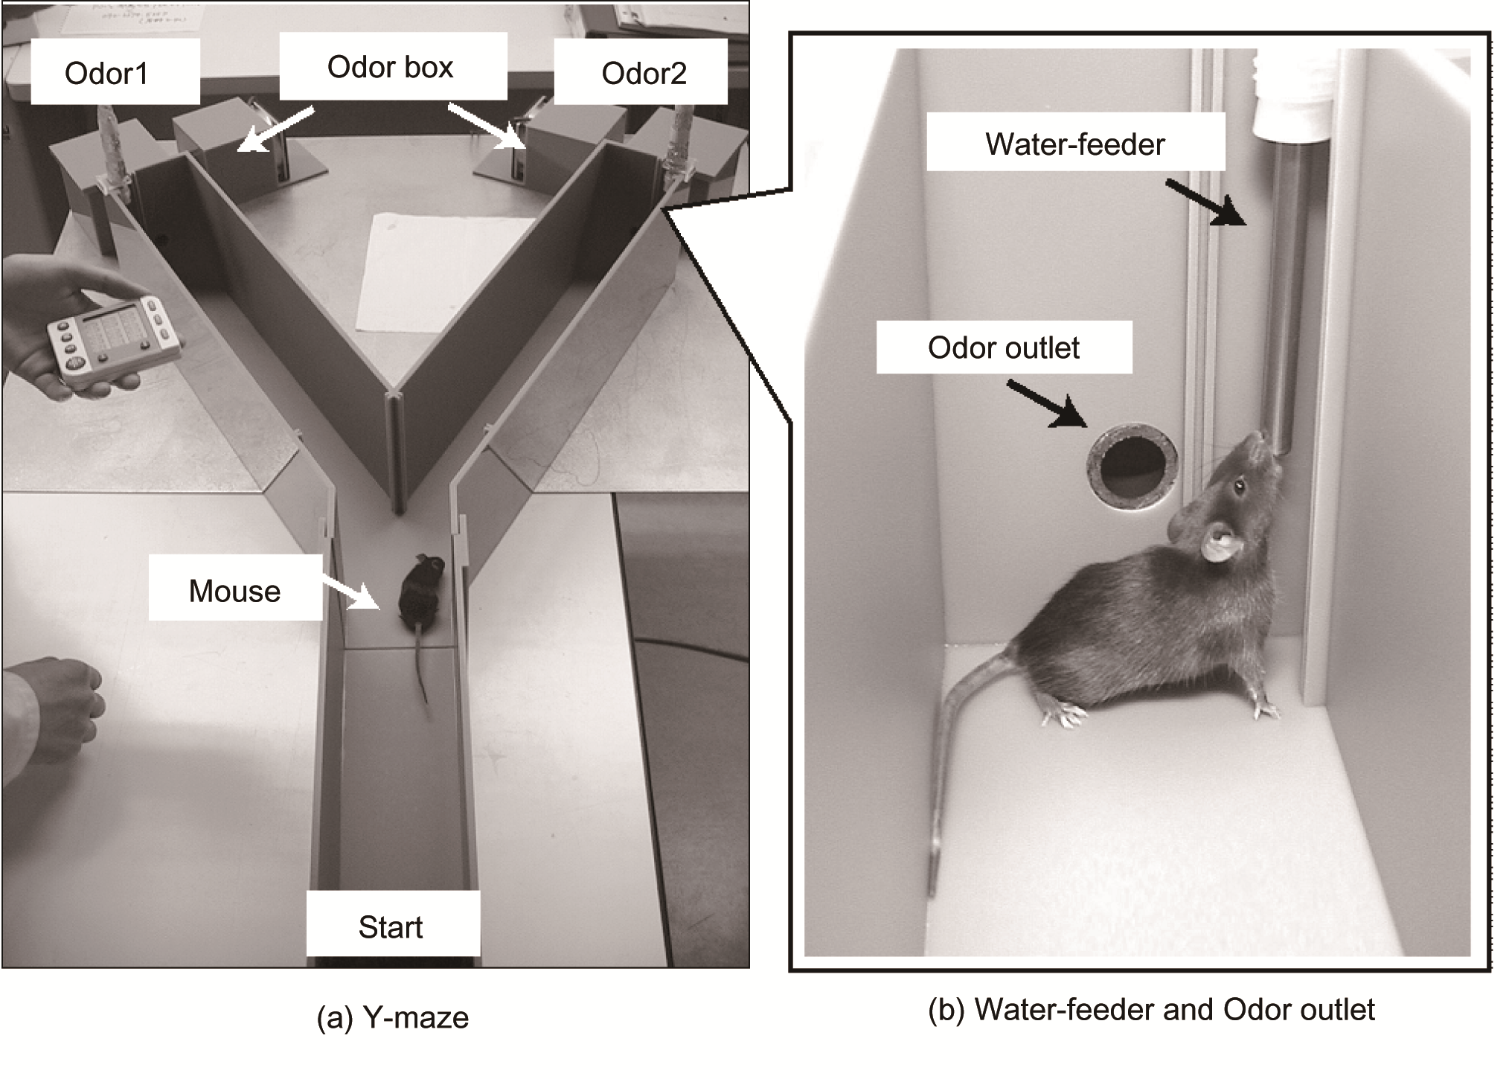Fig A. Odor discrimination experiment using Y-maze.

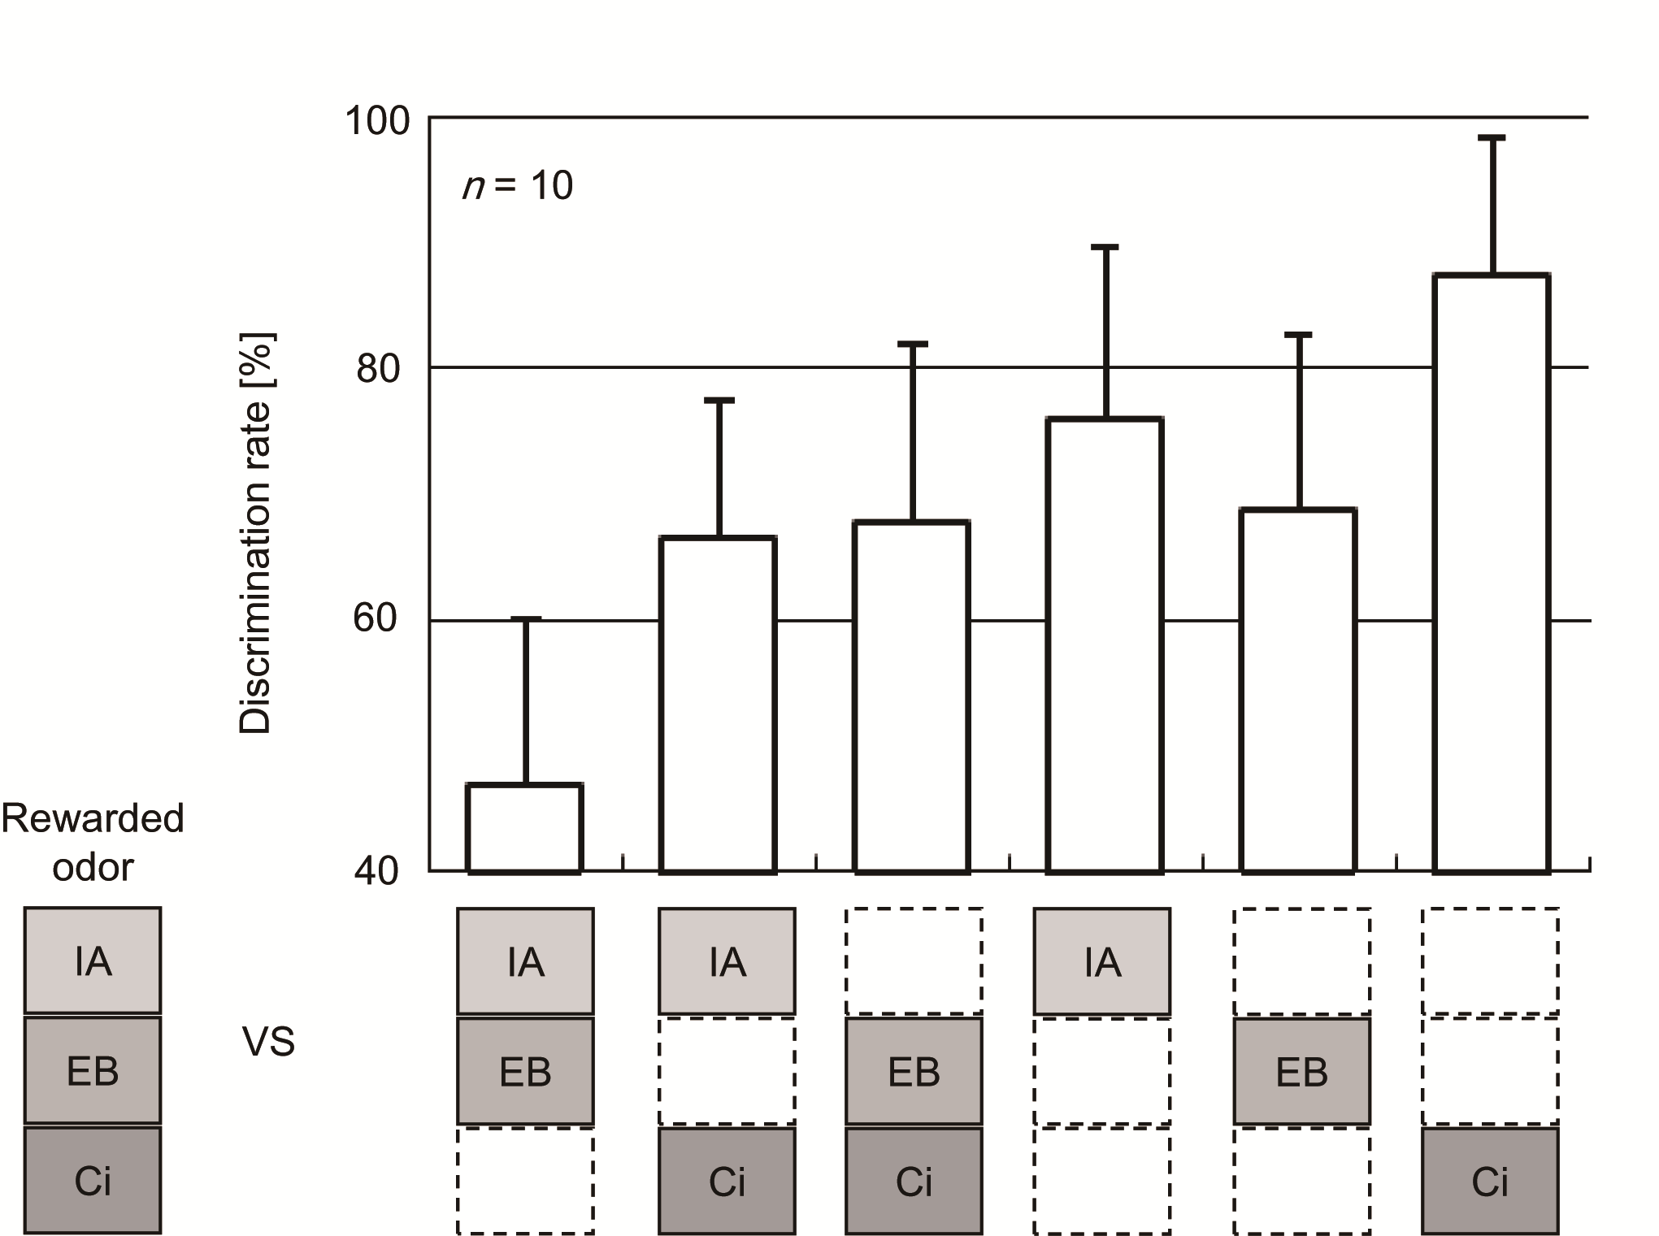
Fig B. Results of odor discrimination experiment

