Table S1 Multil-level Logistic Regression Results of Job Acceptance On Job And Individuals Characteristics.
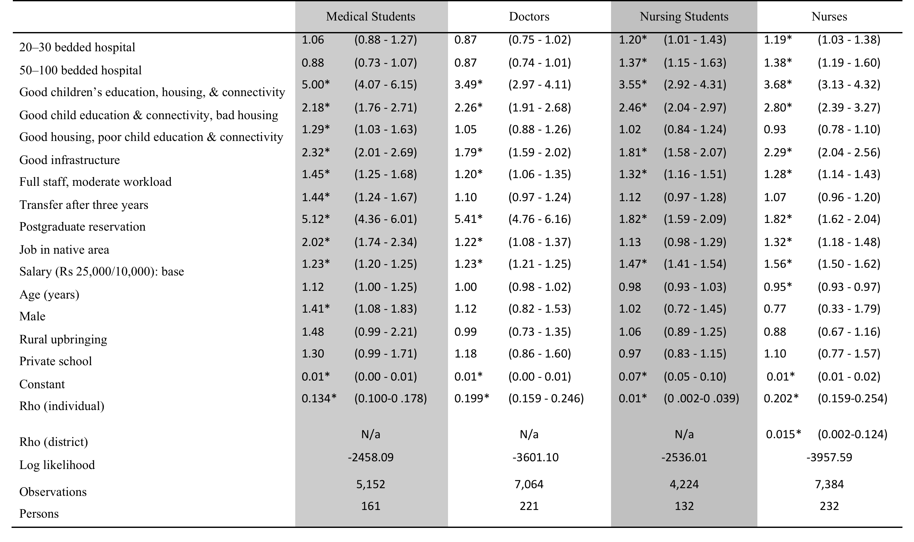
Note: (1) Figures are odds ratio (95% confidence intervals); (2) * Statistically significnat at 5% level.

