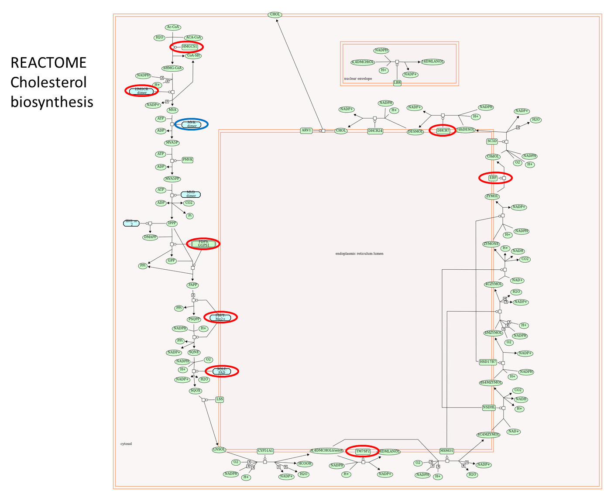

S2 Fig. The REACTOME cholesterol biosynthesis pathway. Genes circled in red were found up-regulated in the lung of statin users. The gene circled in blue was up-regulated by statins in the discovery set, but not validated in the replication sets.

