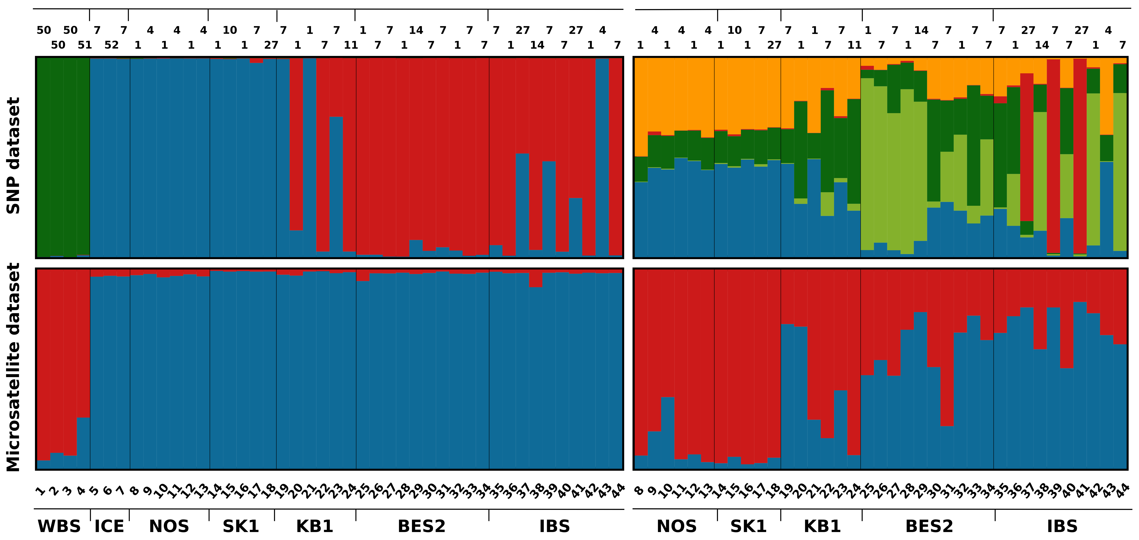

Figure S2. Assignment of individuals into clusters according to best Evanno deltaK values (Table S5) for all regions (left panels), and for the NOS to IBS sub-regions (right panels) based on Structure analyses with SNP (top panels) and microsatellite (bottom panels) marker-sets. The results are grouped by sub-region of origin. Each of the 44 individuals is represented with a vertical column where the coloration is proportional to the individuals estimated membership coefficient in one of the given clusters of genetic similarity. Individuals’ IDs are given below the plots with corresponding mitochondrial haplotypes above the plots. SNPs – all regions K=3; SNPs – NOS-IBS K=5; Microsatellites – all regions K=2; Microsatellites – NOS-IBS K=2.

