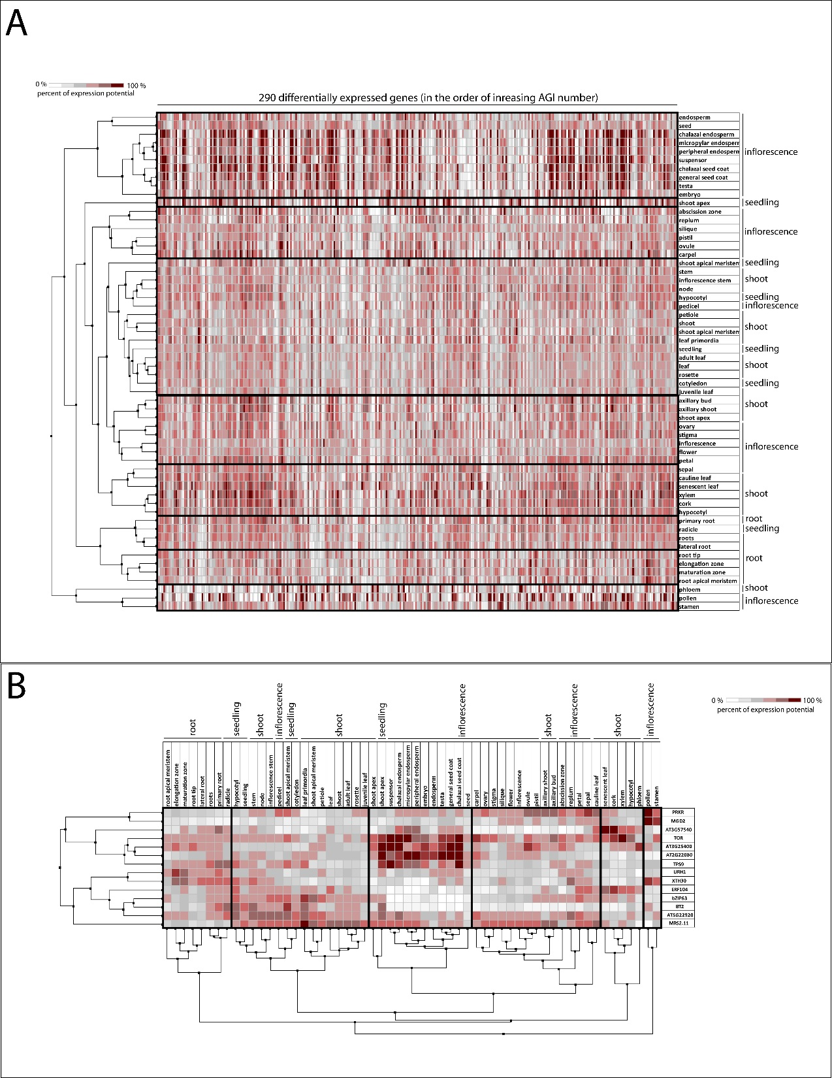
Fig. S5. Distribution of the expression of 290 identified genes (A) and of the 14 selected genes (B) in various tissues/organs. The analysis was conducted with Genevestigator using hierarchical clustering based on the Pearson correlation of the expression profiles.

