S1Fig. Eddy diffusivity (K_{ρ}) section along 23°W (Panel A) and grouped by region (Panel B; colored crosses denote individual profiles, corresponding colored horizontal lines maximum NO_{x} gradient and black line region mean). Mixed layer data are omitted from plots.
A
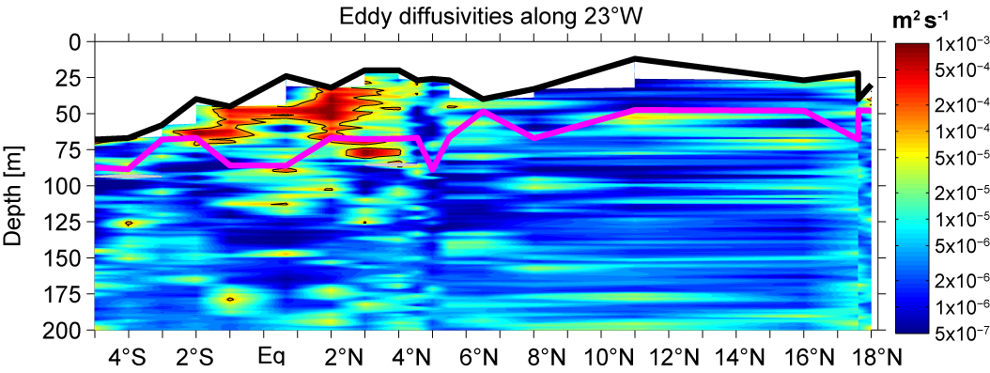
B
