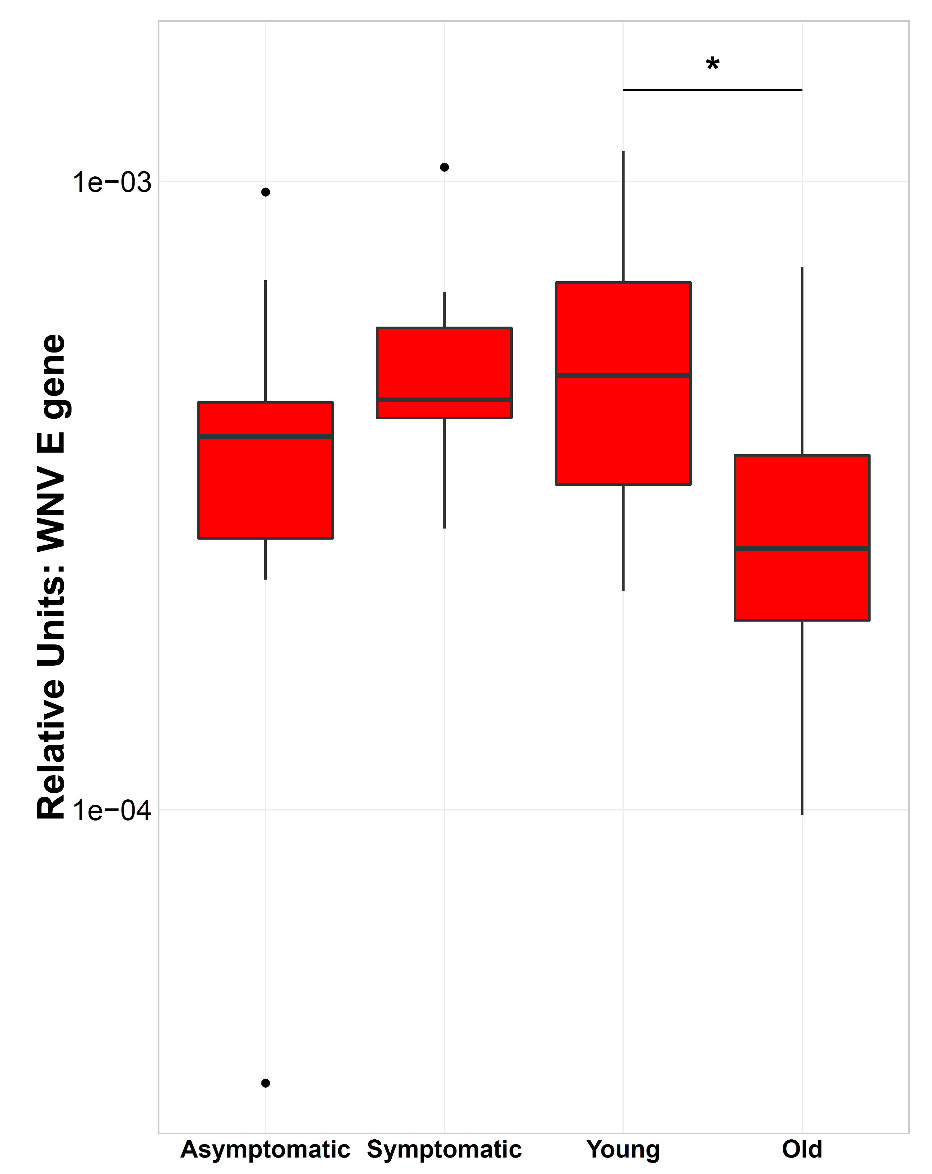

S4 Fig. WNV viral load in PBMCs with infection of WNV in vitro.

