S1 Fig. Architecture of the deep-learning algorithm
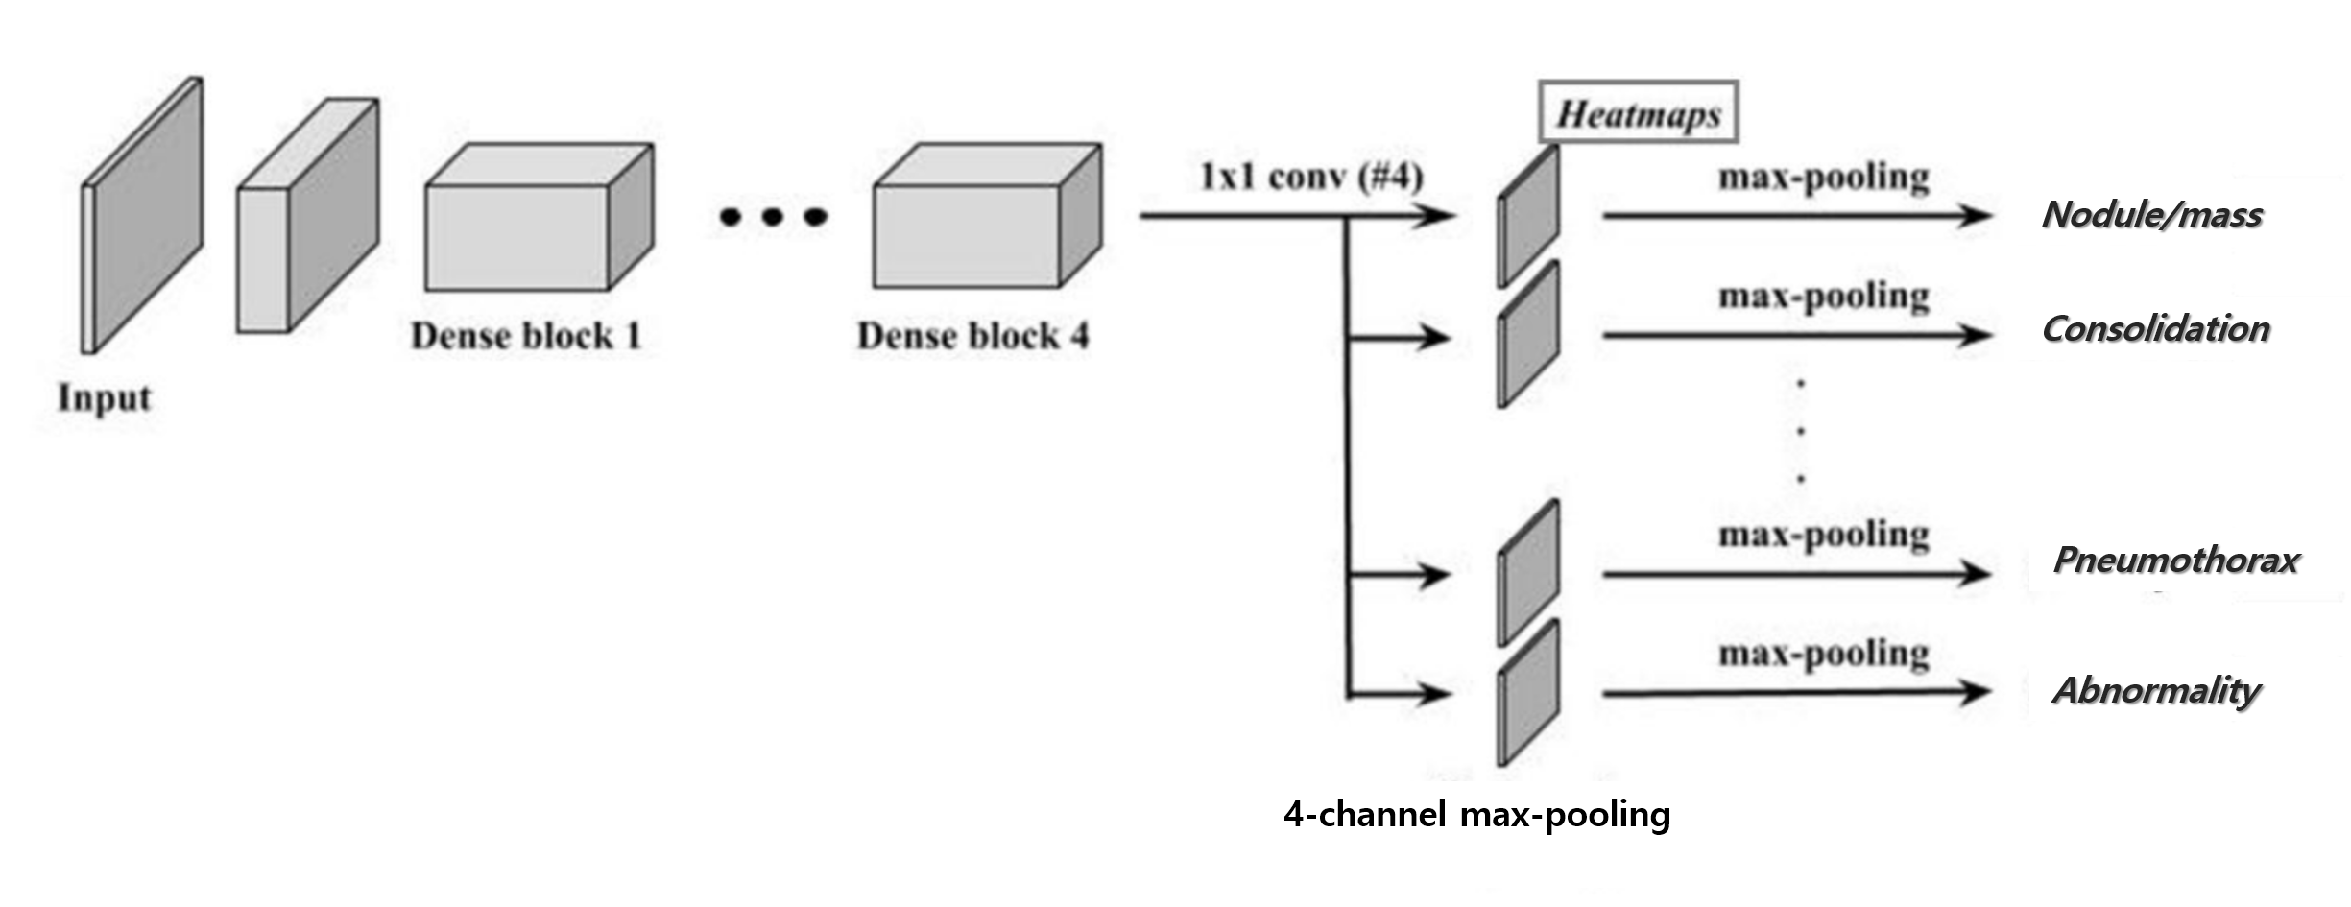
ResNet-34 based architecture of Lunit INSIGHT CXR. Raw pixel map of the DICOM images are passed through 34 convolutional layers that serve as the feature extractor projecting the chest radiograph onto a good representation space. This is followed by four 1 by 1 convolution heads which creates heatmaps of each of four findings. Pixel-wise binary cross entropy loss and image-level binary cross entropy loss are used during training.

