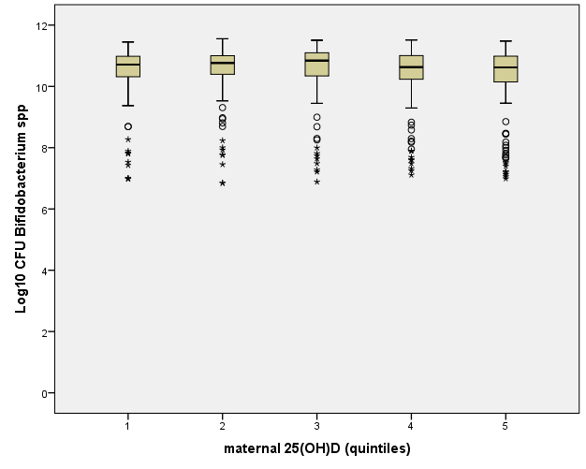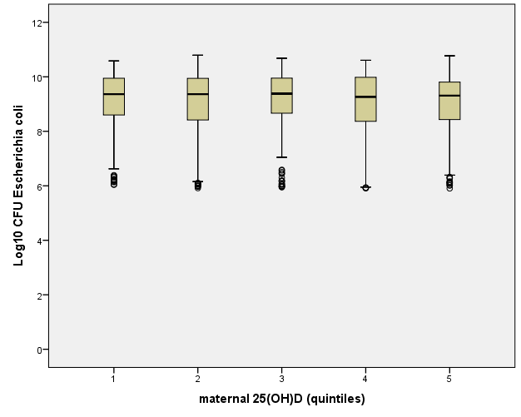

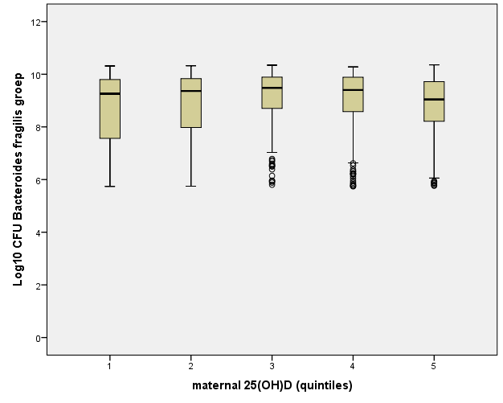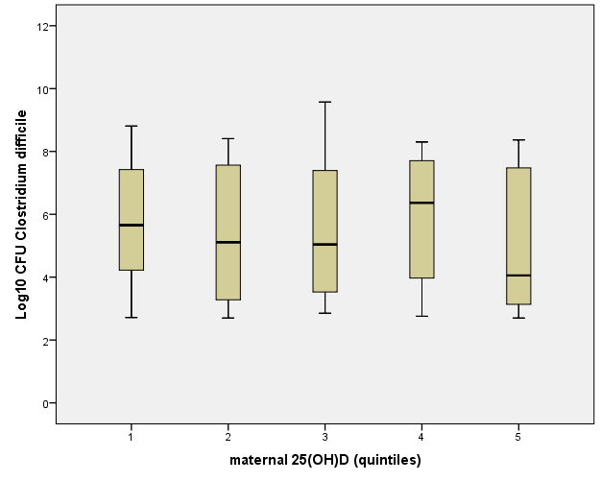

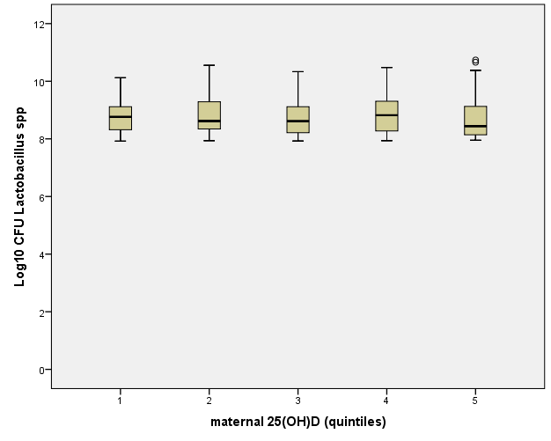

S2 Fig.: Boxplots to describe log10 CFU of Bifidobacterium spp., Escherichia coli, Bacteroides fragilis group, Clostridium difficile, and Lactobaccilus spp. in infants colonized with the respective bacteria in relation to maternal 25(OH)D level (in quintiles)

