Measures

Please note: Data are available as supplementary material. The variable names applied are indicated in bold in the beginning of each item.

Teacher level

Self-efficacy [61]

(4 = fully applies; 3 = largely applies; 2 = does rather not apply; 1 = does not apply at all)

SW1: I am convinced that I am able to successfully teach all relevant subject content to even the most difficult students.

SW2: I know that I can maintain a positive relationship with parents even when tensions arise.

SW3: When I try really hard, I am able to reach even the most difficult students.

SW4: I am convinced that, as time goes by, I will continue to become more and more capable of helping to address my students’ needs.

SW5: Even if I get disrupted while teaching, I am confident that I can maintain my composure and continue to teach well.

SW6: I am confident in my ability to be responsive to my students’ needs even if I am having a bad day.

SW7: If I try hard enough, I know that I can exert a positive influence on both the personal and academic development of my students.

SW8: I am convinced that I can develop creative ways to cope with system constraints (such as budget cuts and other administrative problems) and continue to teach well.

SW9: I know that I can motivate my students to participate in innovative projects.

SW10: I know that I can carry out innovative projects even when I am opposed by skeptical colleagues.

Subject-specific enthusiasm [62]

(4 = fully applies; 3 = largely applies; 2 = does rather not apply; 1 = does not apply at all)

EN3: I am enthusiastic about the subject biology.

EN1: I think biology is an exciting subject.

EN2: I always try to get students enthusiastic about the subject biology.

Enthusiasm for teaching the subject [62]

(4 = fully applies; 3 = largely applies; 2 = does rather not apply; 1 = does not apply at all)

EN5: I teach biology with great enthusiasm.

EN4: Teaching biology is fun.

Student level

Please note: The same items were used in pre- and posttest. Variable names ending with _VT refer to the pretest, variable names ending with _NT refer to the posttest.

Concept maps [71]

Variable names: CW3_VT / CW3_NT

Set of Given Concepts:

blue mussel; byssus; egg; eider duck; human; larvae; mussel breed; oyster; sea star; young mussel; worm

Set of Linking Words:

becomes; develops; eats; protects; displaces; breeds; sticks together; lives in; builds; warms; pulls

Questionnaire [71]

Items for Procedural System Thinking Assessment (procedural system thinking)

VT_M6 / NT_M6: A North Sea exposition plans to put algae in a ‘blue mussel aquarium.’ Are the blue mussels limited by those algae?

VT_M9 / NT_M9: Natural breeds are totally overfished now. How do fishers get their mussels?

VT_M10 / NT_M10: Blue mussels and a lot of plankton is arranged in an aquarium. When Sea stars are added,
□ the amount of plankton decreases.
□ the amount of plankton increases.
□ the amount of plankton remains constant.
□ the amount of Blue mussel decreases.

VT_M13 / NT_M13: Oysters are much stronger than Blue Mussels. Imagine Oysters displacing the mussels in a few years. What are the consequences for eider ducks?

VT_M16 / NT_M16: Sometimes water stays during low tide because of a hard storm. What are the consequences for Blue Mussels?
□ They have more time to feed and to breathe.
□ Sea Stars have more time to feed the mussels.
□ They won’t get enough air to breathe.
□ They won’t get enough water.

VT_M17 / NT_M17: Are Blue mussels able to survive without water?
□ Yes, no problem, this would work endlessly.
□ No, they are not able to survive without the fresh water flow.
□ No, they die immediately in the air.
□ Yes, but only a few hours.

VT_M18 / NT_M18: Oysters don’t feed on mussels and don’t kill them. Why are they still so threat-generating for mussels?

VT_M19 / NT_M19: Why are Blue Mussel breeds important for the Wadden Sea?
□ They offer protection for other animals.
□ It’s confusing for predator to pick a single mussel.
□ They protect the mussels.
□ They offer ground for younger mussels to stick on.

Items for Structural System Thinking Assessment (structural system thinking)

VT_M1 / NT_M1: How many Blue mussels can live on a mussel bed?
□ 10-100
□ 100-200
□ 200-800
□ many thousands

VT_M2 / NT_M2: You’re asked to explain how blue mussels feed. Which of those terms do you need? Circle!
‘inlet opening’ air plankton water filtering
chewing ‘outlet opening’ oxygen

VT_M3 / NT_M3: Which of those circles is the right one?

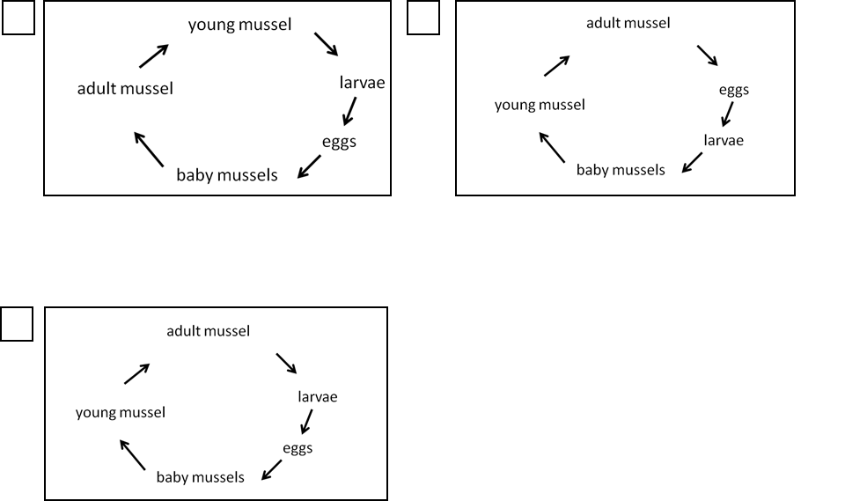

VT_M4 / NT_M4: In spring each female Blue mussel produces millions of eggs. Why is such a big number of eggs reasonable?
□ Many eggs are fed therefore they must produce such a big number.
□ There is no particular reason for it.
□ The mussels feel threatened by predators, therefore they produce such a big number.
□ Many eggs are flushed away, therefore they must produce such a big number.

VT_M5 / NT_M5: Why do blue mussels filtrate the sea water?
□ to clean their bodies
□ to breathe
□ to filtrate food
□ to move

VT_M7 / NT_M7: Circle those terms concerning the breathing of blue mussels!
Oxygen Water Oystercatcher Sand ‘outlet opening’ plankton ‘inlet opening’ blue mussel air

VT_M8 / NT_M8: Are Blue mussels able to breathe?
□ No, they live underwater.
□ Yes, but only at low tide.
□ Yes, they make use of the oxygen in the water.
□ No, they don’t need to.

VT_M11 / NT_M11: Who eats whom?
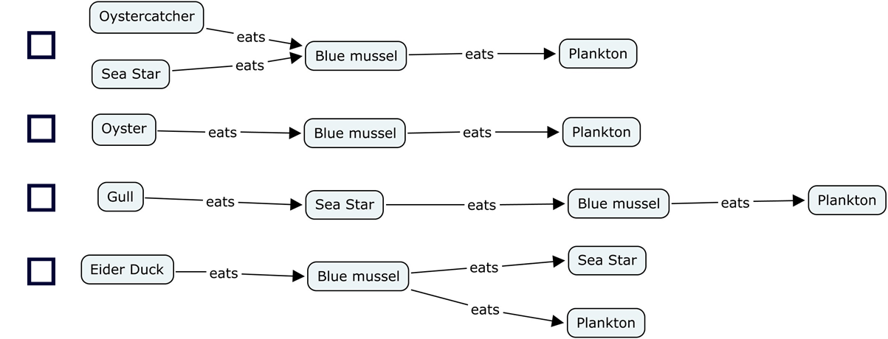

VT_M12 / NT_M12: What would happen if the Blue mussels wouldn’t have a foot?
□ They couldn’t escape from the seagulls.
□ They couldn’t hold on to the ground.
□ They couldn’t reproduce.
□ They would slowly sink into the mud.

VT_M14 / NT_M14: How do Blue mussels breed?
richtig

richtig

□ Little mussels grow out of adult mussels
□ Larvae grow up inside adult mussels and became baby mussels later on.
□ They produce eggs and flush them into the water where they became larvae. Those develop into mussels later on.
□ They produce larvae; those become eggs who later develop into mussels.

VT_M15 / NT_M15: Which of these terms are irrelevant for a Blue Mussel’s life? Strike them out!
Sea Star foot sand human air water oxygen shell

VT_M20 / NT_M20: How do mussel beds develop?
□ Young mussels are flushed together by the water and stay together as a heap.
□ The mussels stick together and thus form big mussel beds.
□ Seagulls chase the mussels together thus forming big mussel beds.
□ Fishing boats chase the mussels together thus forming big mussel beds.
VT_M21 / NT_M21: What happens to the blue mussels at low tide?
□ They are flushed away with the water; otherwise they would dry up.
□ They stay at the bottom the whole tide long.
□ They dig themselves into the bottom.
□ With closed shells, they survive with a small amount of water.

VT_M22 / NT_M22: What do mussels feed on?
□ Basically, they eat worms and crayfish.
□ They filter little particles.
□ Plankton.
□ Little fishes.

VT_M23 / NT_M23: Circle the predators of Blue Mussels!
Common Seal Flatfish Common Shore Crab Plaice Gull Human Oyster Oystercatcher Shark

VT_M24 / NT_M24: How are Blue Mussels able to stick to each other?
□ with their excrement
□ with salt crystals
□ with byssus
□ with food

VT_M25 / NT_M25: What is the difference between natural mussel beds and mussel breeding farms?
□ Sea stars are removed from mussel breeding farms.
□ Natural mussel beds can get very old.
□ In mussel breeding farms the mussels are frequently harvested.
□ Sea stars are removed from natural mussel beds.

VT_M26 / NT_M26: How do Blue Mussels protect themselves from heat at low tide?
□ They open their shells and cool down through an air draft.
□ They back out into the water.
□ They dig themselves into the bottom.
□ They consume just a little amount of water and rest in a kind of sleeping mode.

