Supporting Figure 3. Effect of Fasting on Gestational Age at Birth (in Weeks) Interacted with Dietary Intake and Sleep during Ramadan
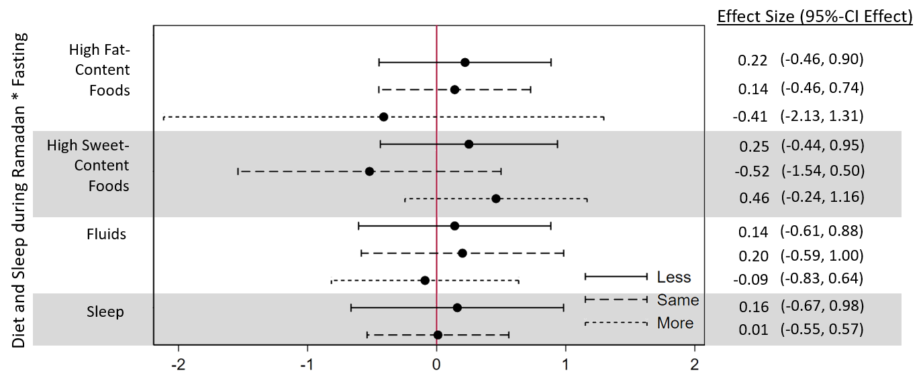
This figure shows the results of four adjusted regressions. In each regression, the fasting variable is interacted with the depicted variable. The reference group is always the offspring of mothers who did not fast. Gestational age at birth is measured in completed weeks.

