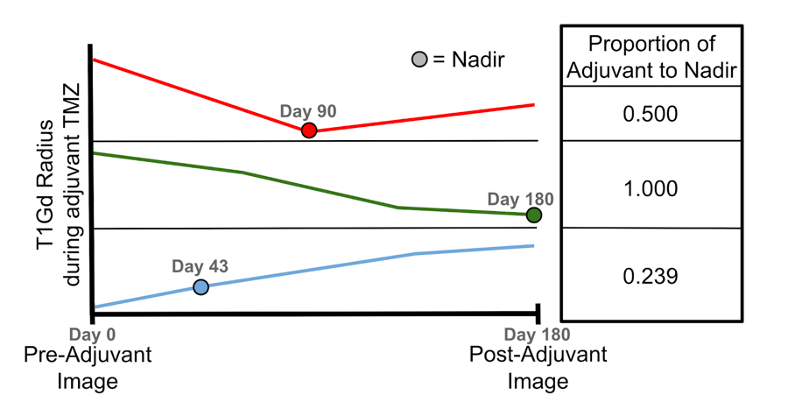

Supplemental Figure S2. Schematic showing T1Gd radius changes from the pre-adjuvant to post-adjuvant imaging time points to demonstrate how nadir is determined and how proportion of adjuvant to nadir is calculated. Proportion of adjuvant to nadir is calculated as number of days from pre-adjuvant image to nadir image divided by number of days between pre-adjuvant and post-adjuvant imaging. Top row: Example of tumor reaching nadir volume before post-adjuvant imaging, where %ΔT1Gd-Nadir (about -0.95) is less than %ΔT1Gd (about -0.50). Middle: Example of tumor reaching nadir at post-adjuvant time point, where %ΔT1Gd-Nadir equals %ΔT1Gd. Bottom: Example of how nadir is determined when tumor volume never decreases below pre-adjuvant value.

