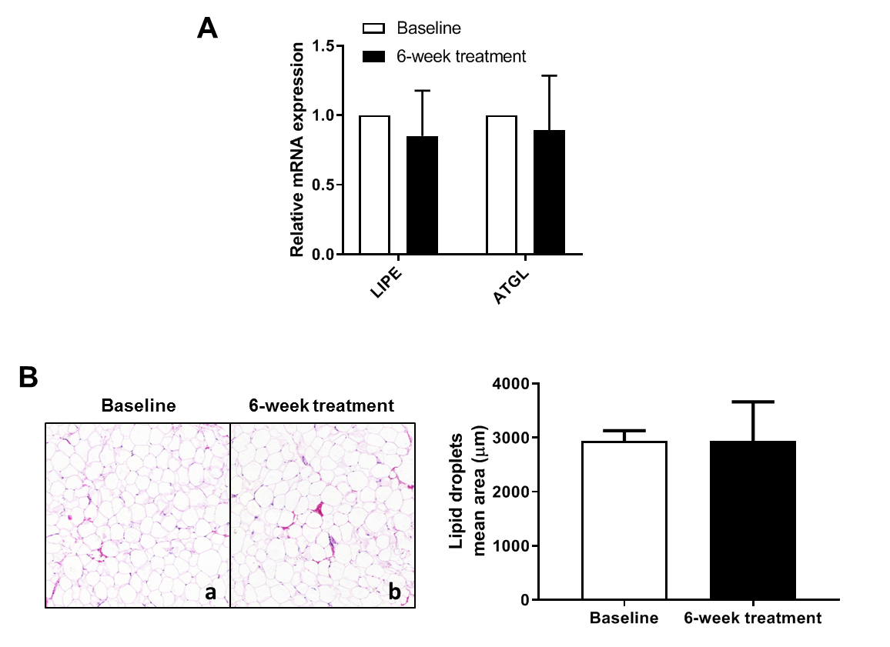
S4 Fig. (A) mRNA levels of genes involved in lipolysis. (B) H&E-stained adipose tissue biopsies at baseline (a) and 6-week treatment (b) and quantification

