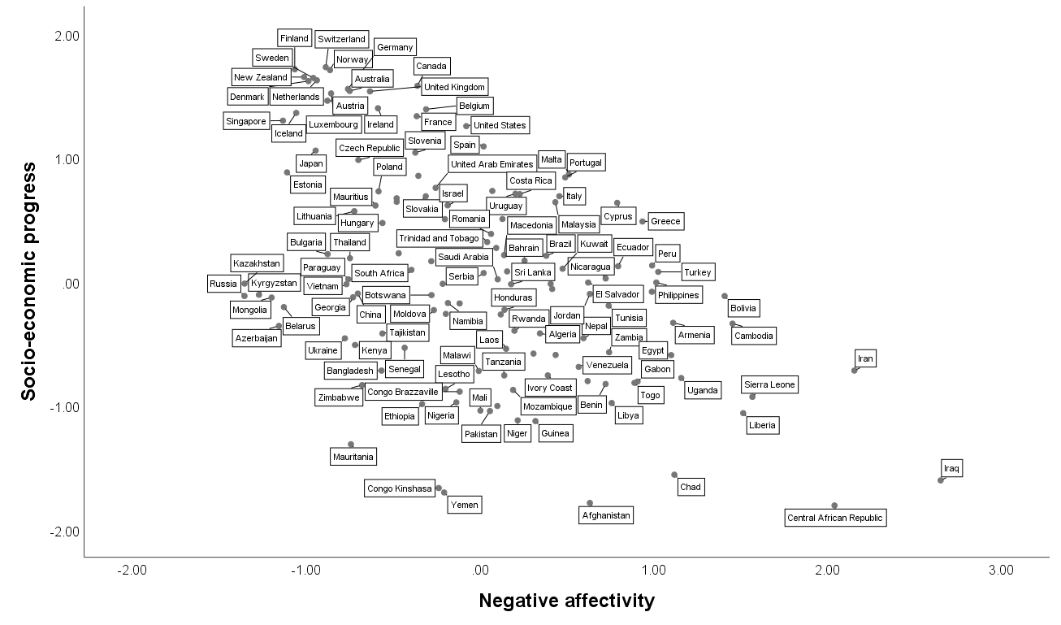

Figure S2
The relationship between negative affectivity and socio-economic progress

