- Achieved power for α = 0.05, a sample size of 440 participants and a large effect size.
(Large effect size: Cohen’s d = 0.8 Odds ratio = 4.27)
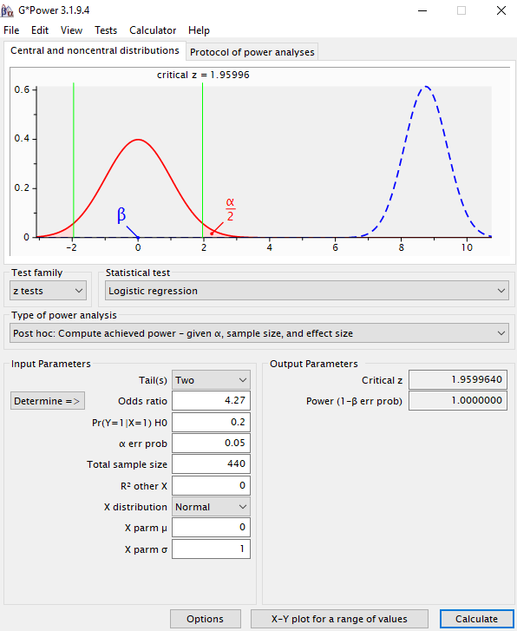
Figure 6. Achieved power for α = 0.05, a sample size of 440 participants and a large effect size.
Comment: For a large effect size, α = 0.05, a sample size of 440 participants, the achieved power was 100% for identifying predictors.

