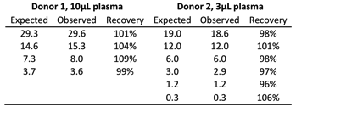

Table S5. Spike-recovery of IP-10 in plasma samples
Spike recovery was performed by spiking recombinant IP-10 (Peprotec, USA) into x10 and x3 diluted plasma samples without detectable IP-10. The average % recovery was calculated as the proportion of spiked standard in the sample (observed) to that of the control spike (expected).

