MONGOLIA

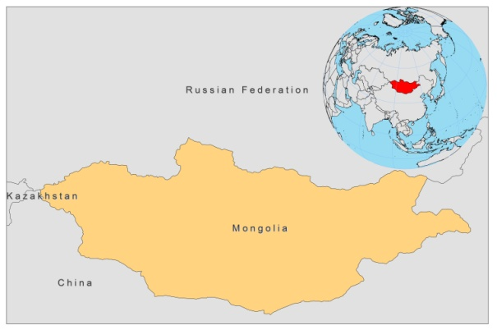

BASIC COUNTRY DATA

Total Population: 2,756,001
Population 0-14 years: 28%
Rural population: 43%
Population living under USD 1.25 a day: 22.4%
Population living under the national poverty line: 35.2%
Income status: Lower middle income economy
Ranking: Medium human development (ranking 110)
Per capita total expenditure on health at average exchange rate (US dollar): 75
Life expectancy at birth (years): 68
Healthy life expectancy at birth (years): 56

BACKGROUND

Leishmania infection was first reported in Mongolia in 1976 in great gerbils; up to 100% of them were infected in some areas in the south of the country [1]. In an 8-year-long and extensive study in Mongolia, no other reservoir could be identified, indicating that L. major in Mongolia is limited to great gerbils only. The parasites identified were L. major and L. gerbilii, the latter a non virulent species. No human cases have been notified. In 1990 a new species, L. turanica, was identified, also only occurring in great gerbils [2].

PARASITOLOGICAL INFORMATION
Leishmania species | Clinical form | Vector species | Reservoirs
L. major | ? | Unknown | Unknown

No further information is available

SOURCES OF INFORMATION

1. Neronov VM, Strelkova MV, Shurkhal AA, Luschekina AA, Artemyev MM (1987). Natural focality of zoonotic cutaneous leishmaniasis in the Mongolia’s Peoples Republic; results and objectives of integrated research. Folia Parasitologica 34: 1-9.

2. Strelkovaa MV, Shurkhal AV, Kellina OI, Eliseev LN, Evans DA et al (1990). A new species of Leishmania isolated from the great gerbil Rhombomys opimus. Parasitology 101: 327-335.

