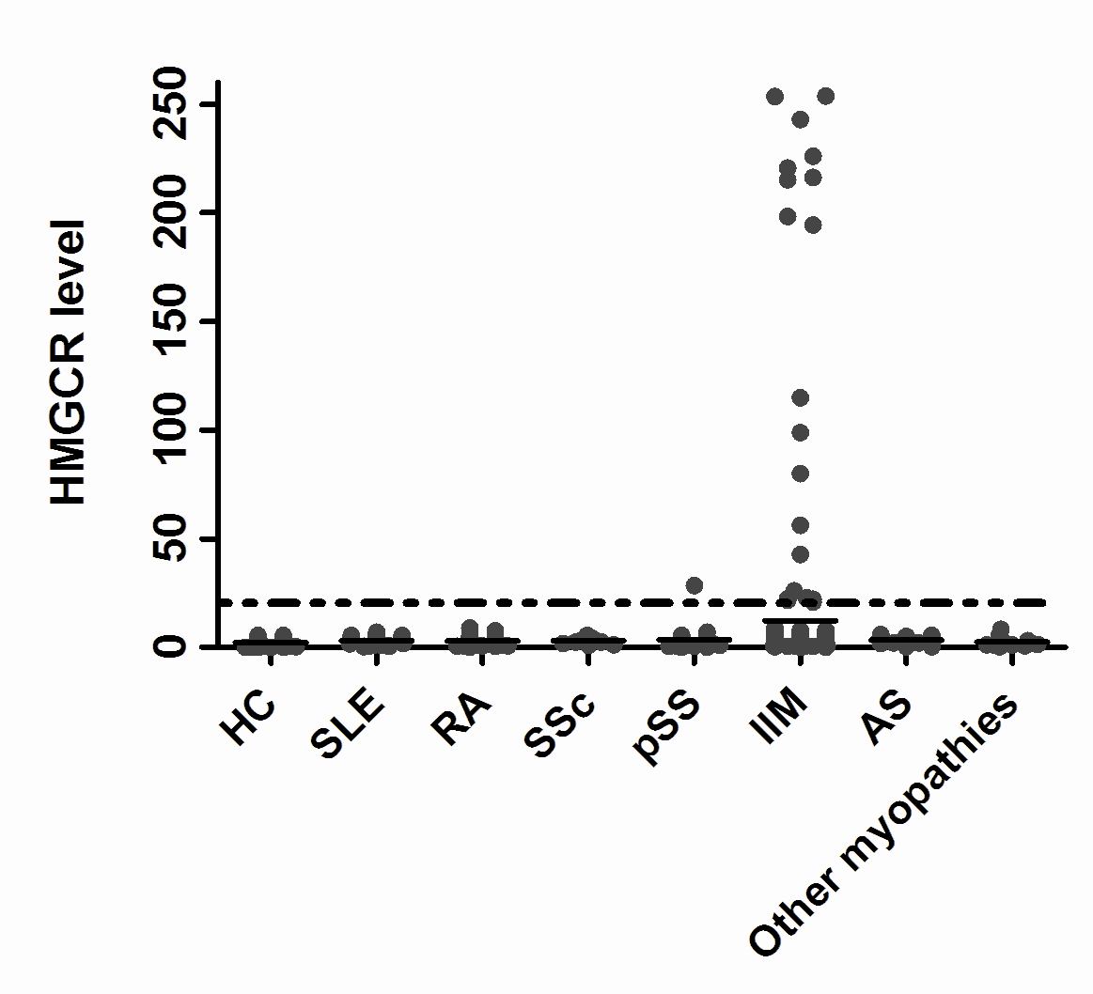

Fig 1. Anti-HMGCR antibody presence in each group

