Coupling environment and physiology to predict effects of climate change on the taxonomic and functional diversity of fish assemblages in the Murray-Darling Basin, Australia
Anielly Galego de Oliveira¹*, Dayani Bailly¹, Fernanda A. S. Cassemiro², Edivando Vitor do Couto³, Nick Bond⁴, Dean Gilligan⁵, Thiago F. Rangel², Angelo Antonio Agostinho¹, Mark J. Kennard⁶
¹Programa de Pós-Graduação em Ecologia de Ambientes Aquáticos Continentais, Núcleo de Pesquisas em Ictiologia, Limnologia e Aquicultura (NUPÉLIA), Universidade Estadual de Maringá, PR, Brazil
² Programa de Pós-Graduação em Ecologia e Evolução Universidade Federal de Goiás, Goiânia, GO, Brazil
³Universidade Tecnológica Federal do Paraná, Campo Mourão, PR, Brazil
⁴Centre for Freshwater Ecosystems, La Trobe University, Wodonga, Victoria 3690, Australia
⁵ NSW Department of Primary Industries – Fisheries, Batemans Bay Fisheries Office, Batemans Bay, New South Wales 2536, Australia.
⁶Australian Rivers Institute, Griffith University, Nathan, Queensland 4111, Australia
*Corresponding author:
Anielly G. Oliveira; e-mail: anielly_oliveira@hotmail.com
Telephone number: +55 44 30114607

Table A. Fish species of the Murray-Darling Basin considered in this study. The list is composed of fish species occupying at least four grid cells and for which functional traits and upper thermal tolerance limit (lethal maximum temperature) data are available.
Order | Family | Species | Common name | Number of occupied cells and relative frequency of occurrence | Conservation Status (IUCN*)
Atheriniformes | Atherinidae | Craterocephalus stercusmuscarum  (Günther 1867) | Un-specked hardyhead | 394 (6.07%)
 | Melanotaenidae | Melanotaenia fluviatilis  (Castelnau 1878) | Murray-Darling rainbowfish | 526 (8.11%)
Perciformes | Chandidae | Ambassis agassizii  Steindachner 1867 | Olive perchlet | 32 (0.49%) | DD
 | Clupeidae | Nematalosa erebi  (Günther 1868) | Bony herring | 860 (13.26%) | LC
 | Eleotridae | Hypseleotris klunzingeri  (Ogilby 1898) | Western carp gudgeon | 1291 (19.90%)
 |  | Mogurnda adspersa  (Castelnau 1878) | Southern purple-spotted gudgeon | 34 (0.52%)
 |  | Philypnodon grandiceps  (Krefft 1864) | Flat-headed gudgeon | 484 (7.46%)
 |  | Philypnodon macrostomus  Hoese and Reader 2006 | Dwarf flat-headed gudgeon | 16 (0.24%)
 | Percichthyidae | Gadopsis marmoratus  Richardson 1848 | River blackfish | 459 (7.07%)
 | Percichthydae | Maccullochella macquariensis  (Cuvier 1829) | Trout cod | 141 (2.17%) | EN
 |  | Maccullochella peelii  (Mitchell 1838) | Murray cod | 731 (11.27%) | CR
 |  | Macquaria ambigua  (Richardson 1845) | Golden perch | 1071 (16.51%)
 |  | Macquaria australasica  Cuvier 1830 | Macquarie perch | 110 (1.69%) | DD
 |  | Nannoperca australis  Günther 1861 | Southern pygmy perch | 167 (2.57)
 | Terapontidae | Bidyanus bidyanus  (Mitchell 1838) | Silver perch | 251 (3.87%) | VU
 |  | Leiopotherapon unicolor  (Günther 1859) | Spangled perch | 469 (7.23%)
Salmoniformes | Galaxiidae | Galaxias maculatus  (Jenyns 1842) | Common galaxias | 34 (0.52%) | LC
 |  | Galaxias olidus  Günther 1866 | Mountain galaxias | 642 (9.88%)
 |  | Galaxias oliros  Raadik 2014 | Obscure galaxias | 61 (0.94%)
 |  | Galaxias arcanus  Raadik 2014 | Riffle galaxias | 32 (0.49%)
 | Retropinnidae | Retropinna semoni  (Weber 1895) | Australian smelt | 1043 (16.08%)
Siluriformes | Plotosidae | Neosilurus hyrtlii  Steindachner 1867 | Hyrtl’s tandan | 59 (0.90%)
 | Plotosidae | Tandanus tandanus  (Mitchell 1838) | Freshwater catfish | 265 (4.08%)
*IUCN = Internation Union for Conservation of Nature

Wager, R. 1996. Maccullochella peelii. The IUCN Red List of Threatened Species 1996: e.T12576A3361423. http://dx.doi.org/10.2305/IUCN.UK.1996.RLTS.T12576A3361423.en.
Wager, R. 1996. Macquaria australasica. The IUCN Red List of Threatened Species 1996: e.T12581A3361826. http://dx.doi.org/10.2305/IUCN.UK.1996.RLTS.T12581A3361826.en.
Wager, R. 1996. Bidyanus bidyanus. The IUCN Red List of Threatened Species 1996: e.T2804A9482704. http://dx.doi.org/10.2305/IUCN.UK.1996.RLTS.T2804A9482704.en.

David, B., West, D, Franklin, P., Allibone, R, Ling, N., Hitchmough, R. & Crow, S. 2014. Galaxias maculatus. The IUCN Red List of Threatened Species 2014: e.T197279A2481214. http://dx.doi.org/10.2305/IUCN.UK.2014-3.RLTS.T197279A2481214.en.

Table B. Environmental attributes used as predictor variables in the species distribution models
Predictor variables (Acronyms) | Predictor variables | Data source  Present/Future
TMEAN; °C | Annual mean temperature | Worldclim/CCAFS
TMAX; °C | Maximum temperature in the hottest month | Worldclim/CCAFS
TMIN; °C | Minimum temperature in the coldest month | Worldclim/CCAFS
PANN; mm | Annual precipitation | Worldclim/CCAFS
PMAX; mm | Precipitation of the wettest month | Worldclim/CCAFS
PMIN; mm | Precipitation of driest month | Worldclim/CCAFS
UFL | Upstream Flow Path Length | Stein et al., 2014
ALT (m) | Altitude | Stein et al., 2014

Data source:
http://www.worldclim.org
http://ccafs-climate.org
Stein, J.L., Hutchinson, M.F., Stein, J.A., 2014. A new stream and nested catchment framework for Australia. Hydrol. Earth Syst. Sci. 18, 1917–1933.

Table C. Brief description of the traits used in the functional analysis.
Biological Attribute | Description | Code
Body morphology
Maximum length | Maximum total body length (cm) | MaxL
Behaviour
Vertical position | Benthic | VPBEN
 | Non-benthic | VPNBEN
Life history
Longevity | Maximum potential life span (years) (Females) | LONG
Age at maturation | Mean age at maturation (years) (Females) | AGEMAT
Parental care | Metric representing the total energetic contribution of parents to their offspring (after Winemiller 1989) | PC
Total Fecundity | Total number of eggs or offspring per breeding season | TFEC
Egg size | Mean diameter of mature (fully yolked) ovarian oocytes (mm) | EGGS
Movement classification | No known movement associated with reproduction | MVT1
 | Potamodromous (spawning migration) | MVT2
 | Amphidromous | MVT5
 | Anadromous | MVT6
 | Catadromous | MVT7
Trophic guild | Herbivore-detritivore (ca. > 25% plant matter) | TG1
 | Omnivore (ca. 5 - 25% plant matter) | TG2
 | Invertivore | TG3
 | Invertivore-piscivore (>10% Fish) | TG4
Physiology | Maximum temperature between cells occupied by species | TMAX
 | Minimum temperature between the cells occupied by species | TMIN

References for more information on Methods:
Olden, J.D. & Kennard, M.J. (2010). Intercontinental convergence of fish life history strategies along a gradient of hydrologic variability. Pp. 83–107 In: Community Ecology of Stream Fishes: Concepts, Approaches, and Techniques. (Eds) K.B. Gido & D.A. Jackson. American Fisheries Society, Symposium 73, Bethesda, Maryland.
Sternberg, D. & Kennard, M.J. (2013). Environmental, spatial and phylogenetic determinants of fish life-history traits and functional composition of Australian rivers. Freshwater Biology. 58: 1767–1778.
Sternberg, D. & Kennard, M.J. (2014). Phylogenetic effects on functional traits and life history strategies of Australian freshwater fish. Ecography. 37: 54–64.
Sternberg, D., Kennard, M.J. & Balcombe, S.R. (2014). Biogeographic determinants of Australian freshwater fish life-history indices assessed within a spatio-phylogenetic framework. Global Ecology and Biogeography. 23: 1387–1397

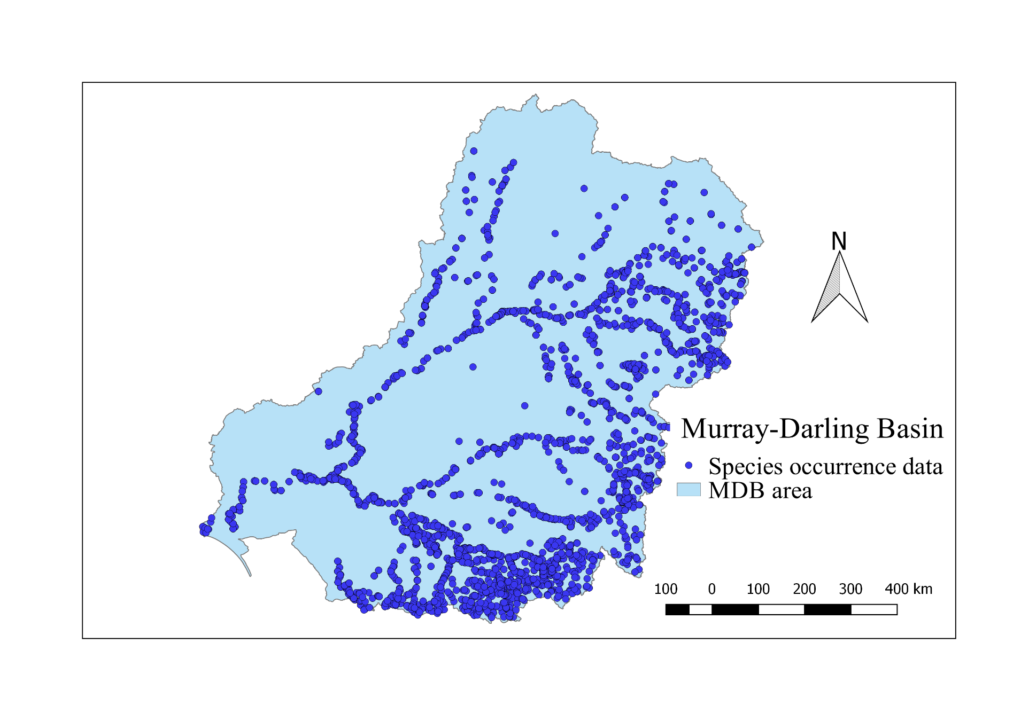
Fig A. Species occurrence data in the Murray-Darling Basin, Australia.

Table D. Indicator values for species’ functional traits in the different scenarios. Higher values represent a high proportional trait representation (i.e. fidelity) in a given scenario.
Trait | Present | 2050 (4.5) | 2050 (8.5) | 2080 (4.5) | 2080 (8.5)
TMAX | 0.25131 | 0.12431 | 0.08541 | 0.08792 | 0.01668
TMIN | 0.09725 | 0.08312 | 0.06963 | 0.07011 | 0.00652
MAXL | 0.26315 | 0.12591 | 0.08426 | 0.08713 | 0.01497
VPBEN | 0.25011 | 0.10723 | 0.06444 | 0.06705 | 0.01493
VPNBEN | 0.23672 | 0.06032 | 0.04573 | 0.04943 | 0.00823
LONG | 0.26485 | 0.12482 | 0.08227 | 0.08561 | 0.01615
AGEMAT | 0.26206 | 0.12293 | 0.08455 | 0.08534 | 0.01642
NONMOV | 0.22526 | 0.10311 | 0.06537 | 0.06991 | 0.01584
POTAMO | 0.24022 | 0.09193 | 0.05151 | 0.05396 | 0.00598
AMPHID | 0.01987 | 0.00341 | 0.00463 | 0.00388 | 0.00032
CATAD | 0.06314 | 0.00003 | 0.00000 | 0.00001 | 0.00000
PARC | 0.26145 | 0.10348 | 0.07318 | 0.07448 | 0.01606
TFEC | 0.27991 | 0.12963 | 0.08141 | 0.08120 | 0.01416
EGGS | 0.26379 | 0.12263 | 0.08420 | 0.08551 | 0.01628
HERB-DET | 0.10373 | 0.07075 | 0.03001 | 0.03098 | 0.00030
OMNI | 0.18755 | 0.05653 | 0.02389 | 0.02747 | 0.00222
INV | 0.24535 | 0.09004 | 0.07251 | 0.07184 | 0.01624
INV-PISC | 0.18063 | 0.05030 | 0.02849 | 0.01879 | 0.00718

