Stabilization of resveratrol in blood circulation by conjugation to mPEG and mPEG-PLA polymers: investigation of conjugate linker and polymer composition on stability, metabolism, antioxidant activity and pharmacokinetic profile.
Basavaraj Siddalingappa^{1,3*}, Heather A. E. Benson*, David H. Brown², Kevin T. Batty¹, Yan Chen¹

¹School of Pharmacy, CHIRI-Bioscience, Curtin University, GPO Box U1987 Perth, Western Australia
²Department of Chemistry, Curtin University, GPO Box U1987 Perth, Western Australia.
³Present Address, Graduate College of Biomedical Sciences, Western University of Health Sciences, Pomona, CA, USA.

Corresponding author: Dr.Basavaraj Siddalingappa, Graduate College of Biomedical Sciences, Western University of Health Sciences, Pomona, CA 91766, USA. Email: bsiddalingappa@westernu.edu; Tel: +1 909 469 6476
.

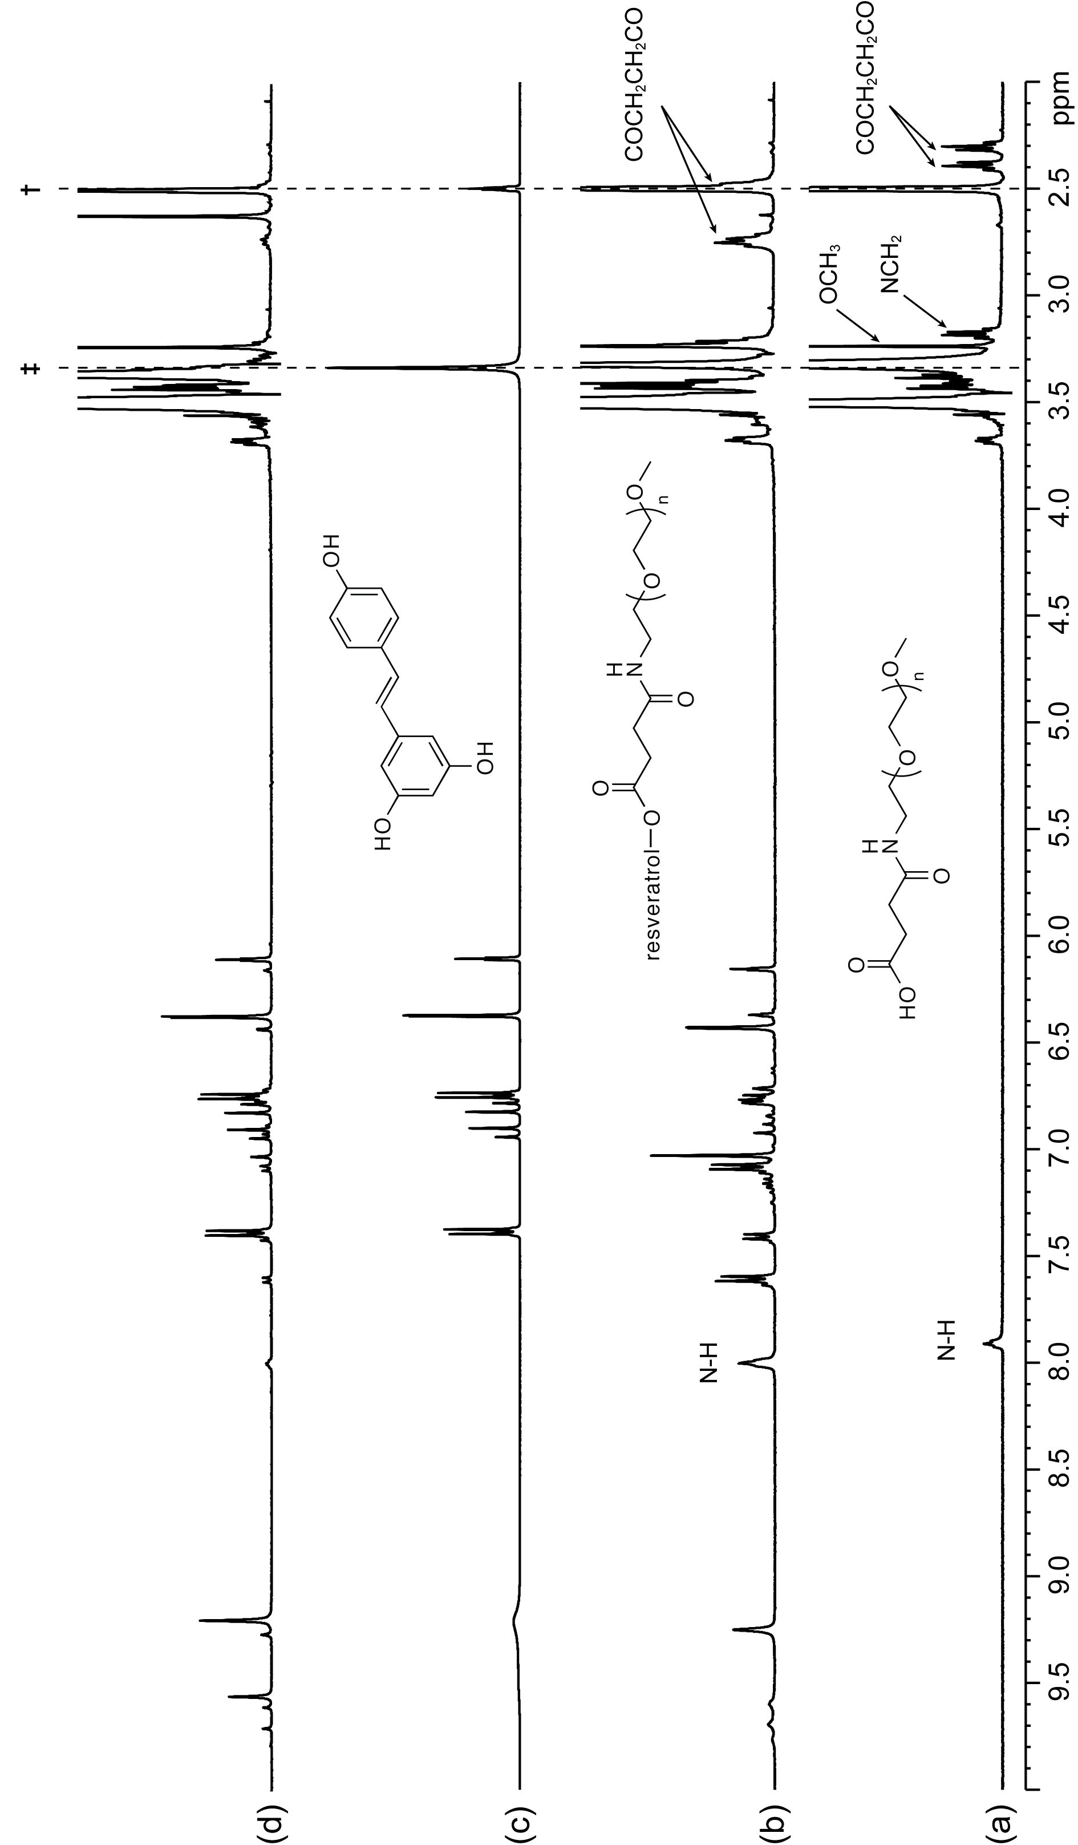
Figure A. ¹H NMR spectra (400 MHz) for: (a) MeO-PEGN-SuccOH; (b) the resveratrol-PEG conjugate mixture from the synthesis of MeO-PEGN-Succ-RSV; (c) resveratrol; and (d) the solution from (b) after treatment with water and heat (90 °C) for ca. 1 week). All solutions are in d₆-DMSO. Key: † = d₅-DMSO, ‡ = H₂O. To identify the low intensity down-field signals the spectra in (a), (b) and (d) have been expanded vertically.

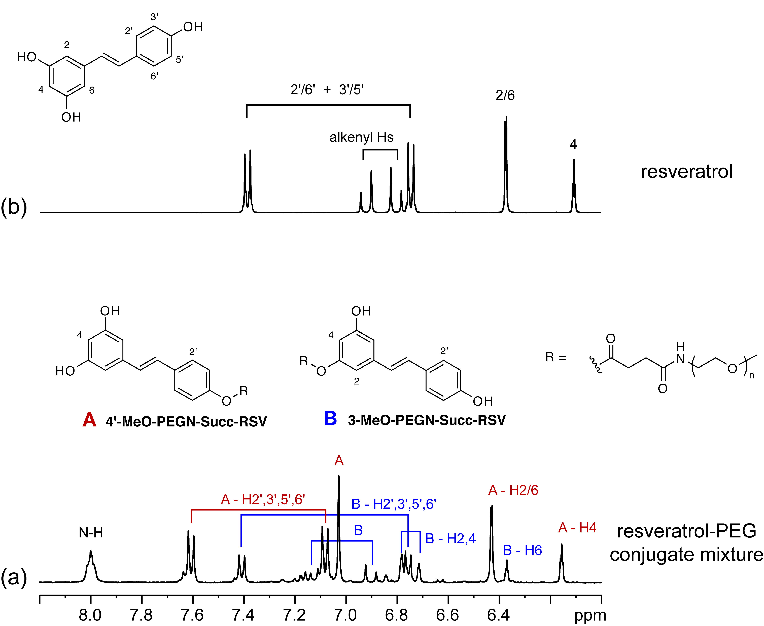
Figure B. The down field region of the ¹H NMR spectra (400 MHz) for: (a) a solution of the resveratrol-PEG conjugate mixture in d₆-DMSO showing the assigned signals for the two major products 4'-MeO-PEGN-Succ-RSV and 3-MeO-PEGN-Succ--RSV; and (b) a solution of resveratrol in d₆-DMSO.

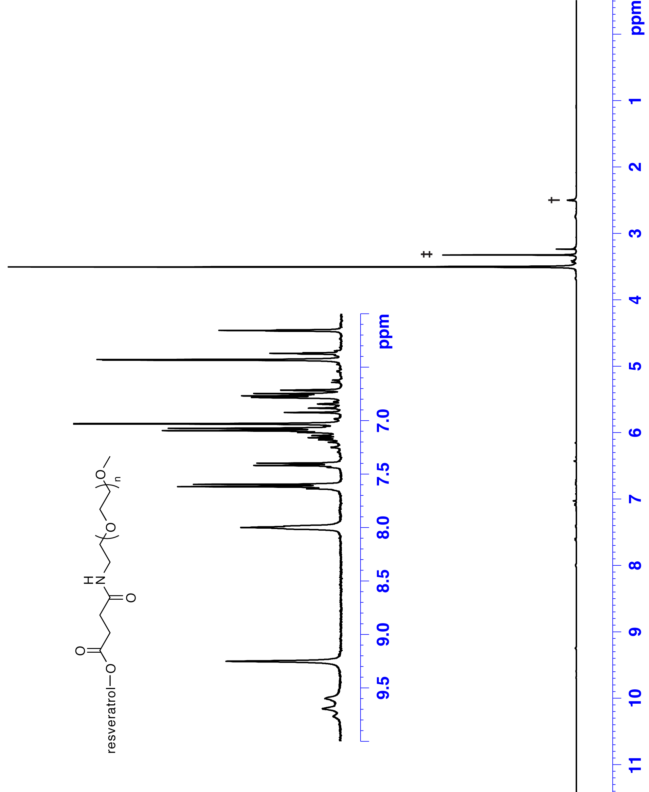

Figure C. ¹H NMR spectra for the MeO-PEGN-Succ-RSV conjugate mixture in d₆-DMSO, recorded at 400 MHz. Key: † = d₅-DMSO, ‡ = H₂O.

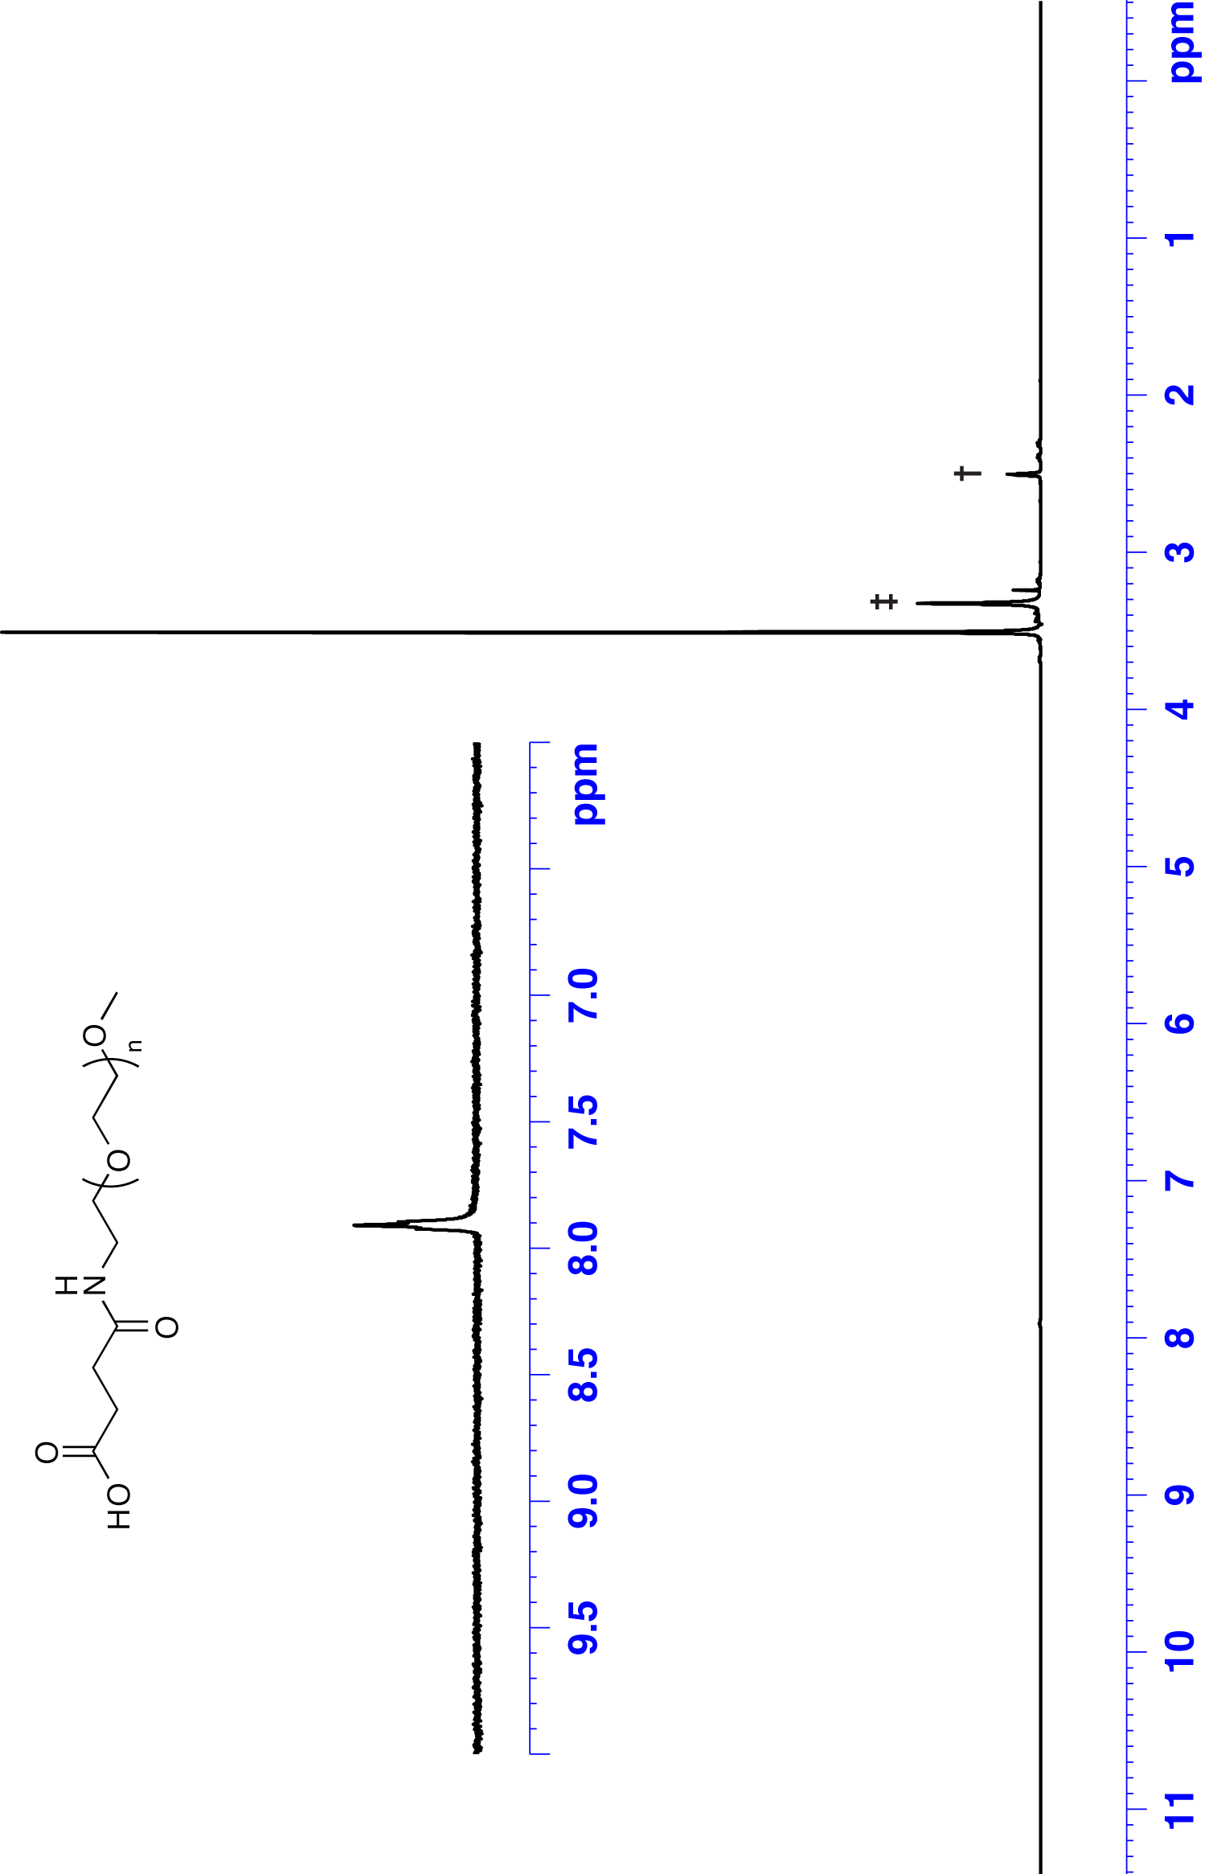

Figure D. ¹H NMR spectra for MeO-PEGN-Succ-OH in d₆-DMSO, recorded at 400 MHz. Key: † = d₅-DMSO, ‡ = H₂O.

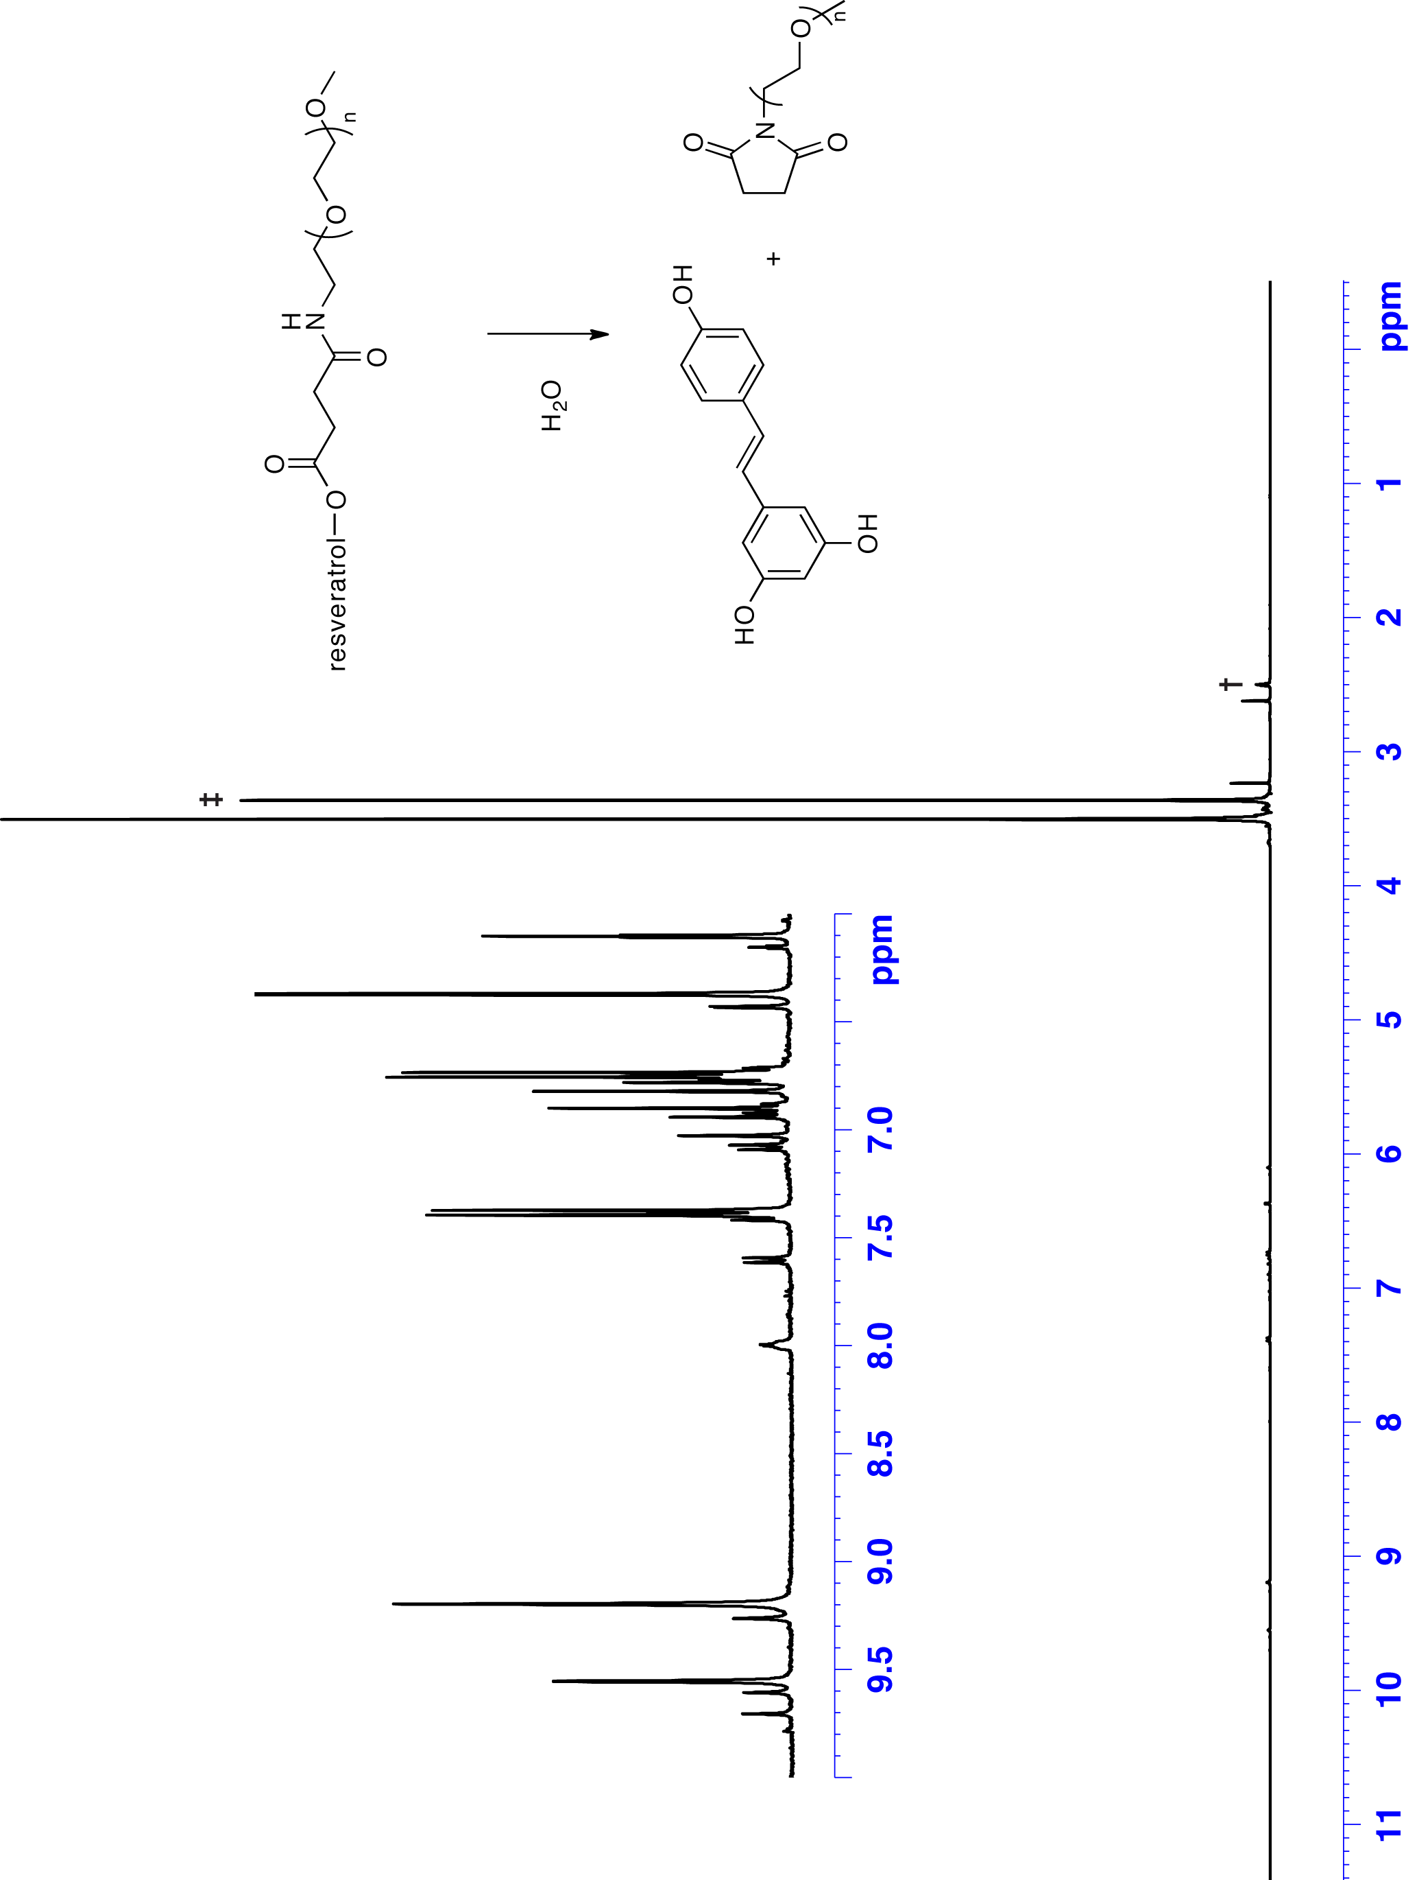
Figure E. ¹H NMR spectra of the MeO-PEGN-Succ-RSV conjugate mixture after treatment with water and heat (90 °C) for ca. 1 week, in d₆-DMSO, recorded at 400 MHz. Key: † = d₅-DMSO, ‡ = H₂O.

