S2 Appendix: Boxplot, mean and range for IPWs, before and after stabilisation (using MI data)
Boxplot of IPW before stabilisation (w) (mean = 1.0 [range 0.2 – 4.9])
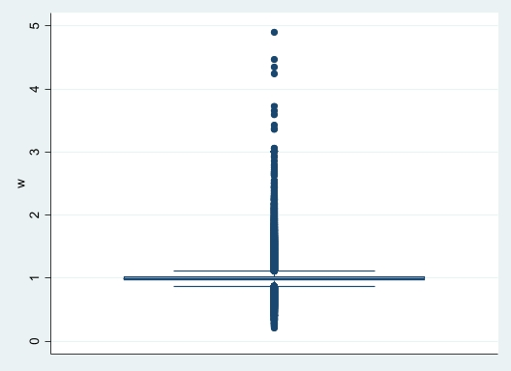
Boxplot of IPW before stabilisation (w99) (mean = 1.0 [range 0.7 – 1.4])
