Additional file 4
S2 Figure. Age-specific alcohol-attributable mortality rates in France (2010) and Finland (2013) for men and women, ages 25-79 (logarithmic scale)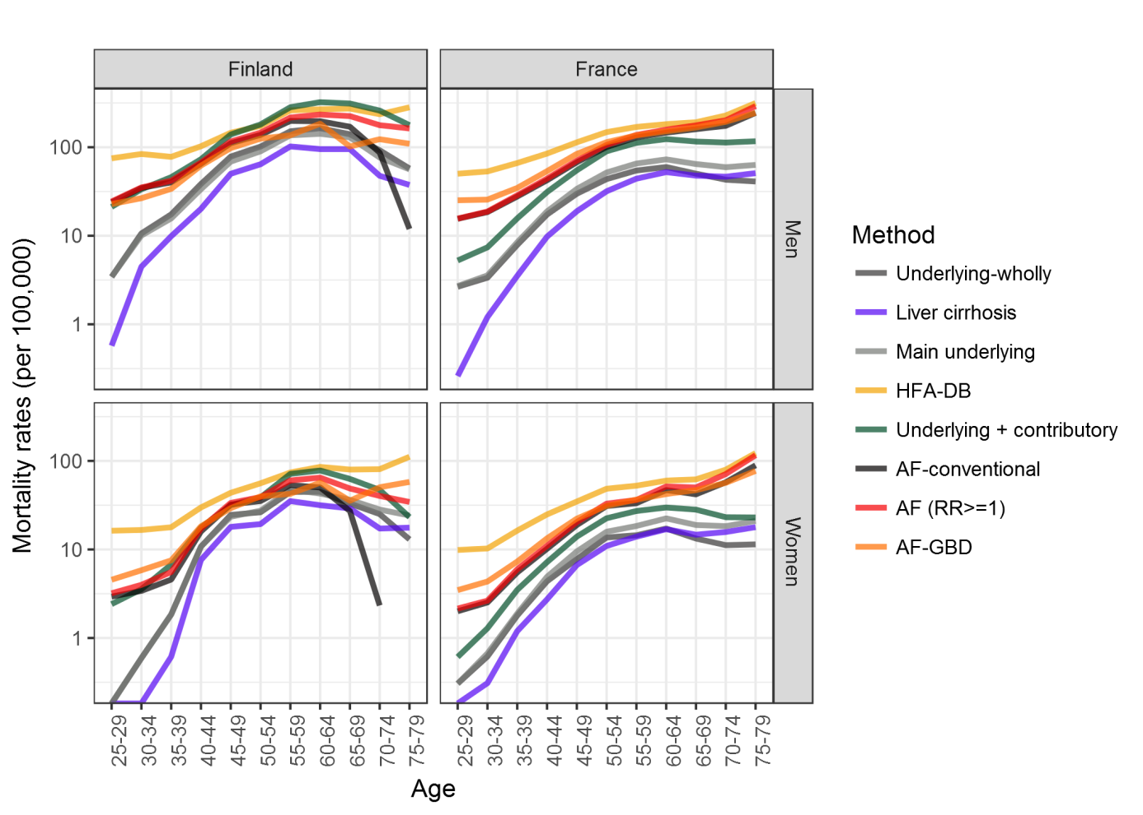
*AF method for Finnish women aged 75-79 is excluded from the plot for visualization reasons as the rate is negative (-35.4).

