S2 Fig
A) x-Octenal isomers
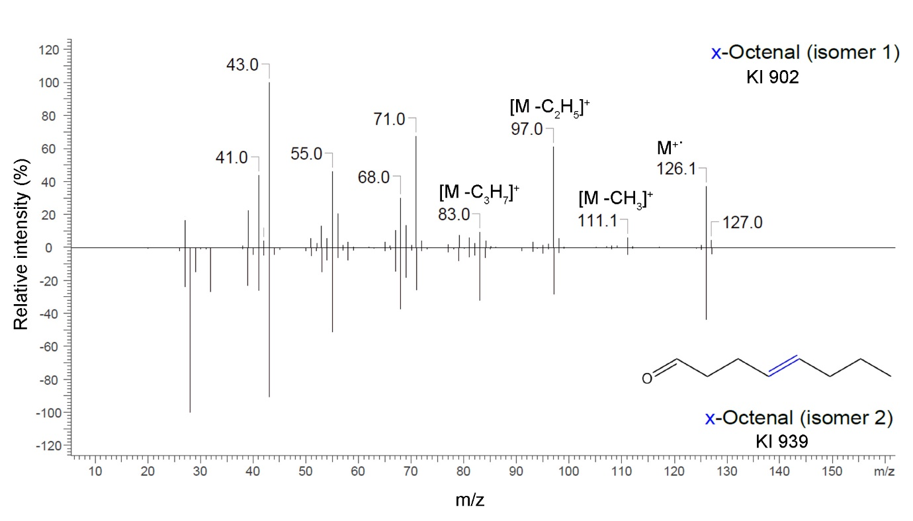
B) x-Octen-1-ol
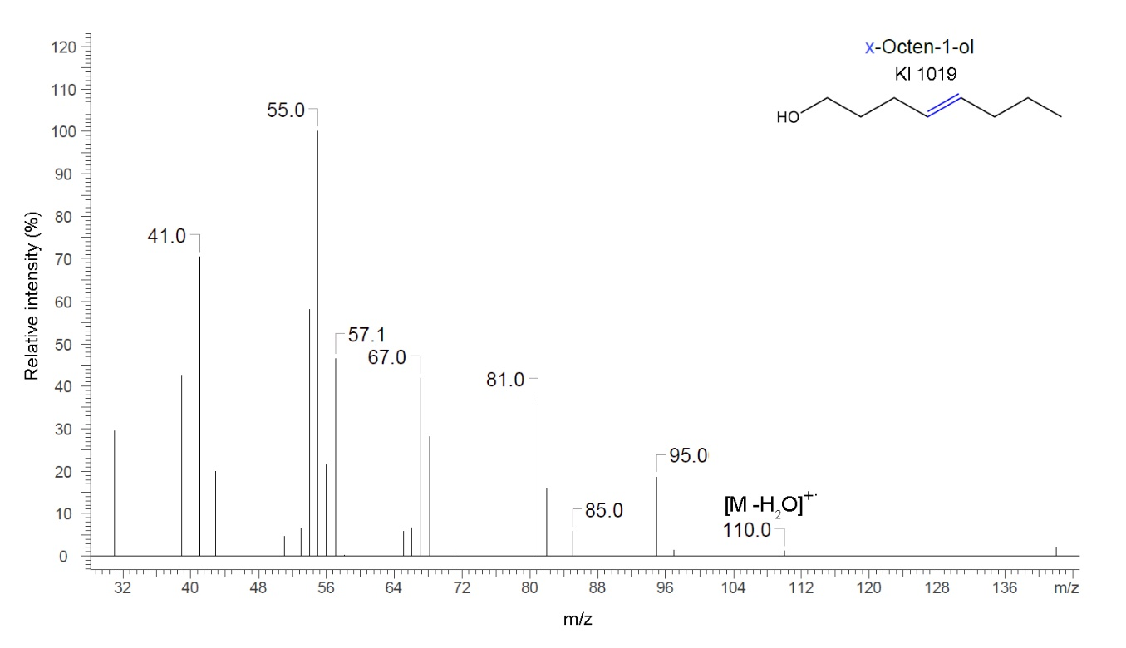

C) N-(n-Pentyl)propanamide
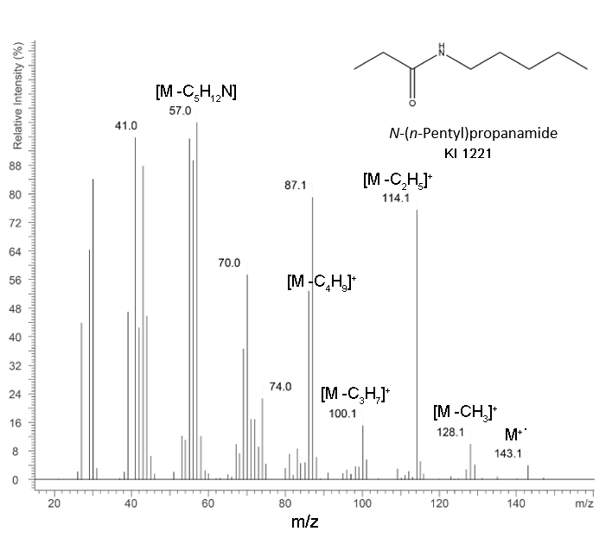
D) N-(n-Pentyl)butanamide
