PATHWAY RESULTS FROM INGENUITY PATHWAY ANALYSIS
Contents
OSTEOGENIC vs. ADIPOGENIC DIFFERENTIATION IN ASC 2
dd7 2
Overall statistic 2
α-adrenergic signaling 3
CCR5 signaling in Macrophages 4
Relaxin signaling 5
OSTEOGENIC vs. ADIPOGENIC DIFFERENTIATION IN ASC 6
dd21 6
Overall statistic 6
Actin cytoskeleton signaling 7
α adrenergic signaling 8
Axonal guidance signaling 9
CCR3 signaling in Eosinophil 10
CCR5 signaling in Macrophages 11
Chemokine signaling 12
Ephrin receptor signaling 13
Fatty acid biosynthesis 14
fMLP signaling in Neutrophils 15
Glutamate receptor signaling 16
LPS/IL-1 Mediated Inhibition of RXR Function 17
Regulation of Actin-based Motility by Rho 18
OSTEOGENIC vs. ADIPOGENIC DIFFERENTIATION IN BMSC 19
dd21 19
LPS/IL-1 Mediated Inhibition of RXR Function 19
BMSC vs. ASC DURING OSTEOGENIC DIFFERENTIATION 20
dd2 20
14-3-3 mediated signaling 20
dd21 21
Keratan sulfate biosynthesis 21
LPS/IL-1 Mediated Inhibition of RXR Function 22
Sulfur metabolism 23
NETWORK AMONG DEG 24
OSTEOGENIC vs. ADIPOGENIC DIFFERENTIATION IN ASC 24
dd2 24
dd7 25
dd21 26
OSTEOGENIC vs. ADIPOGENIC DIFFERENTIATION IN BMSC 27
dd2 27
dd7 28
dd21 29
BMSC vs. ASC DURING OSTEOGENIC DIFFERENTIATION 30
dd2 30
BMSC vs. ASC DURING ADIPOGENIC DIFFERENTIATION 31
dd2 31
dd7 32

OSTEOGENIC vs. ADIPOGENIC DIFFERENTIATION IN ASC

dd7

Overall statistic
Ingenuity Canonical Pathways | -Log(P-value) | -Log(B-H P-value) | Ratio
CCR5 Signaling in Macrophages | 4.29 | 2.21 | 0.0706
Α-Adrenergic Signaling | 3.79 | 2.02 | 0.0686
Relaxin Signaling | 3.54 | 1.94 | 0.0515
Cardiac Hypertrophy Signaling | 2.76 | 1.37 | 0.0364
IL-8 Signaling | 2.67 | 1.37 | 0.0391
Lysine Degradation | 2.36 | 1.14 | 0.0286
Glutamate Receptor Signaling | 2.28 | 1.14 | 0.0476
Cardiac β-adrenergic Signaling | 2.27 | 1.14 | 0.0394
CXCR4 Signaling | 2.18 | 1.12 | 0.0373
CCR3 Signaling in Eosinophils | 2.11 | 1.12 | 0.0435
fMLP Signaling in Neutrophils | 2.09 | 1.12 | 0.0400
Melatonin Signaling | 2.09 | 1.12 | 0.0526
G-Protein Coupled Receptor Signaling | 2.03 | 1.12 | 0.0294
Nitric Oxide Signaling in the Cardiovascular System | 2.03 | 1.12 | 0.0476
cAMP-mediated Signaling | 1.88 | 1.00 | 0.0325
LPS/IL-1 Mediated Inhibition of RXR Function | 1.83 | 0.99 | 0.0266
Cellular Effects of Sildenafil (Viagra) | 1.73 | 0.92 | 0.0308
CDK5 Signaling | 1.71 | 0.92 | 0.0455
Role of NFAT in Regulation of the Immune Response | 1.57 | 0.80 | 0.0272
Sonic Hedgehog Signaling | 1.55 | 0.80 | 0.069
PXR/RXR Activation | 1.54 | 0.80 | 0.0357
PPARÎ±/RXRÎ± Activation | 1.41 | 0.70 | 0.0276
Pyrimidine Metabolism | 1.40 | 0.70 | 0.0177
Thrombin Signaling | 1.34 | 0.69 | 0.0259
Xenobiotic Metabolism Signaling | 1.34 | 0.69 | 0.0206
Ephrin Receptor Signaling | 1.33 | 0.69 | 0.0270

OSTEOGENIC vs. ADIPOGENIC DIFFERENTIATION IN ASC
dd7
Red and green shade in objects denote higher expression in adipogenic and osteogenic, respectively

α-adrenergic signaling
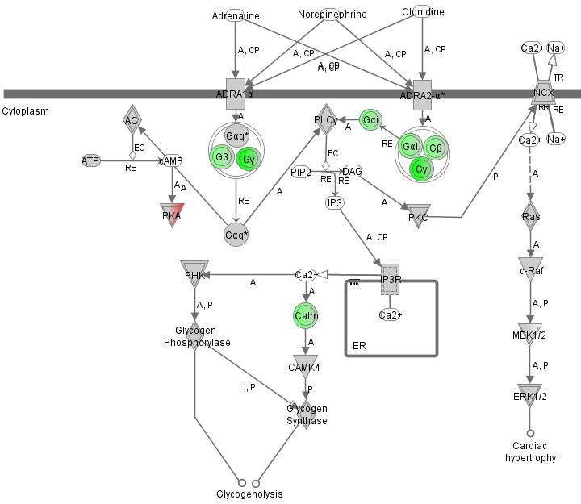

OSTEOGENIC vs. ADIPOGENIC DIFFERENTIATION IN ASC
dd7
Red and green shade in objects denote higher expression in adipogenic and osteogenic, respectively

CCR5 signaling in Macrophages
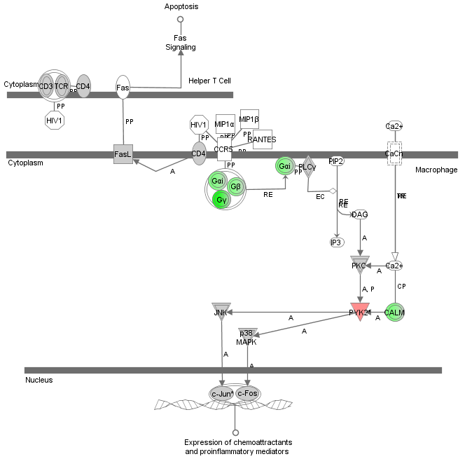

OSTEOGENIC vs. ADIPOGENIC DIFFERENTIATION IN ASC
dd7
Red and green shade in objects denote higher expression in adipogenic and osteogenic, respectively

Relaxin signaling
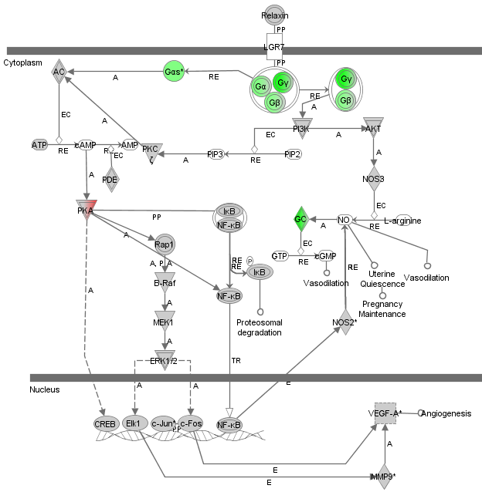

OSTEOGENIC vs. ADIPOGENIC DIFFERENTIATION IN ASC

dd21

Overall statistic
Pathways | -Log(P-value) | -Log(B-H P-value) | Ratio
CCR3 Signaling in Eosinophils | 4.41 | 2.23 | 0.09
Chemokine Signaling | 4.04 | 2.16 | 0.11
LPS/IL-1 Mediated Inhibition of RXR Function | 3.84 | 2.14 | 0.05
Regulation of Actin-based Motility by Rho | 3.59 | 2.07 | 0.09
Glutamate Receptor Signaling | 3.55 | 2.07 | 0.08
CCR5 Signaling in Macrophages | 3.08 | 1.72 | 0.07
Actin Cytoskeleton Signaling | 3.05 | 1.72 | 0.05
fMLP Signaling in Neutrophils | 2.96 | 1.68 | 0.06
Ephrin Receptor Signaling | 2.79 | 1.61 | 0.05
Axonal Guidance Signaling | 2.68 | 1.56 | 0.04
Fatty Acid Biosynthesis | 2.66 | 1.56 | 0.06
α-Adrenergic Signaling | 2.49 | 1.42 | 0.07
Role of NFAT in Regulation of the Immune Response | 2.15 | 1.14 | 0.04
NRF2-mediated Oxidative Stress Response | 2.06 | 1.09 | 0.04
Melatonin Signaling | 1.98 | 1.06 | 0.07
IL-8 Signaling | 1.98 | 1.06 | 0.04
Thrombin Signaling | 1.79 | 0.89 | 0.04
Glycerophospholipid Metabolism | 1.71 | 0.83 | 0.03
CXCR4 Signaling | 1.66 | 0.81 | 0.04
Semaphorin Signaling in Neurons | 1.60 | 0.79 | 0.08
Valine, Leucine and Isoleucine Degradation | 1.60 | 0.79 | 0.04
Tight Junction Signaling | 1.58 | 0.79 | 0.04
Virus Entry via Endocytic Pathways | 1.57 | 0.79 | 0.05
LXR/RXR Activation | 1.53 | 0.77 | 0.05
Cardiac β-adrenergic Signaling | 1.40 | 0.65 | 0.04
Aryl Hydrocarbon Receptor Signaling | 1.33 | 0.59 | 0.04

OSTEOGENIC vs. ADIPOGENIC DIFFERENTIATION IN ASC
dd21
Red and green shade in objects denote higher expression in adipogenic and osteogenic, respectively

Actin cytoskeleton signaling
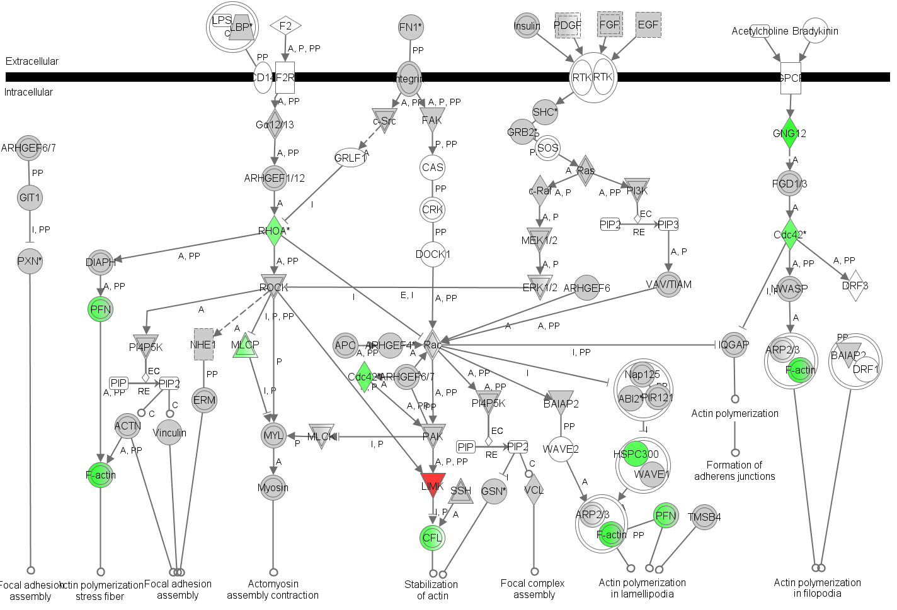

OSTEOGENIC vs. ADIPOGENIC DIFFERENTIATION IN ASC
dd21
Red and green shade in objects denote higher expression in adipogenic and osteogenic, respectively

α adrenergic signaling
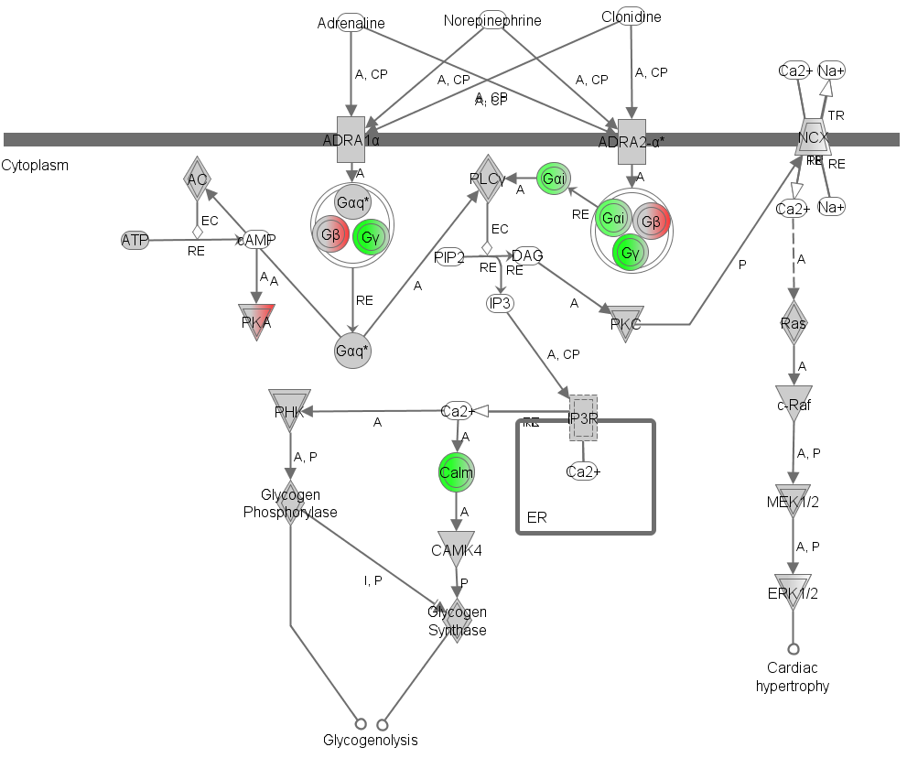

OSTEOGENIC vs. ADIPOGENIC DIFFERENTIATION IN ASC
dd21
Red and green shade in objects denote higher expression in adipogenic and osteogenic, respectively

Axonal guidance signaling

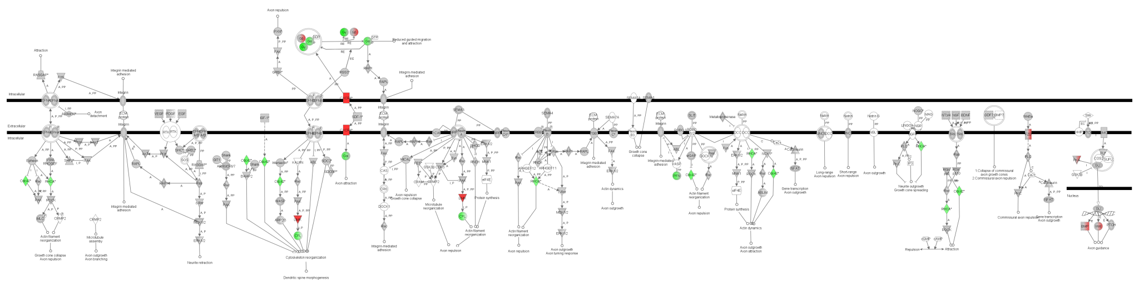
OSTEOGENIC vs. ADIPOGENIC DIFFERENTIATION IN ASC
dd21
Red and green shade in objects denote higher expression in adipogenic and osteogenic, respectively

CCR3 signaling in Eosinophil
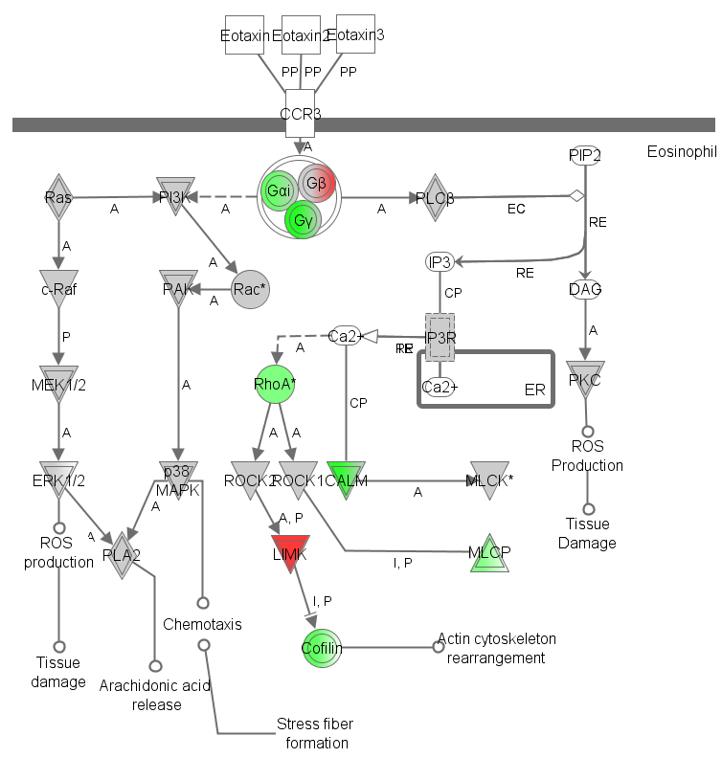

OSTEOGENIC vs. ADIPOGENIC DIFFERENTIATION IN ASC
dd21
Red and green shade in objects denote higher expression in adipogenic and osteogenic, respectively

CCR5 signaling in Macrophages
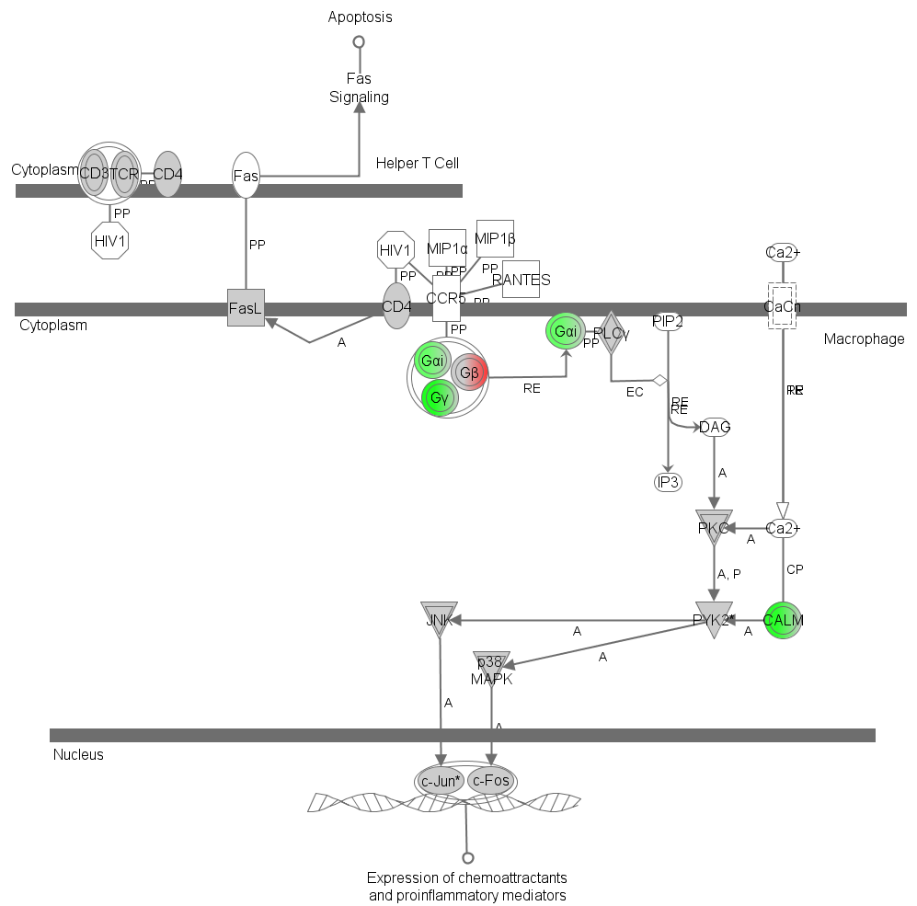

OSTEOGENIC vs. ADIPOGENIC DIFFERENTIATION IN ASC
dd21
Red and green shade in objects denote higher expression in adipogenic and osteogenic, respectively

Chemokine signaling
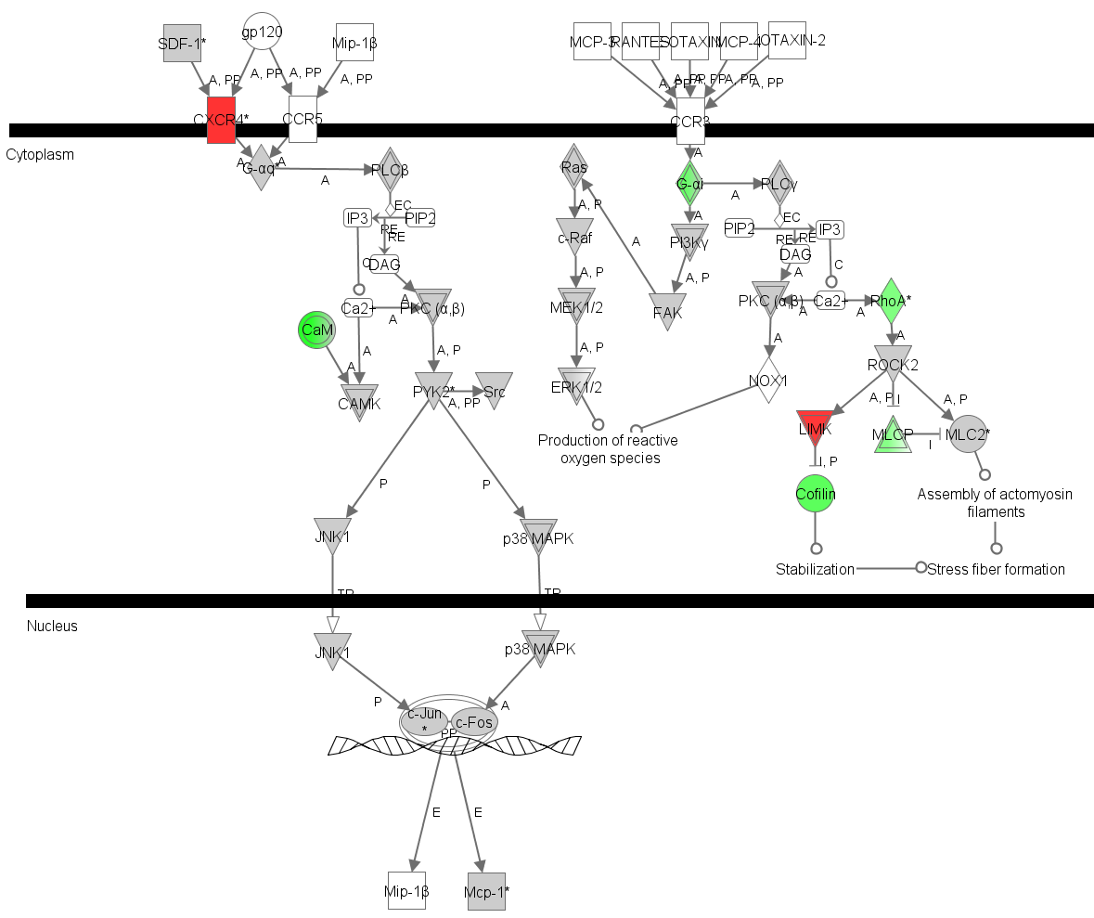

OSTEOGENIC vs. ADIPOGENIC DIFFERENTIATION IN ASC
dd21
Red and green shade in objects denote higher expression in adipogenic and osteogenic, respectively

Ephrin receptor signaling
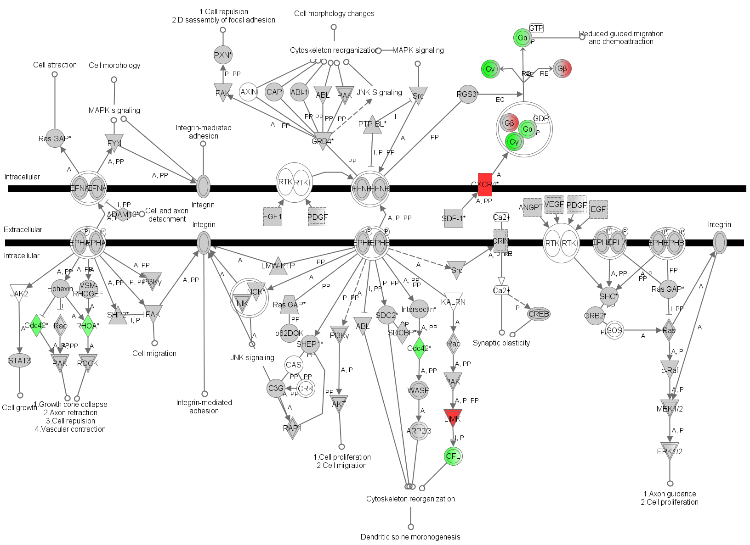

OSTEOGENIC vs. ADIPOGENIC DIFFERENTIATION IN ASC
dd21
Red and green shade in objects denote higher expression in adipogenic and osteogenic, respectively

Fatty acid biosynthesis
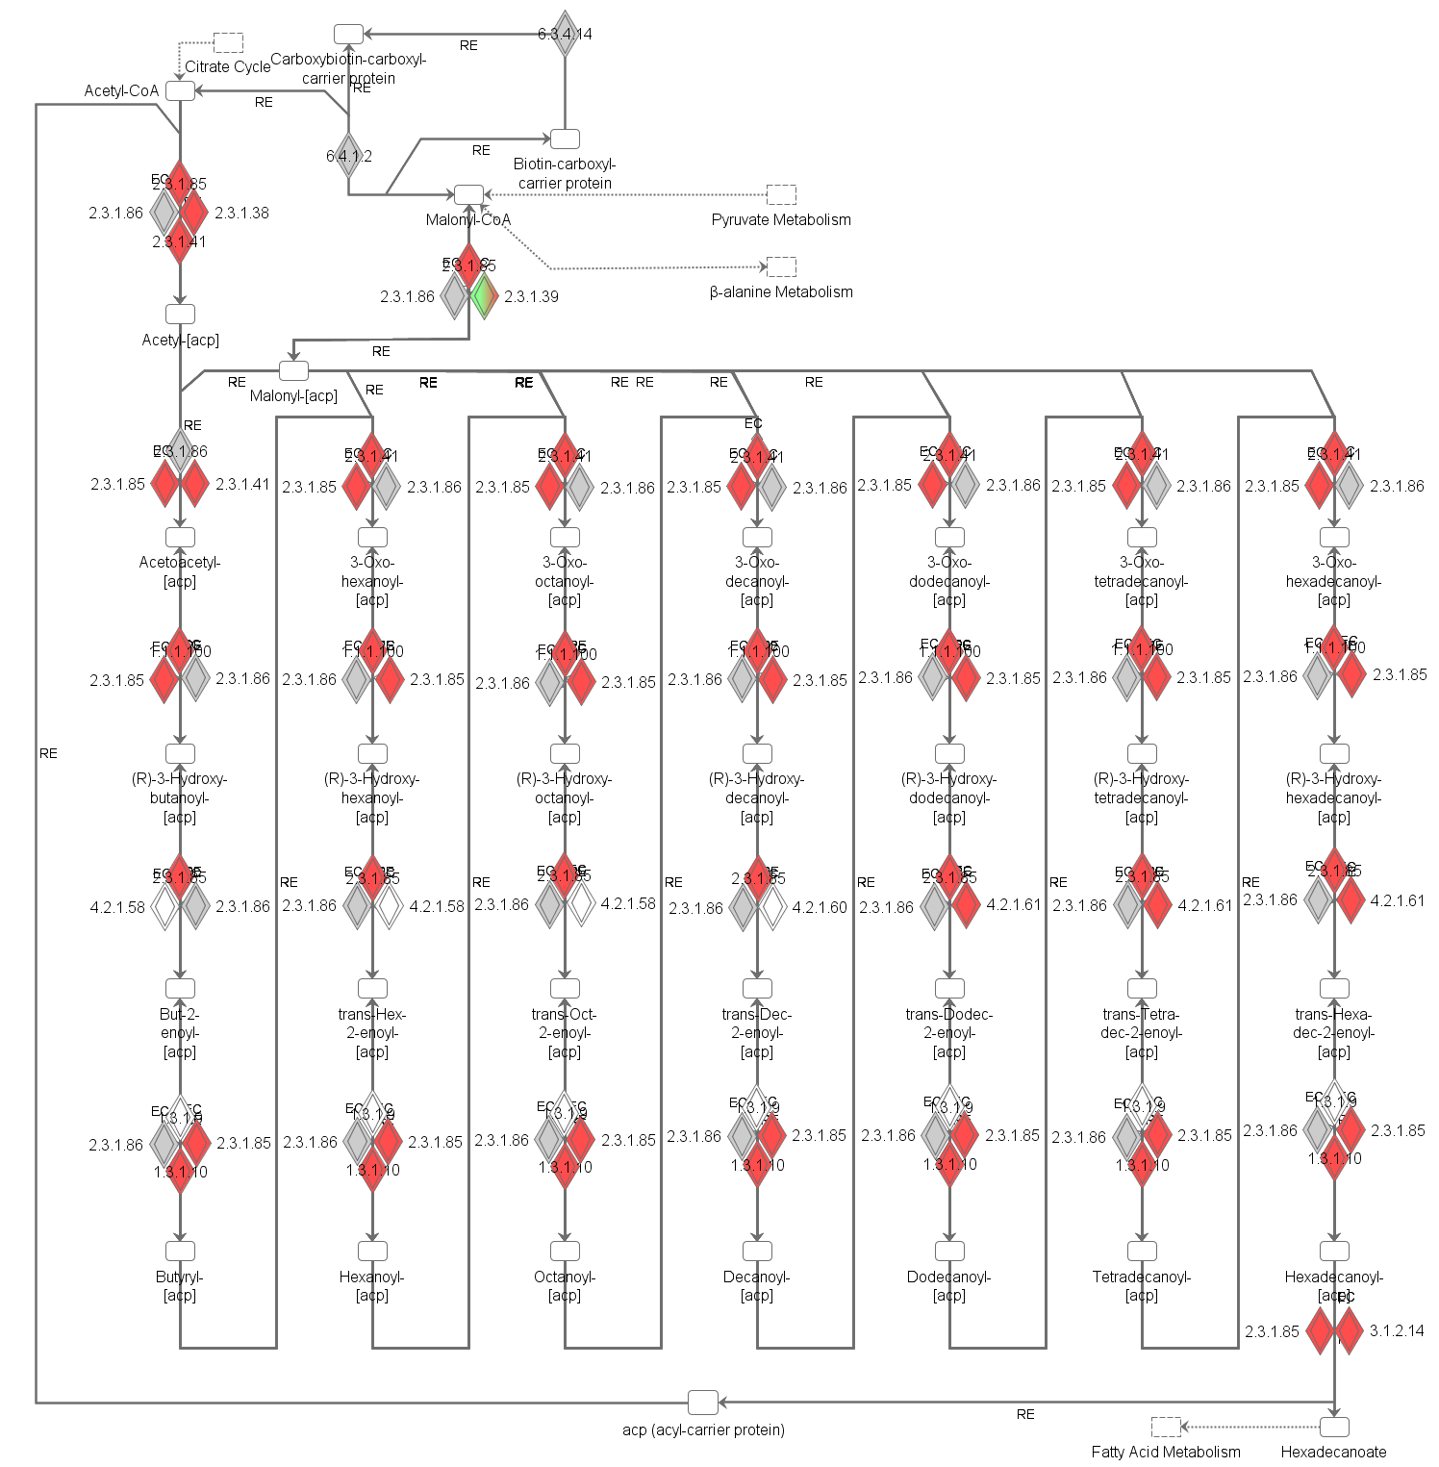

OSTEOGENIC vs. ADIPOGENIC DIFFERENTIATION IN ASC
dd21
Red and green shade in objects denote higher expression in adipogenic and osteogenic, respectively

fMLP signaling in Neutrophils
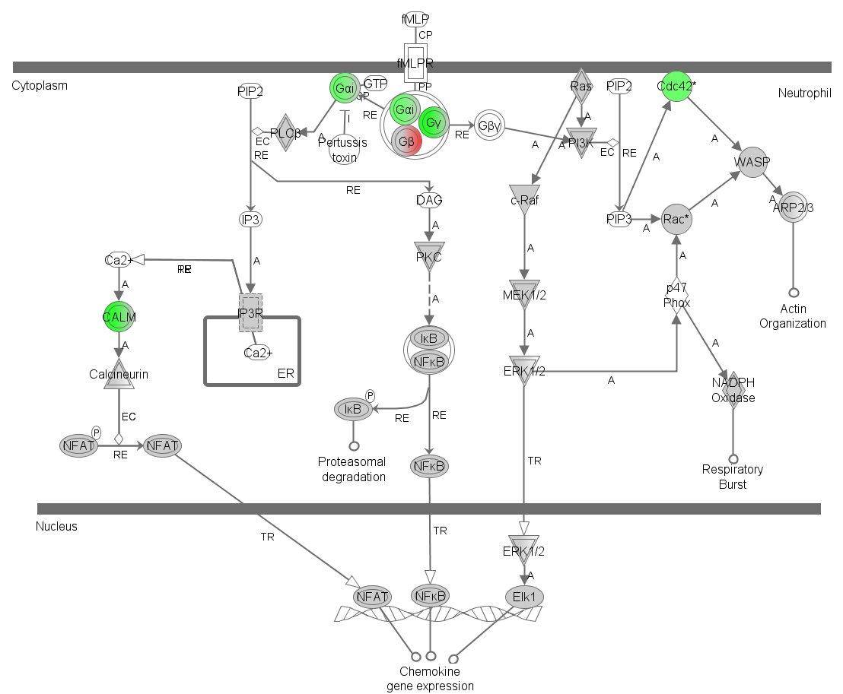

OSTEOGENIC vs. ADIPOGENIC DIFFERENTIATION IN ASC
dd21
Red and green shade in objects denote higher expression in adipogenic and osteogenic, respectively

Glutamate receptor signaling
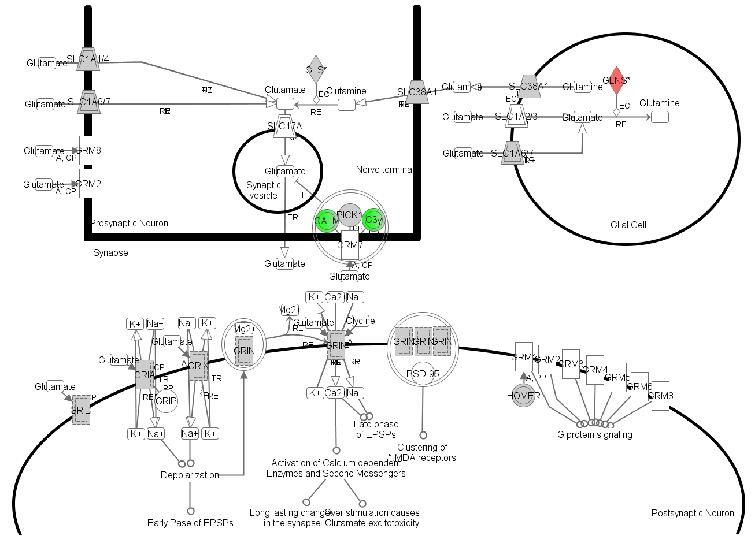

OSTEOGENIC vs. ADIPOGENIC DIFFERENTIATION IN ASC
dd21
Red and green shade in objects denote higher expression in adipogenic and osteogenic, respectively

LPS/IL-1 Mediated Inhibition of RXR Function
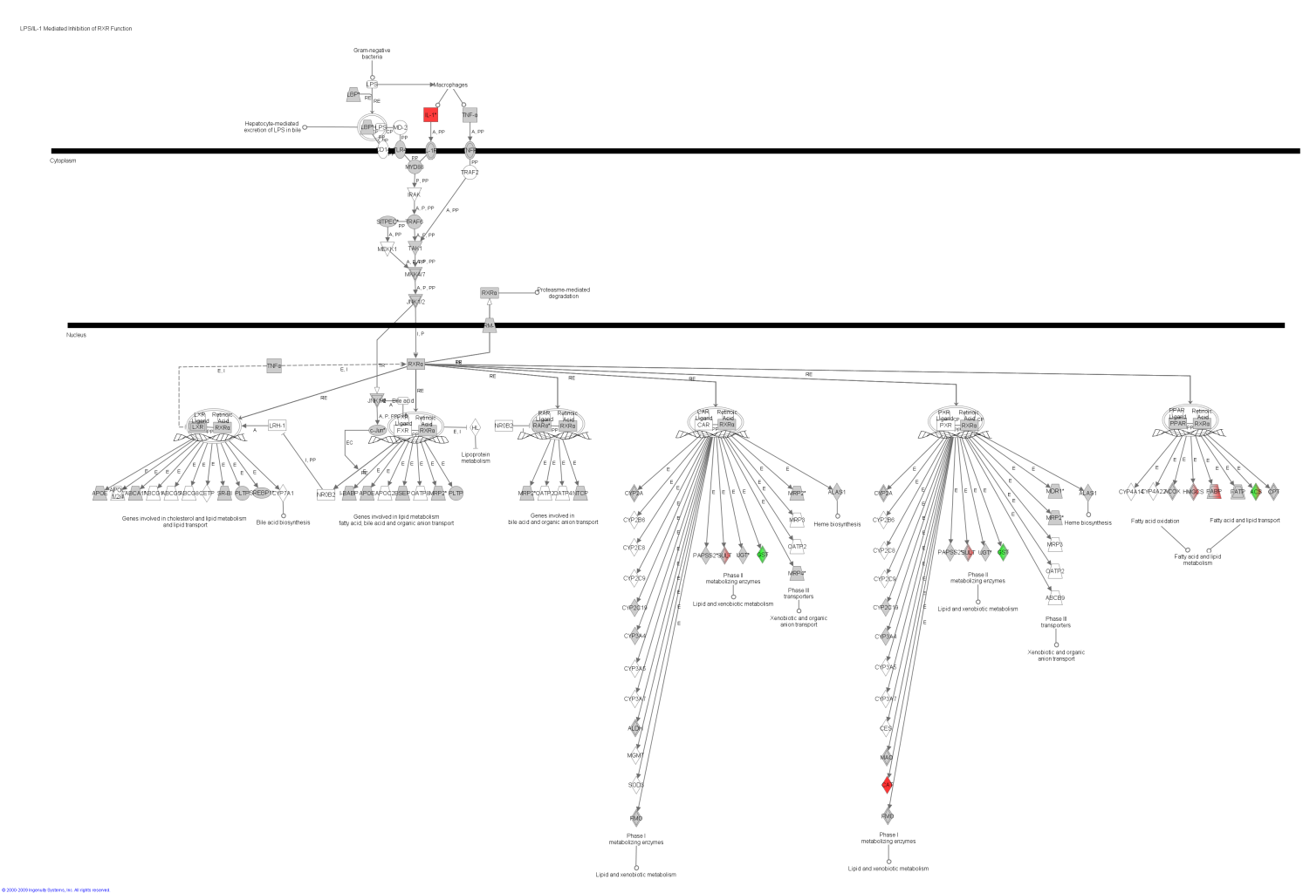

OSTEOGENIC vs. ADIPOGENIC DIFFERENTIATION IN ASC
dd21
Red and green shade in objects denote higher expression in adipogenic and osteogenic, respectively

Regulation of Actin-based Motility by Rho
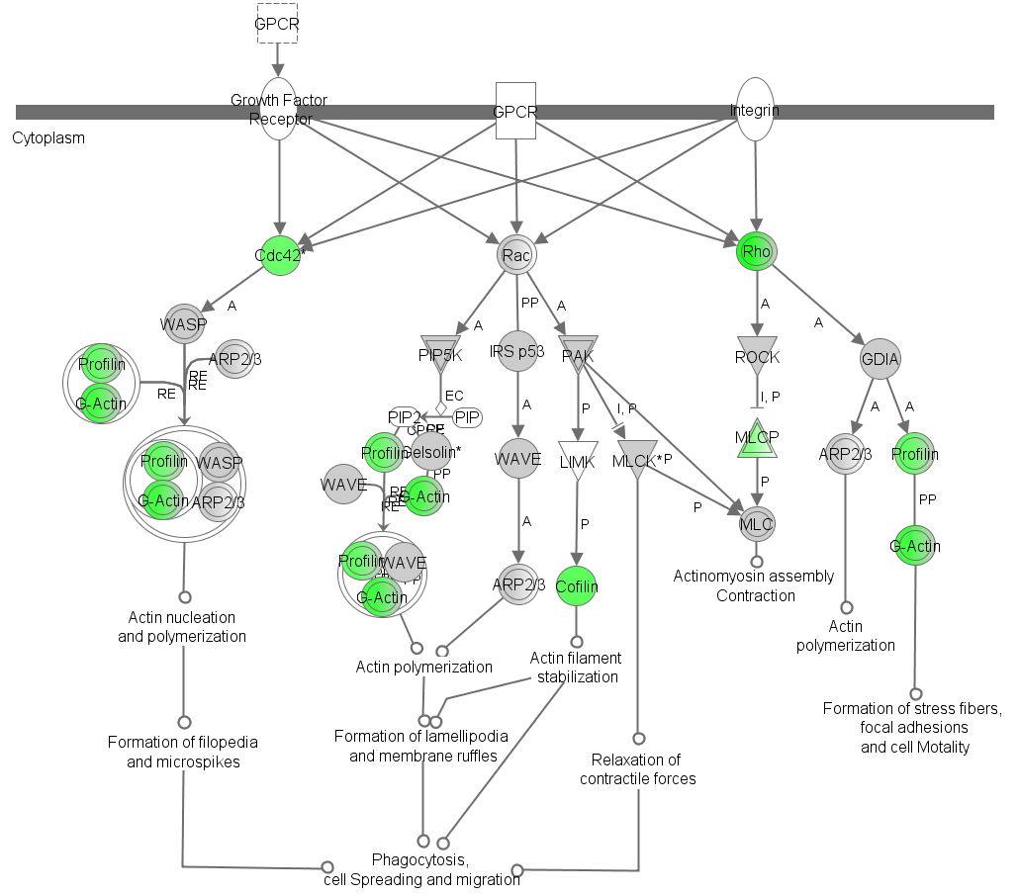

OSTEOGENIC vs. ADIPOGENIC DIFFERENTIATION IN BMSC

dd21
Red and green shade in objects denote higher expression in adipogenic and osteogenic, respectively

LPS/IL-1 Mediated Inhibition of RXR Function
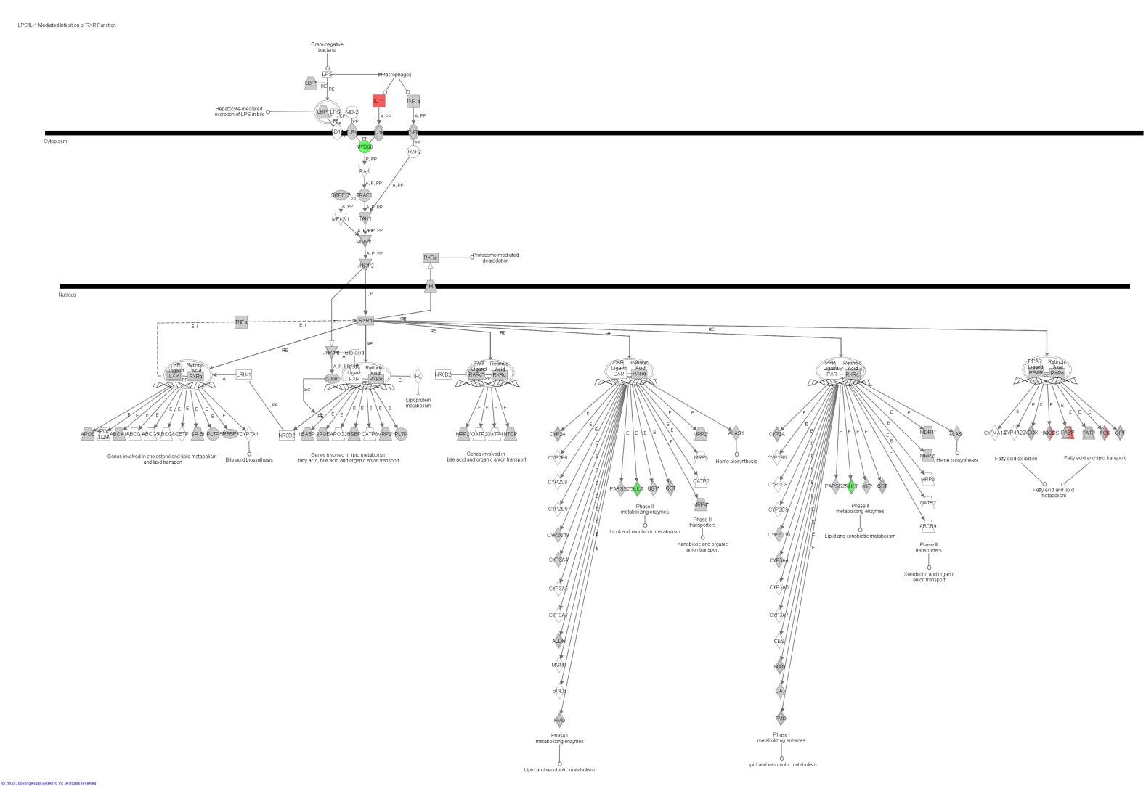

BMSC vs. ASC DURING OSTEOGENIC DIFFERENTIATION

dd2
Red and green shade in objects denote higher expression in BMSC and ASC, respectively

14-3-3 mediated signaling
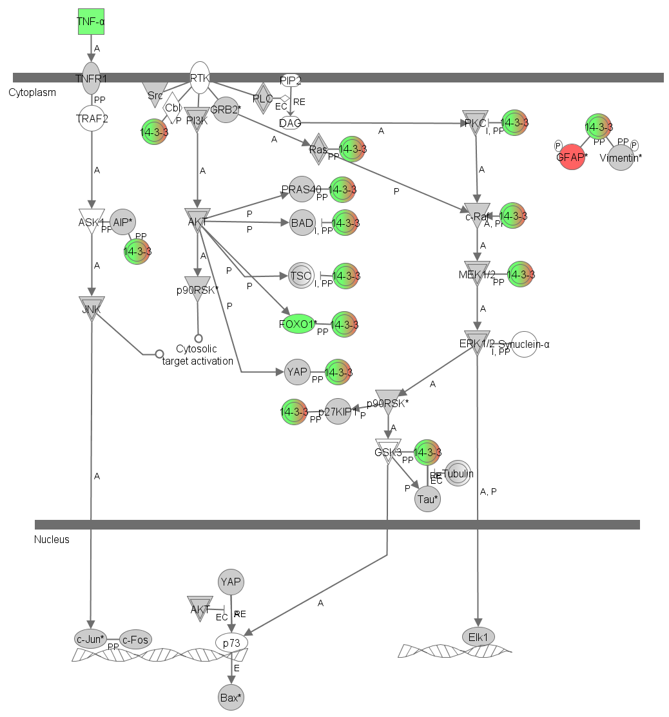
BMSC vs. ASC DURING ADIPOGENIC DIFFERENTIATION

dd21
Red and green shade in objects denote higher expression in BMSC and ASC, respectively

Keratan sulfate biosynthesis
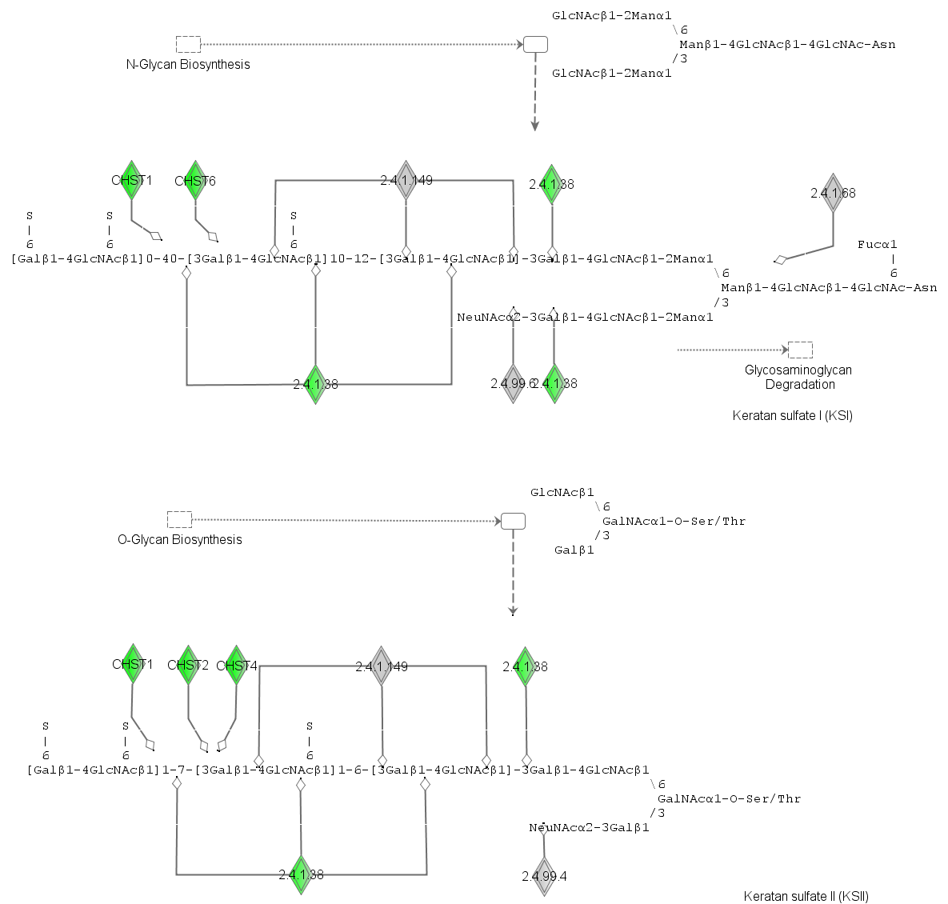

BMSC vs. ASC DURING ADIPOGENIC DIFFERENTIATION
dd21
Red and green shade in objects denote higher expression in BMSC and ASC, respectively

LPS/IL-1 Mediated Inhibition of RXR Function
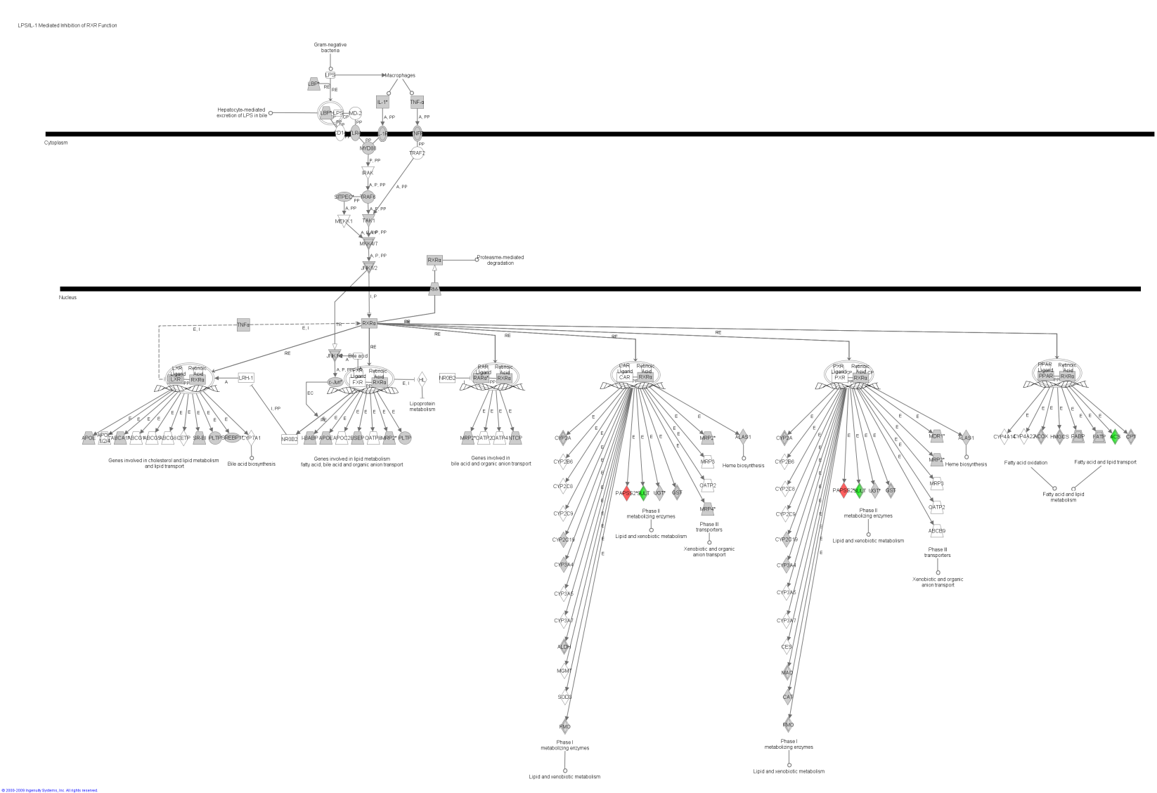

BMSC vs. ASC DURING ADIPOGENIC DIFFERENTIATION
dd21
Red and green shade in objects denote higher expression in BMSC and ASC, respectively

Sulfur metabolism
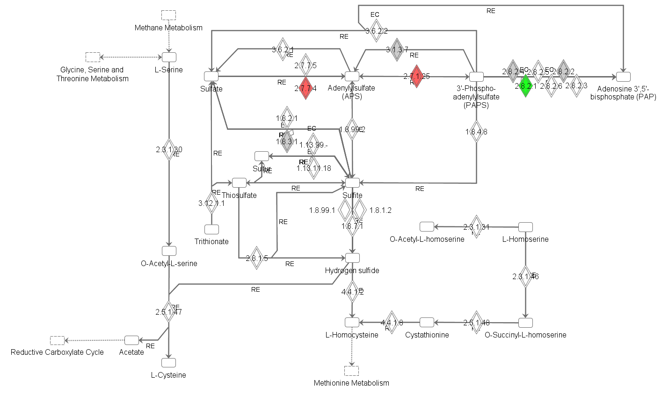

NETWORK AMONG DEG
(from ingenuity pathway analysis)

OSTEOGENIC vs. ADIPOGENIC DIFFERENTIATION IN ASC

dd2
Red and green shade in objects denote higher expression in adipogenic and osteogenic, respectively
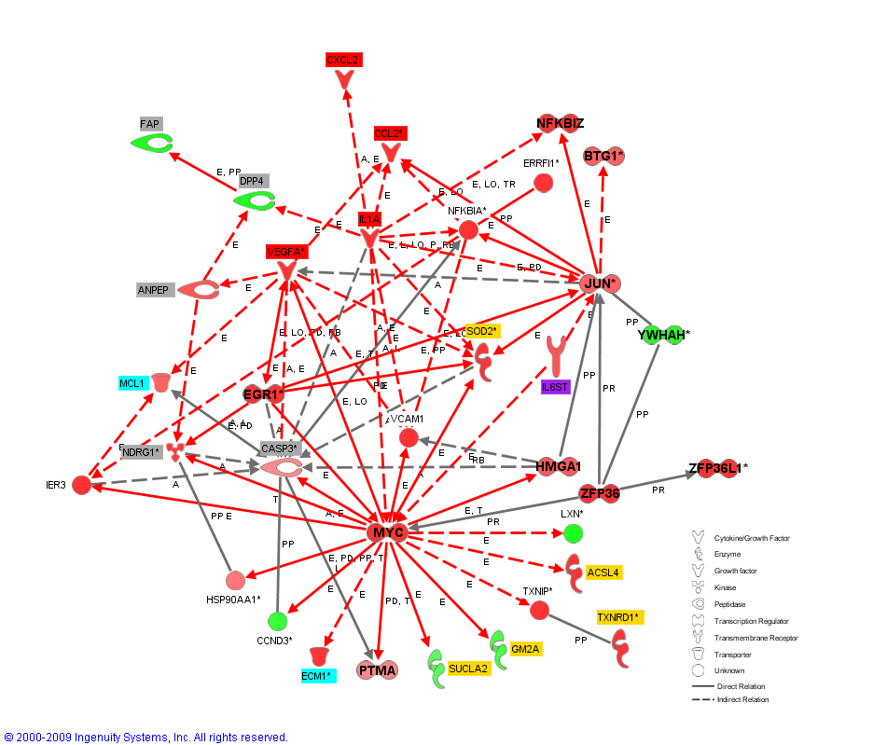

OSTEOGENIC vs. ADIPOGENIC DIFFERENTIATION IN ASC

dd7
Red and green shade in objects denote higher expression in adipogenic and osteogenic, respectively

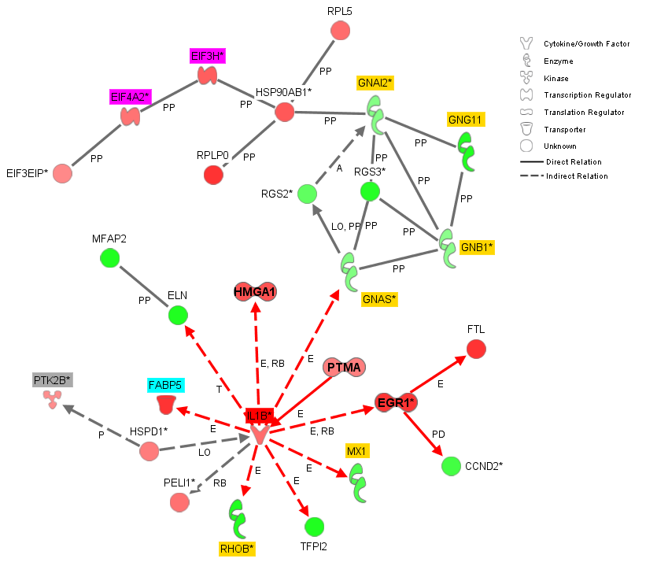

OSTEOGENIC vs. ADIPOGENIC DIFFERENTIATION IN ASC

dd21
Red and green shade in objects denote higher expression in adipogenic and osteogenic, respectively
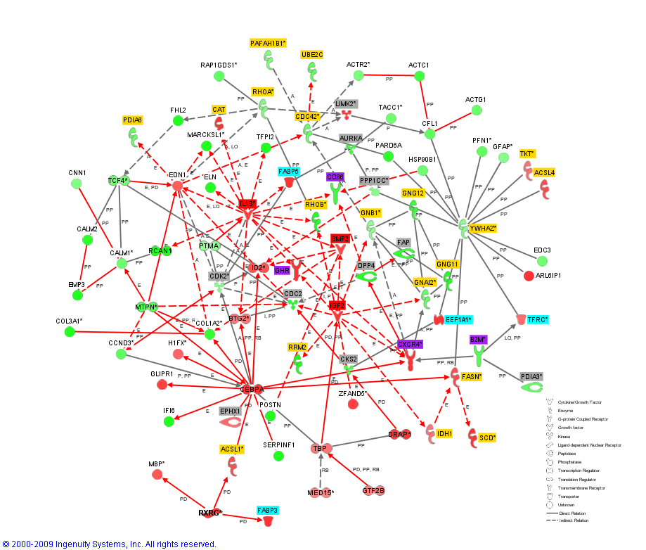

OSTEOGENIC vs. ADIPOGENIC DIFFERENTIATION IN BMSC

dd2
Red and green shade in objects denote higher expression in adipogenic and osteogenic, respectively
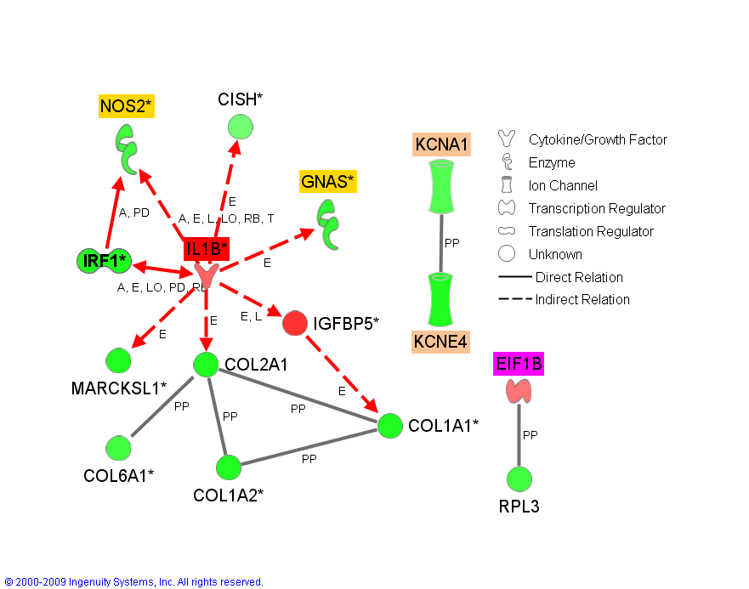

OSTEOGENIC vs. ADIPOGENIC DIFFERENTIATION IN BMSC

dd7
Red and green shade in objects denote higher expression in adipogenic and osteogenic, respectively
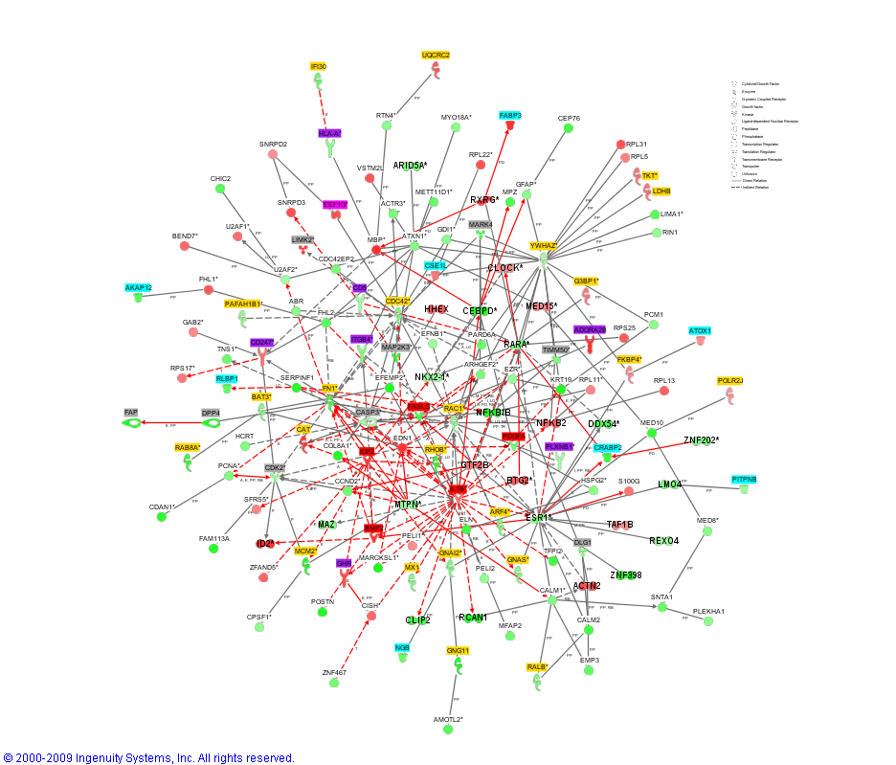

OSTEOGENIC vs. ADIPOGENIC DIFFERENTIATION IN BMSC

dd21
Red and green shade in objects denote higher expression in adipogenic and osteogenic, respectively
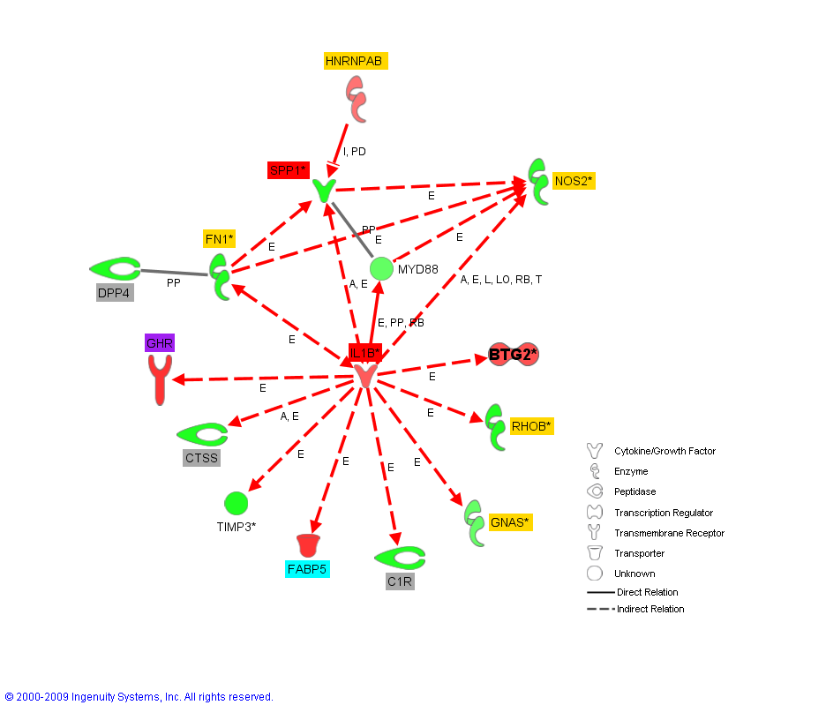

BMSC vs. ASC DURING OSTEOGENIC DIFFERENTIATION

dd2
Red and green shade in objects denote higher expression in BMSC and ASC, respectively
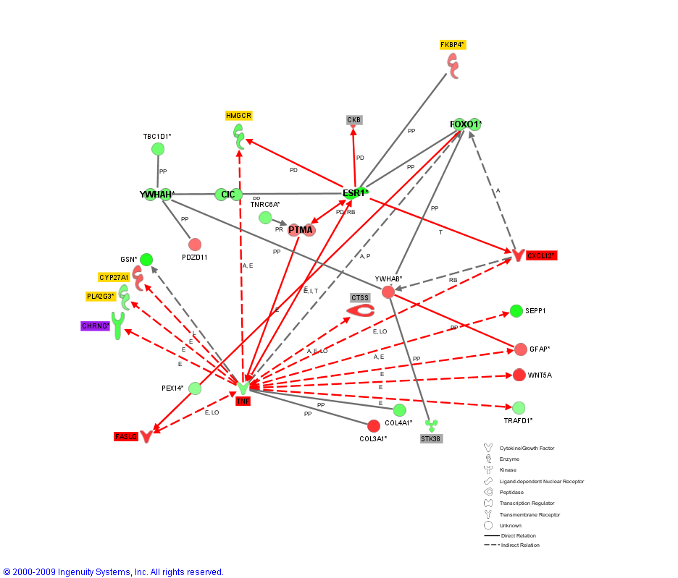

BMSC vs. ASC DURING ADIPOGENIC DIFFERENTIATION

dd2
Red and green shade in objects denote higher expression in BMSC and ASC, respectively
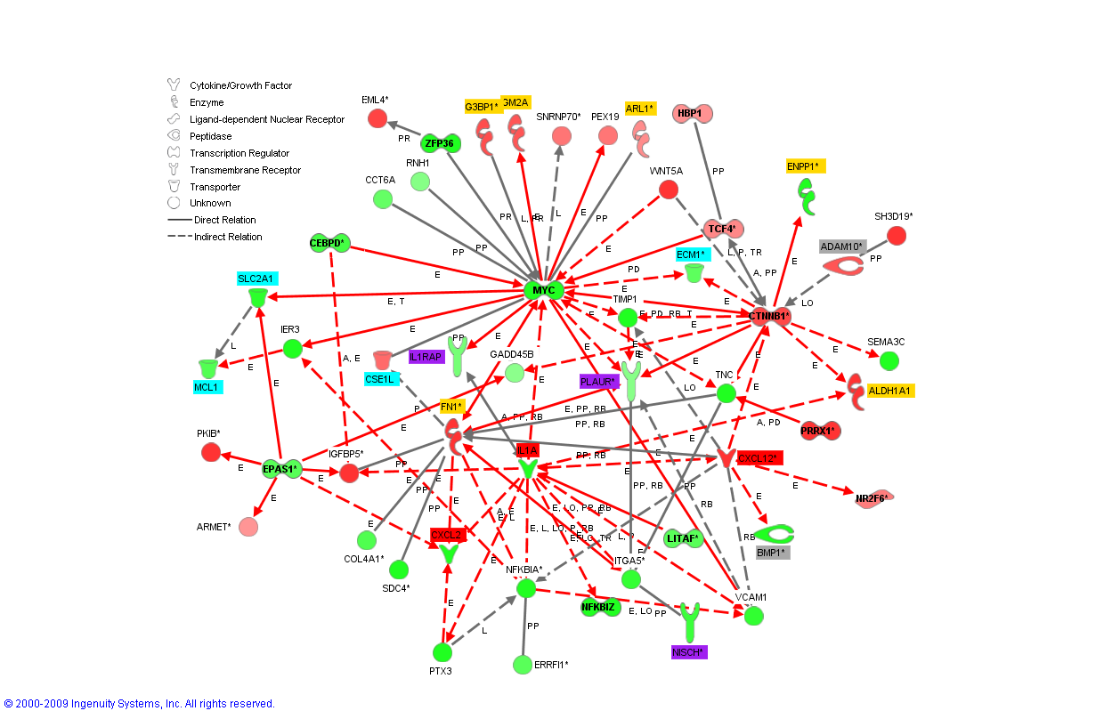

BMSC vs. ASC DURING ADIPOGENIC DIFFERENTIATION

dd7
Red and green shade in objects denote higher expression in BMSC and ASC, respectively

