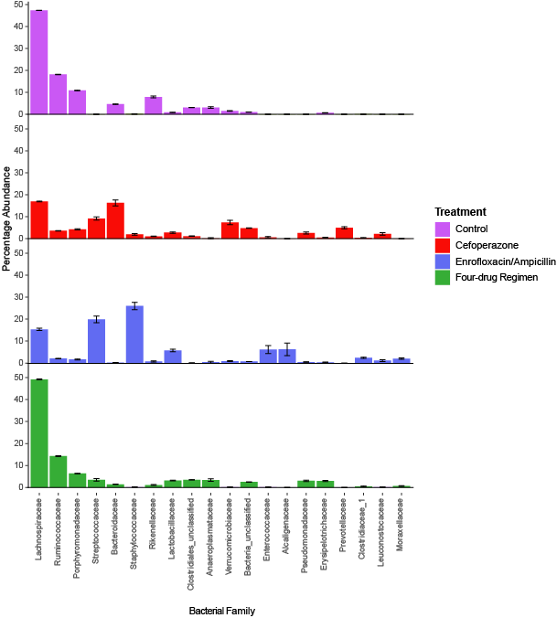
Supplemental Figure 2: Effects of oral antibiotic regimens on bacterial family composition in the mouse cecum. Mice were administered enteral antibiotics via distilled drinking water (cefoperazone, enrofloxacin/ampicillin, or the four-drug regimen); control mice were administered distilled drinking water alone. Mice were provided ad libitum access to food and water and harvested on day 8. n=30 for control, n=10 for antibiotic treatments. Error bars denote SEM.

