The ARRIVE Guidelines Checklist
Animal Research: Reporting In Vivo Experiments
Carol Kilkenny¹, William J Browne², Innes C Cuthill³, Michael Emerson⁴ and Douglas G Altman⁵
¹The National Centre for the Replacement, Refinement and Reduction of Animals in Research, London, UK, ²School of Veterinary Science, University of Bristol, Bristol, UK, ³School of Biological Sciences, University of Bristol, Bristol, UK, ⁴National Heart and Lung Institute, Imperial College London, UK, ⁵Centre for Statistics in Medicine, University of Oxford, Oxford, UK.

 |  | ITEM | RECOMMENDATION | Section/  Paragraph
 |  |  |  | Title
 |  |  |  | Abstract
 | INTRODUCTION
 | 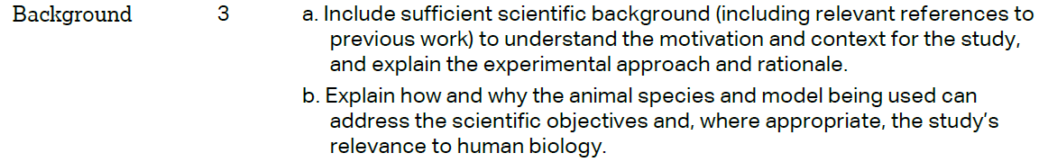 |  |  | Paragraphs 1 and 3-6  Materials & Methods, paragraph 1  Discussion paragraph 2
 |  |  |  | Paragraph 6
 | METHODS
 |  |  |  | Paragraph 2
 | 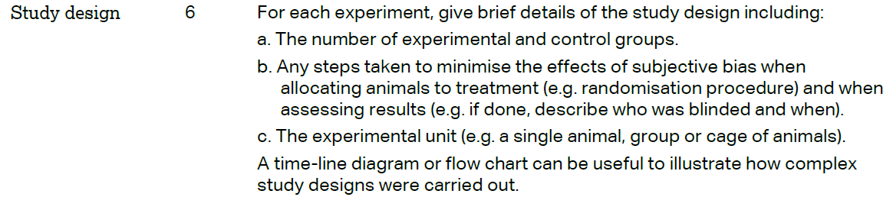 |  |  | Paragraphs 1, 3
 | 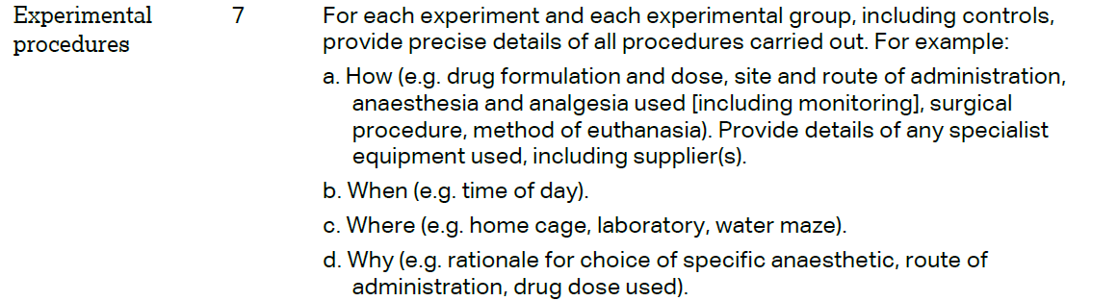 |  |  | Paragraphs 1, 3, 5
 | 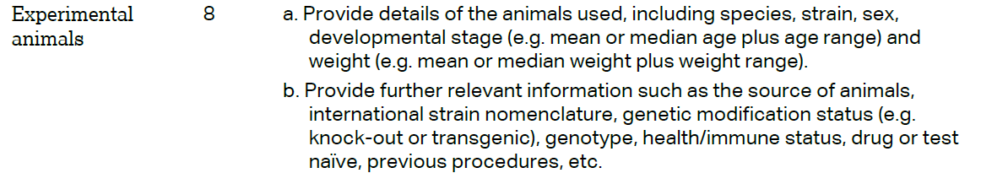 |  |  | Paragraph 1
The ARRIVE guidelines. Originally published in PLoS Biology, June 2010¹
 | 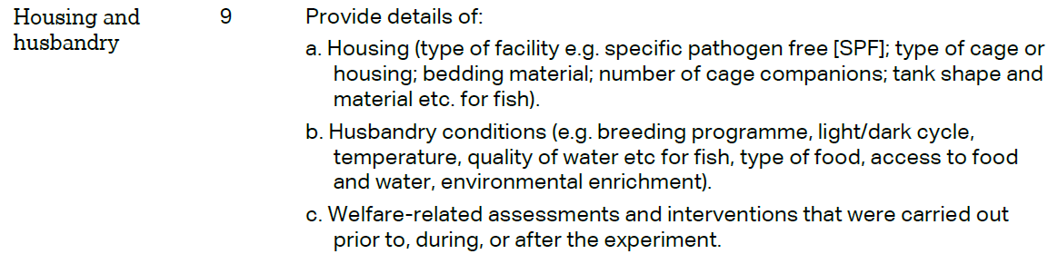 | Paragraph 1
 | 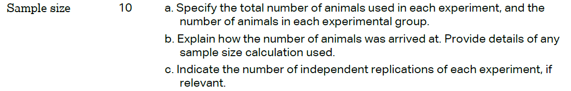 | Paragraphs 1, 3
 | 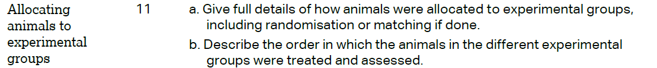 | Paragraphs1, 3
 |  | Paragraphs4-14
 | 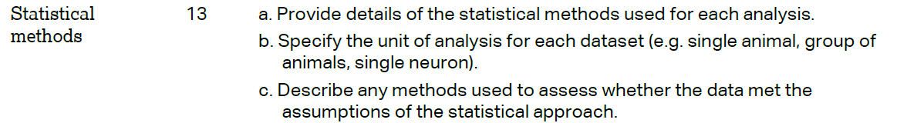 | Paragraph 15
 | RESULTS
Paragraph 1
Paragraph 1, table 1
 |  | Materials & Methods paragraph 1
Paragraphs 1-12
Figures 1-12
Tables 1, 2
 |  | No adverse events
 | DISCUSSION
 | 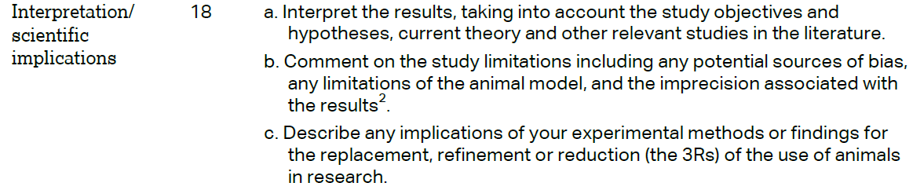 | Throughout
 |  | Paragraph 12
 |  | No funding agencies
