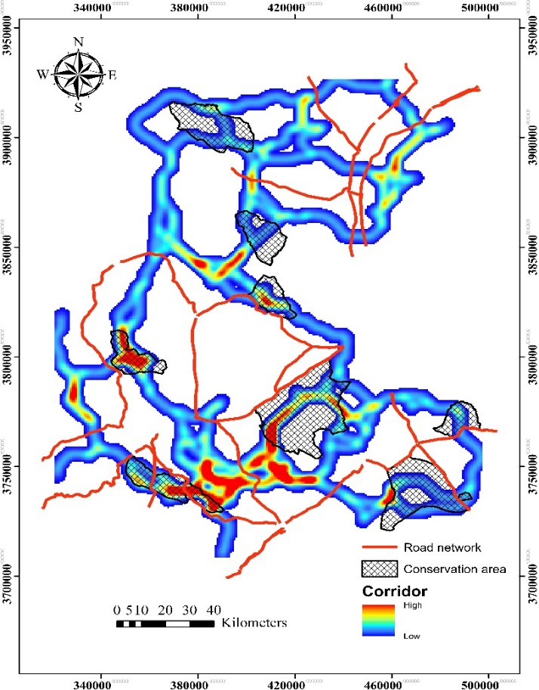

Fig. S5. Predicted corridors’ network linking striped hyaena core habitats and conservation areas at variable extent size of 4 km in central Iran. The colour gradient represents predicted connectivity from weak (blue) to strong (red).

