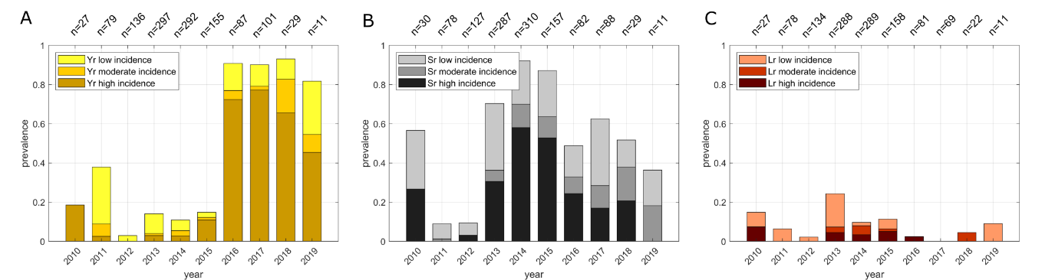
S7 Fig. Interannual variations of disease prevalence (incidence scores) on wheat variety Digalu. (A) wheat stripe rust; (B) wheat stem rust; (C) wheat leaf rust. The labels at the top of the x-axes show the total number of surveys per year. Prevalence is calculated as: [number of surveys with disease incidence (severity) / total number of surveys per wheat variety].

