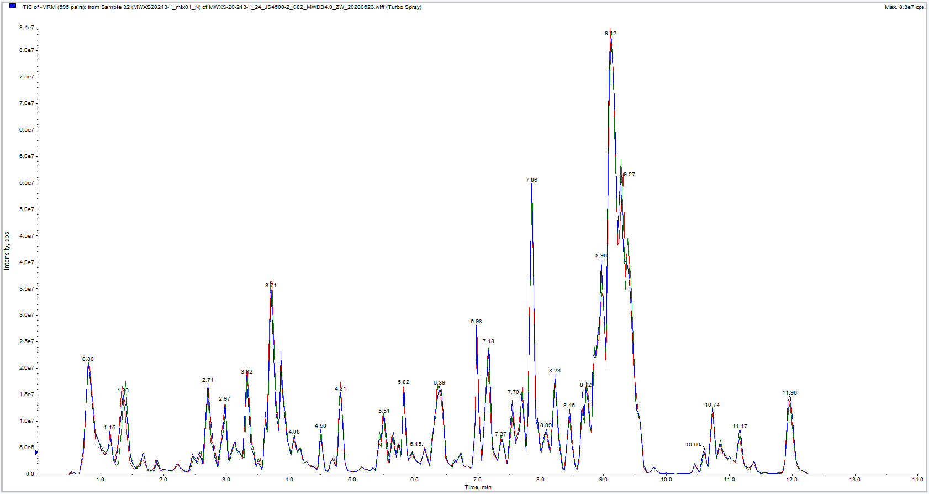
S2 Fig. Total ion chromatogram of quality control samples in negative ion mode

