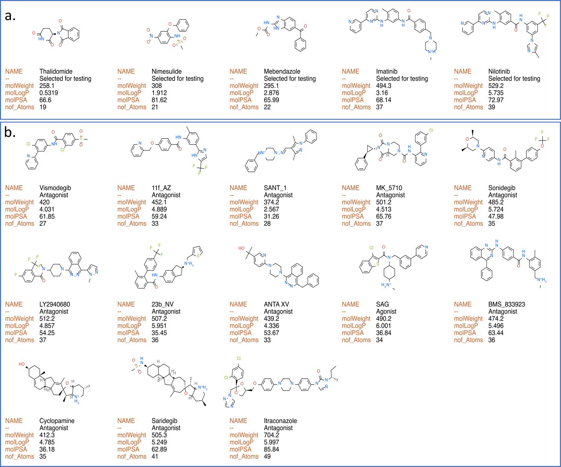
S1 Figure: Calculated properties of SMO Modulators and Drugs Selected for Experimental Validation. (a) Drugs selected for in-vitro validation (b) SMO modulators used in in-silico validation

