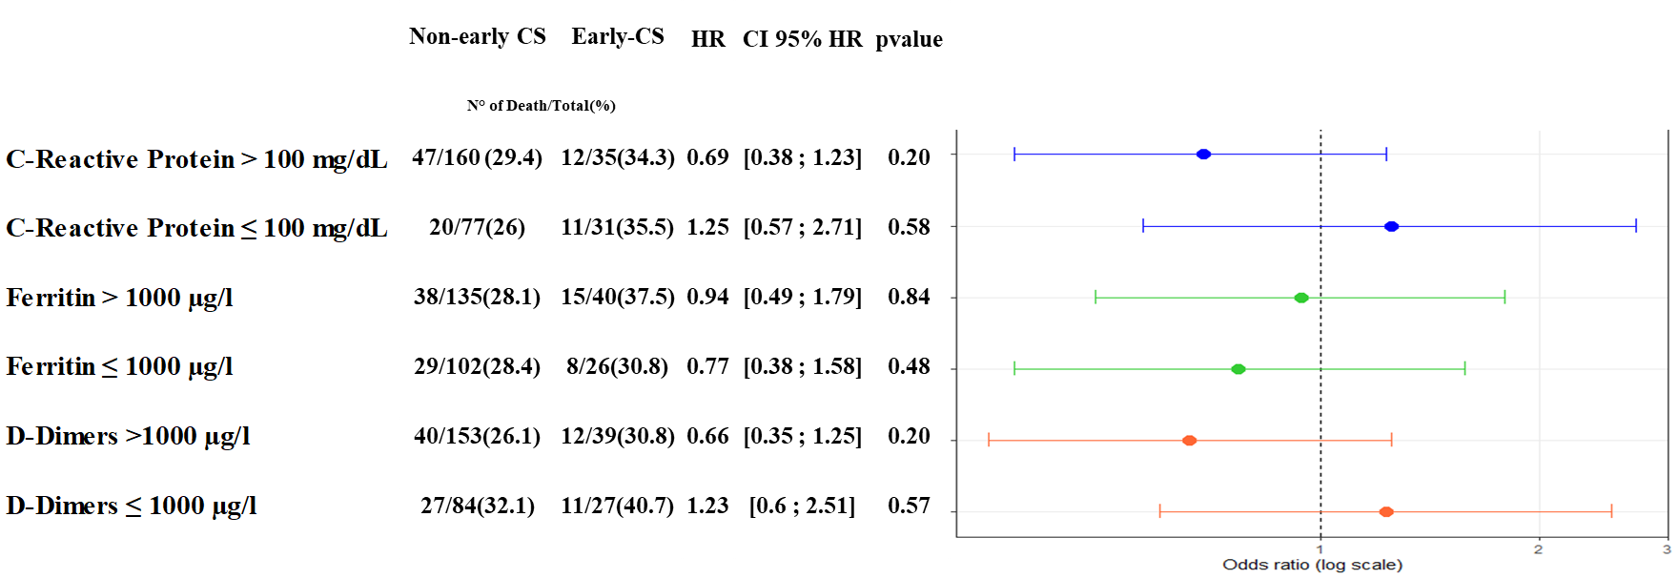
S5 Figure: Subgroup analyses based on C-Reactive protein, Ferritin, and D-Dimer levels: Impact of steroids on the occurrence of death

