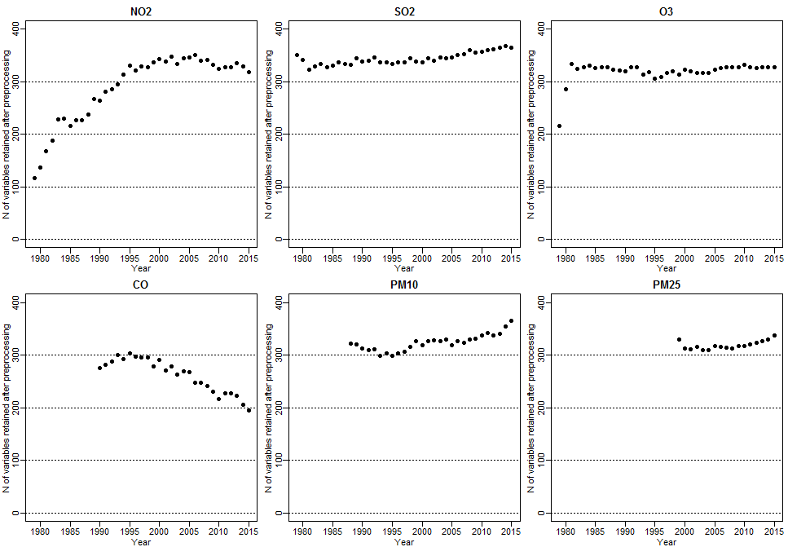
F3. Fig. Numbers of geographic variables retained after excluding least informative variables by pollutant and year

