GAMBIA

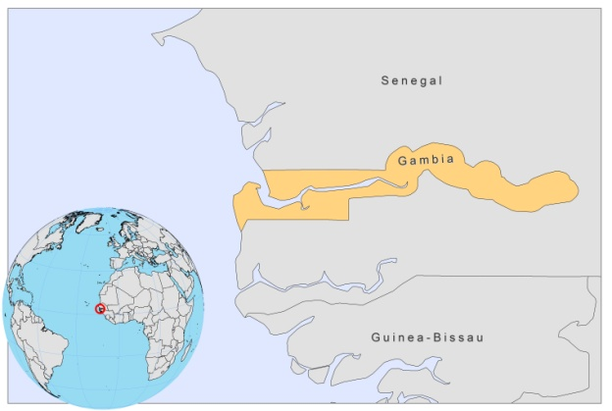

BASIC COUNTRY DATA

Total Population: 1,728,394
Population 0-14 years: 44%
Rural population: 42%
Population living under USD 1.25 a day: no data
Population living under the national poverty line: no data
Income status: Low income economy
Ranking: Low human development (ranking 168)
Per capita total expenditure on health at average exchange rate (US dollar): 26
Life expectancy at birth (years): 58
Healthy life expectancy at birth (years): 50

BACKGROUND INFORMATION

Leishmaniasis is uncommon in Gambia. No recent cases of either VL or CL have been reported. Only 3 human cases of VL have been described in 1949, 1980 and 1982 [1,2]. In 1980, a positive dog was found in the same compound as the human case [3]. This strongly suggests that dogs could be a reservoir of this infection in this area.

For CL, only 10 cases have been reported, 3 before 1980, one in 1980, and 6 in 1982 [1]. No further cases of VL and CL have been documented. As Gambia is part of a proposed CL endemicity belt running across West Africa, cases may occur regularly but remain unreported. P. duboscqi, the proven vector in Senegal, has also been found in the Gambia region [1].

PARASITOLOGICAL INFORMATION

Leishmania species | Clinical form | Vector species | Reservoirs
L. infantum | ZVL | Unknown | Canis familiaris

MAPS AND TRENDS, CONTROL, DIAGNOSIS, TREATMENT, ACCESS TO CARE, ACCESS TO DRUGS

No antimonials are registered.

SOURCES OF INFORMATION

1. Desjeux P (1991). Information on the epidemiology and control of the leishmaniases by country or territory. WHO/LEISH/91.30.

2. Greenwood BM, Ajdukiewicz AB, Conteh S, Hagan P, Mabey DC et al (1984). Leishmaniasis in The Gambia. 3. Is its incidence increasing? Trans R Soc Trop Med Hyg.78(3):407-9.

3. Desjeux P, Bryan JH, Martin-Saxton P (1983). Leishmaniasis in The Gambia. 2. A study of possible vectors and animal reservoirs, with the first report of a case of canine leishmaniasis in The Gambia. Trans R Soc Trop Med Hyg 77(2):143-8.

