Comparison of canopy thresholds using FAO CHELSA for tropical dry forest cover (km²) in 2000 and 2020 between 30˚N and 30˚S.

Canopy Cover | Forest Cover  2000 | Estimated Cover  2020 | Gross Loss  2001-2020 | Percent Loss
Open, > 10% | 9,625,291 | 8,883,523 | 741,768 | 7.71%
Closed, > 40% | 4,931,414 | 4,369,695 | 561,719 | 11.39%
Closed, > 60% | 2,364,346 | 2,085,084 | 279,262 | 11.81%

Comparisons of best methods for estimating tropical dry forest extent and forest cover in 2000 and 2020 with open (> 10% open canopy) and closed (> 40% closed canopy) canopies between 30˚N and 30˚S.

Definition | Source | Canopy | Forest Cover 2000 | Estimated Cover 2020 | Gross Loss 2001-2020 | Percent Gross Loss
Pantropics | GFC | Open  Closed | 27,352,569  20,064,659 | 24,977,794  17,962,101 | 2,374,775  2,102,558 | 8.68%  10.48%
Biodiversity Hotspots | Hoffmann et al. 2016 | Open  Closed | 8,828,443  7,096,634 | 7,679,278  6,034,221 | 1,149,165  1,062,413 | 13.02%  14.97%
FAO | CHELSA | Open  Closed | 9,625,291  4,931,461 | 8,883,523  4,369,742 | 741,768  561,719 | 7.71%  11.39%
Murphy & Lugo | Worldclim | Open  Closed | 11,626,015  7,706,856 | 10,532,421  6,779,772 | 1,093,594  927,084 | 9.41%  12.03%
TSDBF | WWF | Open  Closed | 1,049,668  782,492 | 927,467  670,336 | 122,201  112,156 | 11.64%  14.33%
Consensus (all) | CHELSA | Open  Closed | 98,632  20,758 | 94,772  19,166 | 3,860  1,592 | 3.91%  7.67%
 | Worldclim | Open  Closed | 813,914  332,336 | 769,348  305,973 | 44,566  26,363 | 5.48%  7.93%

Regional comparisons of (a) mean, (b) maximum, and (c) minimum forest cover percentage at 1 km over tropical dry forest field plots in 2000 between 30˚N and 30˚S.

(a) Mean Cover Percentage
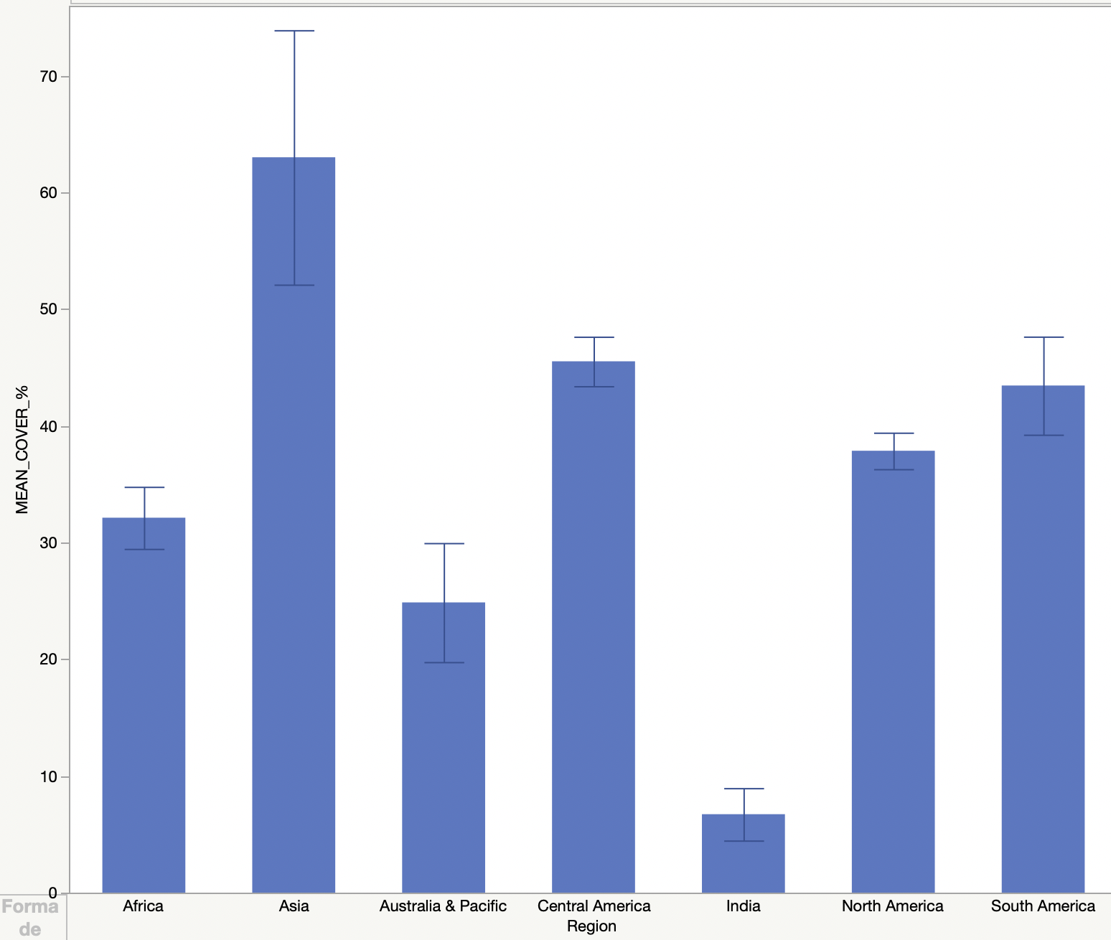

(b) Maximum Cover Percentage
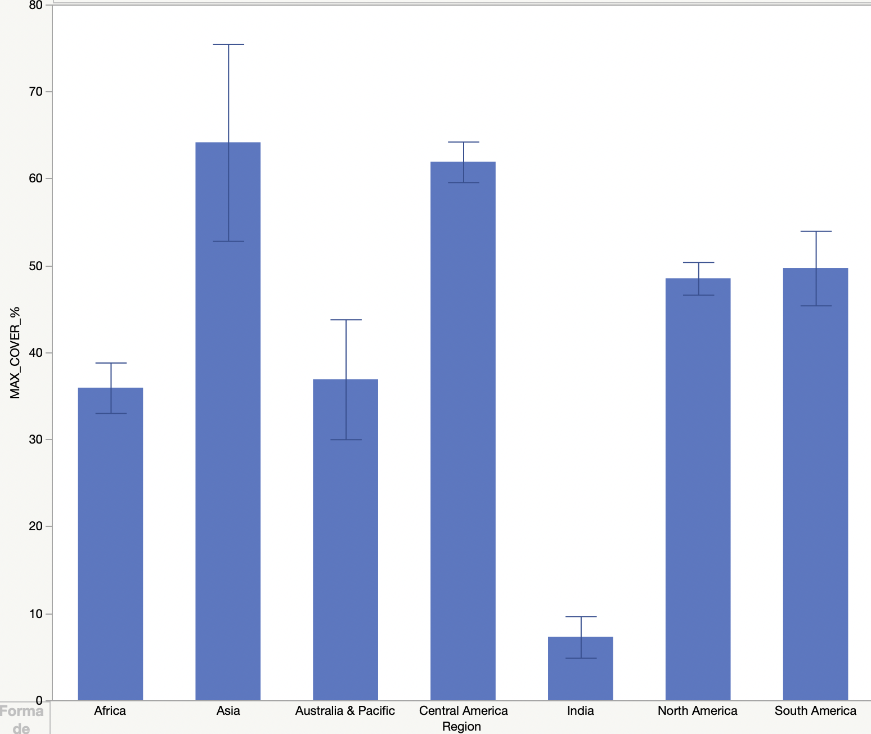

(c) Minimum Cover Percentage
