Supporting information 3

Additional data and figures

S3 Table 1: Observed ABC target summary statistics.
village | HT | PC | Number of necropsied pigs
515 | 0.024 | 0.33 | 17
566 | 0.010 | 0.15 | 16
567 | 0.020 | 0.16 | 44

 | village 515  necro_{i} | village 566  necro_{i} | village 567  necro_{i}
0 | 0,18 | 0,14 | 0,11
1 | 0 | 0 | 0,027
2 | 0 | 0 | 0
3 | 0,11 | 0 | 0,018
4 | 0,036 | 0 | 0
5 | 0 | 0 | 0
The shares of pigs per number of cysts necro_{i}, are normalized using the total number of pigs including non-infected pigs (zero cysts).

S3 Table2: variation ranges for calibration parameters that define the prior marginal distributions for the first ABC-SMC stage
Calibration parameter | Lower limit | Upper limit
pHumanCyst | 0.0 | 5 10⁻³
pigProglotInf (cysts) | 10 | 5000
pigEggsInf (cysts) | 0 | 5000
adherenceToLatrine | 0.1 | 0.95

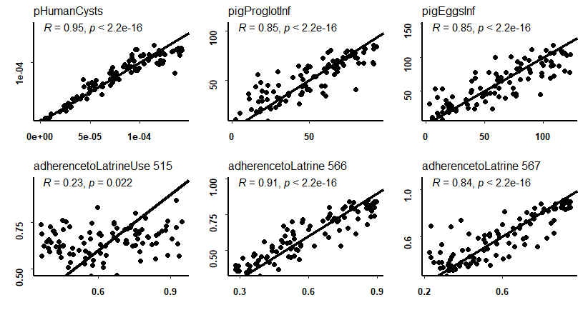
S3 Fig 1: Cross validation necro setup. Cross-validation for 100 randomly selected simulations from the necro calibration setup, third stage. Estimated parameter values are compared to true values for the 6 calibration parameters with the identity line plotted as reference. The correlation coefficient between estimated and true parameter values is shown for each parameter together with the corresponding p value.

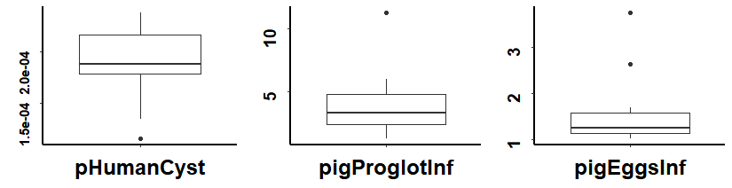
S3 Fig 2: ABC posterior distribution, simplified calibration setup. Horizontal bold lines indicate the posterior distribution median, boxes cover the parameter values above the first quartile and below the third quartile and vertical lines show maximum and minimum values. Black dots show outliers.

