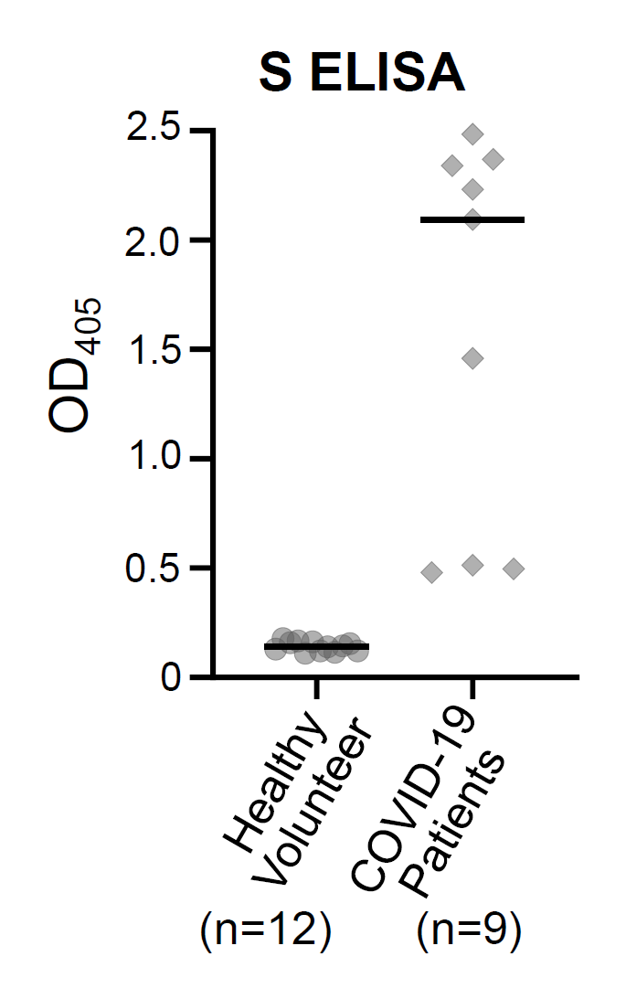
S2 Fig. Anti-S ELISA validation using sera from healthy volunteers and COVID-19 patients. The OD405 values for the 40-fold serum dilution was plotted. Background of the sera from COVID-19 patients were shown in S2 Table. Black bars: medians.

