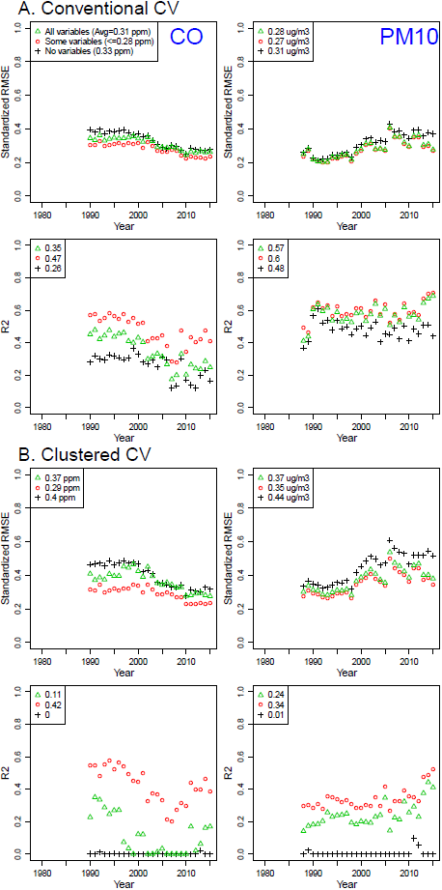
Figure S6. Standardized RMSEs and R²s of the national Integrated Empirical Geographic (IEG) models including no, some, and all variables from conventional and clustered cross-validation (CV) during 1979-2015 for the contiguous U.S. by CO and PM₁₀

